


Provide Food and Beverage Services
D1.HBS.CL5.12
Trainee Manual


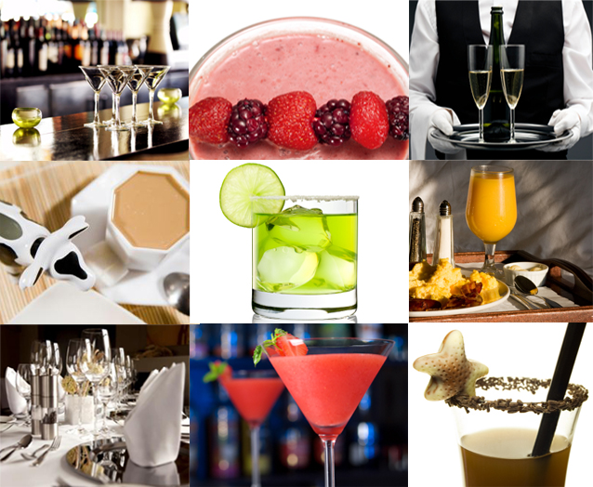



Provide Food and Beverage Services

D1.HBS.CL5.12

Trainee Manual




Project Base
William Angliss Institute of TAFE
555 La Trobe Street
Melbourne 3000 Victoria
Telephone: | (03) 9606 2111
Facsimile: | (03) 9670 1330
Acknowledgements
Project Director: | Wayne Crosbie
Chief Writer: | Alan Hickman
Subject Writer: | Nick Hyland
Project Manage/Editor: | Alan Maguire
DTP/Production: | Daniel Chee, Mai Vu, Kaly Quach

The Association of Southeast Asian Nations (ASEAN) was established on 8 August 1967. The Member States of the Association are Brunei Darussalam, Cambodia, Indonesia, Lao PDR, Malaysia, Myanmar, Philippines, Singapore, Thailand and Viet Nam.
The ASEAN Secretariat is based in Jakarta, Indonesia.
General Information on ASEAN appears online at the ASEAN Website: www.asean.org.
All text is produced by William Angliss Institute of TAFE for the ASEAN Project on “Toolbox Development for Front Office, Food and Beverage Services and Food Production Divisions”.
This publication is supported by the Australian Government’s aid program through the ASEAN-Australia Development Cooperation Program Phase II (AADCP II).
Copyright: Association of Southeast Asian Nations (ASEAN) 2013.
All rights reserved.
Disclaimer
Every effort has been made to ensure that this publication is free from errors or omissions. However, you should conduct your own enquiries and seek professional advice before relying on any fact, statement or matter contained in this book. The ASEAN Secretariat and William Angliss Institute of TAFE are not responsible for any injury, loss or damage as a result of material included or omitted from this course. Information in this module is current at the time of publication. Time of publication is indicated in the date stamp at the bottom of each page.
Some images appearing in this resource have been purchased from stock photography suppliers Shutterstock and iStockphoto and other third party copyright owners and as such are non-transferable and non-exclusive. Clip arts, font images and illustrations used are from the Microsoft Office Clip Art and Media Library. Some images have been provided by and are the property of William Angliss Institute.
Additional images have been sourced from Flickr and SXC and are used under Creative Commons licence: http://creativecommons.org/licenses/by/2.0/deed.en

File name: TM_Provide_F&B_Services_Refined





Table of Contents
Introduction to trainee manual 1
Unit descriptor 3
Assessment matrix 7
Glossary 11
Element 1: Prepare food and beverage environment for service 15
Element 2: Set tables 39
Element 3: Meet and greet guests 71
Element 4: Take food and beverage orders 85
Element 5: Serve food 105
Element 6: Serve drinks 117
Element 7: Present account to guest 137
Element 8: Provide departure services 149
Element 9: Conduct shut down activities 155
Presentation of written work 177
Recommended reading 179
Trainee evaluation sheet 181
Trainee self-assessment checklist 183

Introduction to trainee manual

To the Trainee
Congratulations on joining this course. This Trainee Manual is one part of a ‘toolbox’ which is a resource provided to trainees, trainers and assessors to help you become competent in various areas of your work.
The ‘toolbox’ consists of three elements:
- A Trainee Manual for you to read and study at home or in class
- A Trainer Guide with Power Point slides to help your Trainer explain the content of the training material and provide class activities to help with practice
- An Assessment Manual which provides your Assessor with oral and written questions and other assessment tasks to establish whether or not you have achieved competency.
The first thing you may notice is that this training program and the information you find in the Trainee Manual seems different to the textbooks you have used previously. This is because the method of instruction and examination is different. The method used is called Competency based training (CBT) and Competency based assessment (CBA). CBT and CBA is the training and assessment system chosen by ASEAN (Association of South-East Asian Nations) to train people to work in the tourism and hospitality industry throughout all the ASEAN member states.
What is the CBT and CBA system and why has it been adopted by ASEAN?
CBT is a way of training that concentrates on what a worker can do or is required to do at work. The aim is of the training is to enable trainees to perform tasks and duties at a standard expected by employers. CBT seeks to develop the skills, knowledge and attitudes (or recognise the ones the trainee already possesses) to achieve the required competency standard. ASEAN has adopted the CBT/CBA training system as it is able to produce the type of worker that industry is looking for and this therefore increases trainees’ chances of obtaining employment.
CBA involves collecting evidence and making a judgement of the extent to which a worker can perform his/her duties at the required competency standard. Where a trainee can already demonstrate a degree of competency, either due to prior training or work experience, a process of ‘Recognition of Prior Learning’ (RPL) is available to trainees to recognise this. Please speak to your trainer about RPL if you think this applies to you.
What is a competency standard?
Competency standards are descriptions of the skills and knowledge required to perform a task or activity at the level of a required standard.
242 competency standards for the tourism and hospitality industries throughout the ASEAN region have been developed to cover all the knowledge, skills and attitudes required to work in the following occupational areas:
- Housekeeping
- Food Production
- Food and Beverage Service
- Front Office
- Travel Agencies
- Tour Operations.
All of these competency standards are available for you to look at. In fact you will find a summary of each one at the beginning of each Trainee Manual under the heading ‘Unit Descriptor’. The unit descriptor describes the content of the unit you will be studying in the Trainee Manual and provides a table of contents which are divided up into ‘Elements’ and ‘Performance Criteria”. An element is a description of one aspect of what has to be achieved in the workplace. The ‘Performance Criteria’ below each element details the level of performance that needs to be demonstrated to be declared competent.
There are other components of the competency standard:
- Unit Title: statement about what is to be done in the workplace
- Unit Number: unique number identifying the particular competency
- Nominal hours: number of classroom or practical hours usually needed to complete the competency. We call them ‘nominal’ hours because they can vary e.g. sometimes it will take an individual less time to complete a unit of competency because he/she has prior knowledge or work experience in that area.
The final heading you will see before you start reading the Trainee Manual is the ‘Assessment Matrix’. Competency based assessment requires trainees to be assessed in at least 2 – 3 different ways, one of which must be practical. This section outlines three ways assessment can be carried out and includes work projects, written questions and oral questions. The matrix is designed to show you which performance criteria will be assessed and how they will be assessed. Your trainer and/or assessor may also use other assessment methods including ‘Observation Checklist’ and ‘Third Party Statement’. An observation checklist is a way of recording how you perform at work and a third party statement is a statement by a supervisor or employer about the degree of competence they believe you have achieved. This can be based on observing your workplace performance, inspecting your work or gaining feedback from fellow workers.
Your trainer and/or assessor may use other methods to assess you such as:
- Journals
- Oral presentations
- Role plays
- Log books
- Group projects
- Practical demonstrations.
Remember your trainer is there to help you succeed and become competent. Please feel free to ask him or her for more explanation of what you have just read and of what is expected from you and best wishes for your future studies and future career in tourism and hospitality.

Unit descriptor
Provide Food and Beverage Services
This unit deals with the skills and knowledge required to Provide Food and Beverage Services in a range of settings within the hotel and travel industries workplace context.
Unit Code:
D1.HBS.CL5.12
Nominal Hours:
120

Element 1: Prepare food and beverage environment for service
Performance Criteria
1.1 Check requirements for the upcoming service session
1.2 Check cleanliness of the facility and conduct spot and makeup cleaning as required
1.3 Set up dining area for trading session
1.4 Process incoming reservations to the establishment

Element 2: Set tables
Performance Criteria
2.1 Match table setting to menu for the session
2.2 Set tables and dress where appropriate
2.3 Complete final inspection of room and table set ups
2.4 Identify and report recurring problems with set up to the appropriate person to prevent recurrence

Element 3: Meet and greet guests
Performance Criteria
3.1 Welcome guests on arrival
3.2 Seat guests at nominated or designated tables
3.3 Offer pre-meal services
3.4 Present menus and wine/drink lists
3.5 Provide service advice and information to guests

Element 4: Take food and beverage orders
Performance Criteria
4.1 Take beverage orders and food orders
4.2 Sell menu items and drinks proactively
4.3 Recommend wines and drinks to accompany selected foods
4.4 Respond to guest queries regarding menu items and drink choices
4.5 Transfer orders to service and preparation points
4.6 Adjust settings/covers to reflect menu items selected
4.7 Liaise with other staff regarding intended service delivery

Element 5: Serve food
Performance Criteria
5.1 Serve bread rolls at table
5.2 Serve dishes as ordered by guests
5.3 Check guest satisfaction as part of service delivery
5.4 Take remedial action in the event of guest dissatisfaction
5.5 Clear table at appropriate times throughout meal and on completion of meal

Element 6: Serve drinks
Performance Criteria
6.1 Serve pre-dinner drinks to table
6.2 Serve wines to table
6.3 Serve after-meal drinks to table
6.4 Coordinate timing of beverage service to match courses/menu items being served
6.5 Clear glasses and beverage items

Element 7: Present account to guest
Performance Criteria
7.1 Compile guest account ready for presentation
7.2 Present account to guest
7.3 Accept payment for account
7.4 Process payment of account

Element 8: Provide departure services
Performance Criteria
8.1 Assist guest in leaving table
8.2 Provide end-of-service assistance, as required
8.3 Farewell guests

Element 9: Conduct shut down activities
Performance Criteria
9.1 Turn off electrical and service-related equipment, where appropriate
9.2 Remove used linen items for laundering
9.3 Store, stock and replenish, where necessary, for next service session
9.4 Dispose of waste
9.5 Clear and clean service area and service items
9.6 Conduct session de-briefing
9.7 Conduct handover to incoming shift, where appropriate

Assessment matrix
Showing mapping of Performance Criteria against Work Projects, Written Questions and Oral Questions
The Assessment Matrix indicates three of the most common assessment activities your Assessor may use to assess your understanding of the content of this manual and your performance - Work Projects, Written Questions and Oral Questions. It also indicates where you can find the subject content related to these assessment activities in the Trainee Manual (i.e. under which element or performance criteria). As explained in the Introduction, however, the assessors are free to choose which assessment activities are most suitable to best capture evidence of competency as they deem appropriate for individual students.
 |  |  | Work Projects | Written Questions | Oral Questions
Element 1: Prepare food and beverage environment for service
1.1 | Check requirements for the upcoming service session |  | 1.1 | 1,2 | 1
1.2 | Check cleanliness of the facility and conduct spot and makeup cleaning as required |  | 1.2 | 3 | 2
1.3 | Set up dining area for trading session |  | 1.3 | 4 | 3
1.4 | Process incoming reservations to the establishment |  | 1.4 | 5 | 4
Element 2: Set tables
2.1 |  | Match table setting to menu for the session | 2.1 | 6 | 5
2.2 |  | Set tables and dress where appropriate | 2.2 | 7,8 | 6
2.3 |  | Complete final inspection of room and table set ups | 2.3 | 9 | 7
2.4 |  | Identify and report recurring problems with set up to the appropriate person to prevent recurrence | 2.4 | 10 | 8
Element 3: Meet and greet guests
3.1 | Welcome guests on arrival |  | 3.1 | 11 | 9
3.2 | Seat guests at nominated or designated tables |  | 3.2 | 12 | 10
3.3 | Offer pre-meal services |  | 3.3 | 13 | 11
3.4 | Present menus and wine/drink lists |  | 3.4 | 14 | 12
3.5 | Provide service advice and information to guests |  | 3.5 | 15 | 13
Element 4: Take food and beverage orders
4.1 |  | Take beverage orders and food orders | 4.1 | 16,17 | 14
4.2 |  | Sell menu items and drinks proactively | 4.2 | 18 | 15
4.3 |  | Recommend wines and drinks to accompany selected foods | 4.3 | 19 | 16
4.4 |  | Respond to guest queries regarding menu items and drink choices | 4.4 | 20 | 17
4.5 |  | Transfer orders to service and preparation points | 4.5 | 21 | 18
4.6 |  | Adjust settings/covers to reflect menu items selected | 4.6 | 22 | 19
4.7 |  | Liaise with other staff regarding intended service delivery | 4.7 | 23 | 20
Element 5: Serve food
5.1 | Serve bread rolls at table |  | 5.1 | 24 | 21
5.2 | Serve dishes as ordered by guests |  | 5.2 | 25 | 22
5.3 | Check guest satisfaction as part of service delivery |  | 5.3 | 26,27 | 23
5.4 | Take remedial action in the event of guest dissatisfaction |  | 5.4 | 28 | 24
5.5 | Clear table at appropriate times throughout meal and on completion of meal |  | 5.5 | 29,30 | 25
Element 6: Serve drinks
6.1 |  | Serve pre-dinner drinks to table | 6.1 | 31 | 26
6.2 |  | Serve wines to table | 6.2 | 32,33 | 27
6.3 |  | Serve after-meal drinks to table | 6.3 | 34 | 28
6.4 |  | Coordinate timing of beverage service to match courses/menu items being served | 6.4 | 35 | 29
6.5 |  | Clear glasses and beverage items | 6.5 | 36 | 30
Element 7: Present account to guest
7.1 | Compile guest account ready for presentation |  | 7.1 | 37 | 31
7.2 | Present account to guest |  | 7.2 | 38 | 32
7.3 | Accept payment for account |  | 7.3 | 39 | 33
7.4 | Process payment of account |  | 7.4 | 40 | 34
Element 8: Provide departure services
8.1 |  | Assist guest in leaving table | 8.1 | 41 | 35
8.2 |  | Provide end-of-service assistance, as required | 8.2 | 42 | 36
8.3 |  | Farewell guests | 8.3 | 43 | 37
Element 9: Conduct shut down activities
9.1 |  | Turn off electrical and service-related equipment, where appropriate | 9.1 | 44 | 38
9.2 |  | Remove used linen items for laundering | 9.2 | 45 | 39
9.3 |  | Store, stock and replenish, where necessary, for next service session | 9.3 | 46 | 40
9.4 |  | Dispose of waste | 9.4 | 47 | 41
9.5 |  | Clear and clean service area and service items | 9.5 | 48 | 42
9.6 |  | Conduct session de-briefing | 9.6 | 49 | 43
9.7 |  | Conduct handover to incoming shift, where appropriate | 9.7 | 50 | 44

Glossary
Term | Explanation
Account | A folio or file in which transactions can be recorded
‘Accoutrements’ | Items used to fit out the tables. Also referred to as centre pieces
A la carte | It is the term used for a menu that has individually priced dishes. A la carte means ‘from the card/menu’
A la carte setting | Basic table setting for an individual cover
Anticipate | To realize beforehand; foretaste or foresee
Balancing | The process undertaken at the end of a shift to determine if actual takings balance or match recorded takings
Bain Marie | A large pan that is filled with hot water and has a heat source. Smaller pans can be set in the larger pan to keep food warm or cook food slowly
Briefing | A meeting to discuss an upcoming shift
Cash Float | A specific amount of money, made up of various amounts, used for cashiers to give change
Centrepiece | A large central object which serves a decorative purpose
Charge | A transaction resulting from the sale or use of a product or service
Checklist | List used to identify complete list of activities to be performed
Contamination | Spoilage of safe food: food must be thrown out
Cover | A place setting for a guest OR word used to describe the number of guests
Crockery | A term used to identify plates, cups, saucers and bowls normally made from china
Cruet | French term for salt and pepper shakers or an oil and vinegar set
Customer | A person who purchases goods or services from another, buyer, patron
Cutlery | A term used to identify knives, forks, spoons, teaspoons and service utensils made from stainless steel
Dining environment | The dining area
EFTPOS | Electronic Funds Transfer at Point of Sale. An electronic method of payment using a credit or debit card
Financial transaction | The monetary dealings between the customer and the establishment
Gueridon trolley | A movable service or trolley from which food can be carved, filtered, flambéed or prepared and served
Handover | A period of time in which different shifts will have time to exchange information that will benefit and ensure the smooth continuation of the department
Hot box | A container used to keep plates warn prior to serve
House account | An account established for a person or company who is not accommodated in a guest room
Maitre d’ / Maître d'hôtel | A dining-room attendant who is in charge of the waiters and the seating of customers
Mill | Used to grind salt and pepper; a grinding mill grinds solid materials so they are smaller
Mise en place | French term meaning ‘put in its place’- the preparation of items and areas before service
Opening procedure | The tasks, responsibilities or step by step instruction to be performed before the start of service
POS terminals | Point of Sale terminals or cash registers
Post mix | A drink dispensing system for simultaneous dispensing of syrup and water/soda in a single valve chamber to produce a flavoured drink
Smorgasbord | An assortment of foods served as a buffet meal
Table d'hôte | A French term meaning ‘host's table’
Table side service | Service that takes place near a customer table
Tableware | Items that are placed on a customer table including cutlery, crockery and glassware
Temperature Danger Zone | Is between 5˚C and 60˚C and is the temperature at which bacteria can grow most rapidly to dangerous levels in food
Tent cards | Cards used for the display of information or advertising folded in a triangular fashion to stand freely on a table
Variance | The difference between the actual takings (total of payments) against recorded payments
Work station | An area where a person works or where items needed for the completion of tasks are kept or stored
X reading | A reading or report on all the financial transactions processed through the cash register during the shift or day
Y reading | A final report on all the financial transactions that have been processed through the register during the shift or day, and this reading also clears the register’s memory of those transactions, leaving the register ready for the next day’s or shift’s transactions

Element 1:
Prepare food and beverage environment for service

1.1 Check requirements for the upcoming service session

Introduction
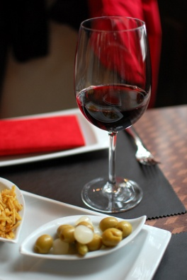
The industry boasts a wide variety of food and beverage outlets.
The notes provided in this manual are intended as a guide to what is generally applicable. However you are advised to identify what specifically applies at your workplace and comply with those requirements where they differ from what is provided in these notes.
In many instances the preferred methods, techniques and protocols will reflect the nature and style of the establishment and the atmosphere, image and environment it wishes to create.
For example, one establishment may aim for a casual dining environment while another aims for a more formal approach.
Neither is right or wrong. They are simply different and it is your responsibility to provide the style of service appropriate for the venue where you work.
If unsure about what applies where you work, speak to your supervisor.
Understanding your role
The basis of doing any job properly is knowing what is required of you, regardless of industry or position.
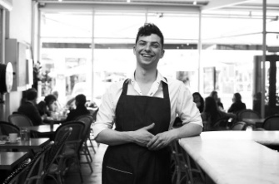
All jobs have unique activities or ‘tasks’ attached to them and, in theory, if everyone does what they should then the integration of everyone’s efforts will result in the intended objectives and outcomes for the business and customers.
This manual looks at the common roles and functions associated with providing food and beverage services within a hospitality establishment.
As mentioned above, the diversity of the food and beverage industry will often mean that the different functions and activities to be performed by food and beverage servers will vary to meet the style of service provided.

Identifying individual responsibilities
There are a number of ways to identify the responsibilities of food and beverage servers. Given that each organisation will have established positions in which individual staff members are employed, finding out information is fairly easy.
The ways to identify individual roles, responsibilities and tasks include:
- Organisational hierarchies. Each organisation will have established work groups, each with their own positions
- Contract. This outlines your job including any responsibilities and conditions of employment
- Job Description. Most jobs will have a separate job description that will identify the activities that you need to perform as part of your role
- On-the-job training – specific to individual venues and individual sections/rooms within venues
- Standard Operating Procedures (SOPs). Standard instructions indicating how to perform specific tasks and the order of sequence
- Policies. Rules to follow in an organisation relating to difference circumstances
- Procedures. Step by step instruction detailing how to complete an activity
- Daily Task Sheets. These may allocate specific tasks to perform that may relate to a specific activity or event
- Direct requests. These can come from by management, colleagues or customers
- Observation. Quite often you will have a feeling when a certain task needs to take precedence over others. This is intuition.
Understanding the upcoming service session
Before we start to prepare for a session we must understand what is likely to take place in the upcoming session.
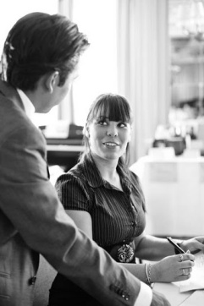
Whilst there may be set activities that take place, no doubt there will be factors that need to be considered as they will impact likely events.
The more we can accurately prepare for upcoming events the more effective, efficient and less stressful it will be on all stakeholders including managers, staff and customers.
So how can we anticipate and understand upcoming sessions?
The following are activities that are commonly undertaken to help prepare staff for a shift.

Checking reservations
The first task is normally to check the reservations to gain an understanding of how busy the outlet will be and to help in the allocation of duties to staff.
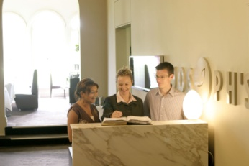
Information to check in relation to reservations includes:
- Number of guests including type of guests. For example, a baby may require a high chair
- Name of guest or organisation
- Whether it is a private event or not
- Size of bookings. This can indicate where their table has to be placed simply because it won’t fit in certain locations
- Customer’s arrival time. This helps identify rush times and when additional reservations can be made
- Check if they have requested ‘smoking’ or non-smoking’
- Special requests such as the guest requesting a specific table number, specific location, dietary requirements or that they have brought a birthday cake
- Needs of guests such as wheelchair access or stated need to be in a private location.
Consider anticipated trade
When checking reservations, it is also important to take into consideration the anticipated level of ‘walk in’ customers. These customers are those who do not have a booking, but merely walk in off the street looking for a table.
The level of ‘walk in’ trade may be influenced by:
- Historical information
- Events or local attractions. They may be theatre shows, festivals or sporting events starting at specific times, which are located close to the premises
- Weather
- Hotel occupancy, if dining premises is within a hotel
- Advertising and promotions undertaken by the venue or room – which may include consideration of:
- Media and newspapers
- Website
- Facebook
- Trip Advisor
- Yellow Pages.

Check menu for the session
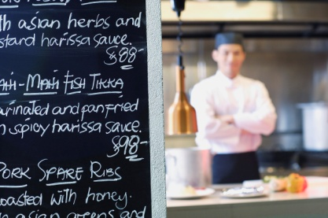
The menu can change daily, depending on the availability of the menu items and the chef’s choices.
It is vital for all service staff commencing a service session to be aware of any menu variations and know what the daily specials are.
In addition, the kitchen may require service staff to ‘push’ certain dishes to clear them, or because they represent an especially profitable dish.
It is also important to identify any menu items which are unavailable for the session to avoid guest disappointment.
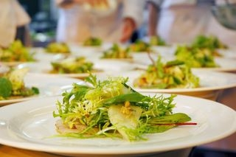
Some specials or variations that could occur on a daily or service by service basis may include:
- Fish of the day
- Soup of the day
- Specials of the day
- Vegetables of the day
- Dessert of the day
- Specific constraints on this individual upcoming session
- Beverages involved in Happy Hour.
When the guests are presented with the menu, they should be informed of any changes, specials or limitations at this stage to avoid disappointment and frustration should they order items that are unavailable.
Changes and specials may also be written up on a board, and brought to a guest’s attention upon seating. Chalkboards should be kept clean and all handwriting should be neat and legible.
Lots of different menu presentation options exist, from print-based options, through hand-written boards to electronic displays.
Check internal requirements
Besides the above mentioned impacts on upcoming session, there are usually a number of internal requirements that need to be considered including:
Special service protocols
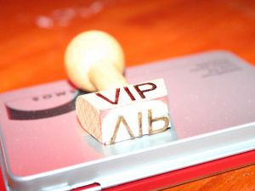
Service styles, menus or promotions may change to cater to a dedicated theme or group. In addition specific service standards will also impact service.
Arrival and treatment of VIPs
VIPs can include:
- Royal families
- Ministers
- Guests staying in Executive Suites
- Executives
- Senior management
- Regular in-house guests
- Important potential or existing clients
- External customers
- Large groups.
Where VIPs are expected, this will likely impact service through the need for:
- Higher service levels – more experienced staff or greater numbers of staff allocated to the VIPs
- Need for private area – sections may need to be closed off or priority tables to be reserved
- Specialised dishes – this may include 3 course set menus through to specialty menu items
- Butlers
- Food testers.
Priorities
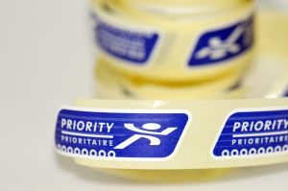
Each organisation will have priorities which they want to achieve in relation to operational activities, sales or profitability.
This will influence:
- The style of service
- Promotions
- Bookings taken – one of 2 sittings per session.
Limitations for service
There may be a range of limitations that impact on an upcoming session including, but not limited to:
- Pre-existing group bookings, for example external conferences or groups staying in the hotel
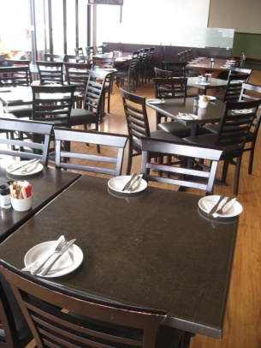
- Meetings that have been booked in the outlet. Normally these include hotel management meetings but could also include breakout rooms for conferences
- Repairs to equipment or sections of the outlet
- Staffing limitations either to back of house (chefs) or front of house (service staff)
- Equipment limitations. Naturally each outlet will only have a certain amount of floor space or limited number of tables and chairs that can fit within it. In addition kitchens can only produce a specified amount of menu items in a given period of time.

1.2 Check cleanliness of the facility and conduct spot and makeup cleaning as required

Introduction
Staff working in a food and beverage facility will be responsible for checking the food and beverage area prior to opening/service to ensure its cleanliness and, where required, taking corrective action.
In most establishments, employees are rostered on for a minimum of half an hour depending on bookings and the size of the facility before a shift starts, to prepare a restaurant or dining area for service.
The preparation of a restaurant is vital for the efficient and successful running of any meal shift. Things need to be checked, stocked, positioned and cleaned before a restaurant opens to the public, and if a restaurant is unprepared, service may be slow, inefficient and seen as unprofessional by the customer, who then may decide not to return.
You need to be ready for service when the doors open. Otherwise you always seem to be playing catch-up, and never get on top of what needs to be done.

Cleaning and checking the restaurant area
All areas need to be checked for cleanliness or cleaned prior to service.
Most establishments employ cleaners to do the bulk of the cleaning during the hours the area is closed. However, throughout the day, certain areas must be monitored for their ongoing cleanliness and any problem areas must be rectified promptly. These problems cannot wait until the daily major cleaning service.
These procedures follow any establishment schedule. They cover a wide diversity of tasks and equipment. The size of the venue, the number of staff, the number of covers, layout, service style and opening hours will all impact on the cleaning and checking that are required.
Areas to check for cleanliness may include:
- Furniture – tables and chairs
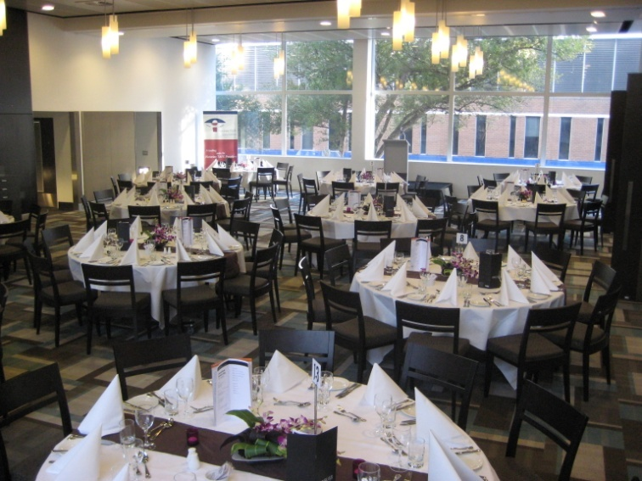
- Wall hangings – pictures or displays
- Fixtures – light fittings and door knobs
- Plants – indoor plants and pots
- Glass – windows, panels and doors
- Floor – carpet and tiled areas
- Work stations – waiter’s sideboard
- Toilets – rest areas
- Hostess stand
- Menu display stand
- Buffet line
- Bar.
Checking and cleaning customer facilities
Facilities can say a lot about the hygiene levels and standards of an establishment.
Customers dislike visiting facilities in a venue that are messy or unclean, and often infer things about other areas of the property based on what they find in these public areas.
It is therefore very important to keep these areas clean. Waiting staff cannot afford to adopt a view that says ‘these are not my areas – it’s not up to me’.
They are – and it is!
Customer facilities may include the waiting area, the toilets, non-smoking areas and external areas.
Waiting area
This area is used to seat customers who may be waiting for a table, or waiting for other guests to arrive.
Waiting areas usually have seating, offer written material for customers to read, and have some sort of view to keep customers engaged while they are waiting.
Waiting areas may also have a cloakroom to store customers’ property. It is vital for cloakrooms to be clean and well maintained in order to reduce the risk of damaging customers’ property, and to create an initial impression of care and attention to detail throughout the entire property.
Waiting areas are usually near the front entrance, and are often the first area a customer enters. This first impression of the establishment is very important so cleanliness and tidiness is essential.
In addition, staff who work here must realise that their dress, actions and demeanour are likewise critical. They must also realise that customers will see them before they talk to them, and are forming an opinion of the establishment long before the first word is said.
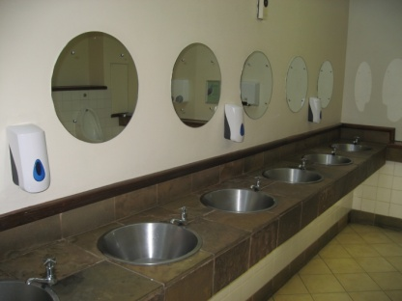
Toilets
The restroom area must be kept clean at all times and well stocked with the necessary items.
Depending on the number of patrons, some restroom areas can get quite messy during service.
The following areas in a restroom must be checked for cleanliness and stocked before service and regularly throughout a shift. Checks should include:
- Hand soap/hand sanitiser should be provided – and refilled when empty
- Benches – making sure they are free from water, soap scum, tissues and glassware
- Toilet cubicles – checking they are stocked with toilet paper and that the toilet bowl and seat is clean
- Urinal – checking they are clean and in good working order with deodorant blocks supplied where appropriate
- Hand towel dispenser – making sure it is stocked with woven paper towels
- Hand dryer – verifying it is clean and in good working order
- Waste paper basket – emptying it as required and ensuring it is not overflowing, and is fitted with a bin liner that is in good order
- Floor – making sure it is clean and free from rubbish and liquid spillage
- Making sure the area has a clean and hygienic smell.
Unfortunately, some customers visiting hospitality establishments could be ill, and if someone has been ill in a toilet or restroom, then the problem must be addressed immediately. Even though it’s a dirty job, you’ve got to fix it. You must not just ignore it.
If you can’t do it, get a cleaner on to it immediately.
When these checks and cleaning duties are being performed, it is also necessary for you to keep an eye peeled for any pieces of furniture, or other items that require repair or which may pose a danger. These should be reported to the appropriate person (supervisor or the maintenance department), and removed from service where warranted.
Work within guidelines for Occupational Safety and Health (OSH) regarding cleaning toilet areas, such as wearing disposable gloves, taking all necessary measures to protect yourself against injury when dealing with chemicals and being alert to the possibility that needles may have been disposed of in the toilet cubicles or in the waste bins.
Smoking areas
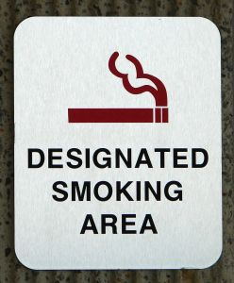
The main cleaning of this area should have been done by the cleaning staff but your role may include:
- Checking that the cleaning of this area has been done and arranging for supplementary cleaning where required
- Doing spot cleaning of areas and items that require it. The cleaners may not always clean this area to the standard you want, or which is required
- Placing ashtrays in the area – on tables, on the floor
- Placing advertising material in the area to promote the food and beverages available and to promote upcoming events, special occasions etc.
- Watering plants in the area.
External areas
External areas are areas outside the premises and can include footpaths, gardens and car parks.
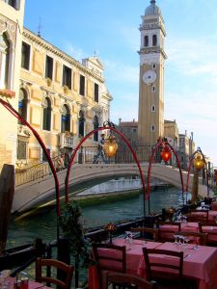
These areas are often forgotten by staff who normally work inside the premises, but they are very important because these areas are the ones that customers see before they enter the food and beverage area. Once again, they start forming impressions about the food and beverages and the service they will receive based on these factors.
Duties regarding these areas are usually limited to the basics such as:
- Sweeping or hosing an area
- Picking up rubbish
- Collecting any glasses etc. that guests may have taken outside.

1.3 Set up dining area for trading session

Introduction
Once the facility is clean and tidy, it is now time to start to ‘set up’ the dining area so that it is ready for service. Naturally this must reflect the requirements as identified in Section 1.1 of this manual.
There is a wide variety of tasks that need to be performed, all of which are interlinked and are as important as each other.
Given that the service session is normally very busy with serious time restraints, it is vital that any preparation is done in advance.
This section will explore what items need to be set up in the dining area itself. Sections 2.1 and 2.2 will look at the specific tasks related to setting tables to reflect expected dining demands.
Set up furniture
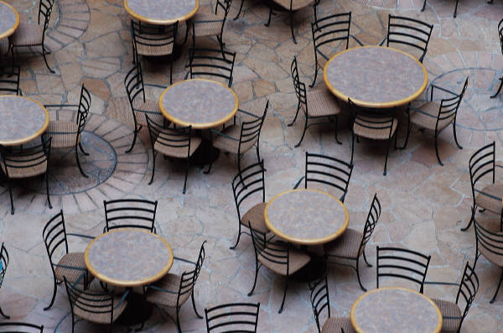
A major task in preparing a food and beverage service area for service is to set up the furniture in the room.
‘Furniture’ primarily refers to tables and chairs.
The room may be set up:
- In a standard fashion where it is set exactly the same for each session regardless of bookings, day of the week, time of the day
- To reflect the identified service session needs, as discussed in Section 1.1 of this manual.
Update floor plan
A floor plan is a map of how the tables are to be positioned in a dining area or restaurant.
A new floor plan is created in many establishments for each and every service session. While these floor plans may all be similar, there will sometimes be subtle variations, and at other times big differences between them.
Much of what we do in the hospitality industry is based on intelligent and adequate planning. A floor plan is one aspect of that planning.
A floor plan sets out:
- Where the tables will be physically positioned
- The number of covers on each table
- The table numbers
- Which waiters will serve which tables.
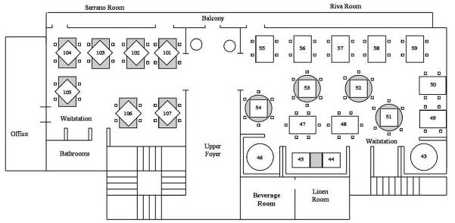
Table arrangement and placement can vary according to the type and style of menu being served, and each floor plan must take a number of points into consideration to ensure customer convenience and safety.
These points may include:
Reservations
- Number of guests
- Size of bookings
- Customer’s arrival time
- Special requests
- Needs of guests.
Shape and design of the room
This involves taking into account the structure of the room in relation to issues such as:
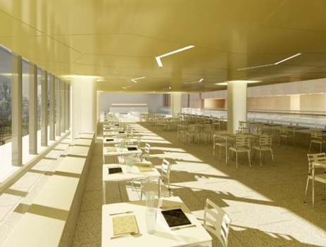
- Tiered floors – split level dining areas are notoriously difficult to prepare a table plan for as they tend to waste a lot of space
- Location and size of dance floors
- Location of windows
- Number and size of entertainment areas
- Required thoroughfares to allow both guest access to tables, toilets etc. and to allow staff sufficient room to move around the floor and service the tables
- The amount of room required for staff movement must reflect the style of service being offered. For example, more room is needed between tables if gueridon trolleys are going to be used as part of the service.
Most floor plans will allow several primary service routes for waiting staff to take on the floor so that all the tables can be serviced
- Location and number of booths or alcoves that exist in the room – if applicable.
Immovable objects
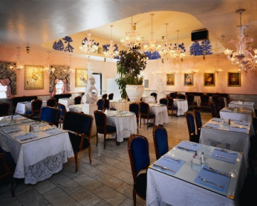
Within most rooms there will be various objects that cannot be moved and there is therefore a need to plan around them. They include:
- Waiters stations
- Pillars
- Staircases
- Display cases.
Style of furniture
These will also influence the layout of the floor plan. Factors involved are:
- Shape of tables – round, square, half-moon, quarter-circle
- Size of tables – two-person, or four-person
- Type of chair used at the tables.
Exits and doors
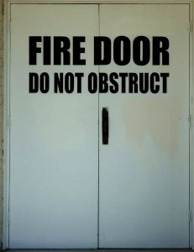
The location of doors and whether or not they open inwards or outwards must be taken into account in relation to:
- Service doors – to and from the kitchen, bar
- Fire exits
- Restroom doors
- Main entrance to the room.
It is standard practice to try to seat guests away from doors wherever possible as these areas are likely to be high-traffic areas that can detract from the guest enjoyment of their dining experience.
Further considerations
Further points that may need to be factored in include:
- Leaving space for guests to move in and out from their table with safety and without having to ask others to stand up
- Providing customers with enough space around the table to grant a level of privacy. Placing tables ‘too close’ to others is to be avoided
- Avoiding placing tables in draughty areas, directly under speakers or air conditioning, or too close to waiter’s stations
- Making provision for hats and coats, where applicable.

Customer and service personnel access
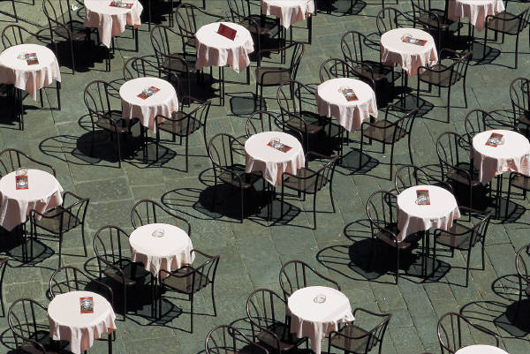
One important point that needs to be considered is ensuring adequate access for both customers and service staff.
A room that is over-crowded has the potential to reduce customer satisfaction. This may be due to being too close to others, and via the potential for service levels to be reduced because of the difficulty staff have in getting to tables.
It can also present a potential danger if there is a need to evacuate the room for any reason.
Access routes into the room and between tables must ensure:
- The ability of all patrons to move freely to and from their tables
- Room for staff to service individual tables – that is, to move freely and easily around individual tables
- Room for staff to wheel service trolleys around the room and to individual tables
- Ease of access to facilities in the room such as toilets, viewing areas and service points such as bars, food pick-up points and dance floor
- Waiting staff can have freedom of movement around their waiting stations.
Allocating waiting stations to staff
Once the tables have been set up, it is quite common for the manager to assign sections and tables to specific staff members. The waiting staff may now be responsible for setting up their own tables and during service itself. Depending on the style of service, a specified number of customers may be allocated to a staff member, based on a pre-determined ration. In most restaurants this ration may be one staff member per 20 customers.
There are a number of considerations that will affect this ratio including:
- Types of customers. Some customers will be more difficult to service including parties or those with many special requests. Also VIPs may require more attentive service
- Amount of people per table. It is easier to service two tables of 10 customers than 10 tables of 2 customers. Hence staff may be given a maximum of 5 tables.
- Type of service. If customers are eating from a buffet or from a set menu, the amount of tasks to be performed by waiters will be reduced, therefore more customers may be allocated
- Level of service where staff are required to provide gueridon service, involving preparing or cooking dishes at the table, the amount of customers they will be able to professionally service will reduce dramatically
- Experience of staff. Naturally new staff will not be able to deal with larger numbers of customers. In addition where experienced staff are training new staff, their expected level of productivity with be reduced
- Location of tables where tables are located a great distance from food outlets, kitchens or work stations, more time will be required to travel between these locations.
When allocating tables, you may find that customers may have specifically asked for a certain staff member, or are used to certain tables. These must be taken into consideration.
Prepare and adjust the environment
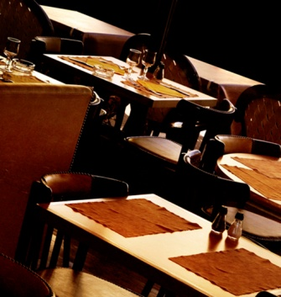
The ambience and comfort level of a restaurant must be taken into consideration when preparing for service.
It should also be continuously monitored during service to ensure it is in line with policy and requirements. Most venues will have set requirements in relation to:
- The temperature settings on the climate control or air conditioning systems
- The lights that have to be turned on or off
- The level at which sound systems operate.
Comfort and ambience
Some of the factors in achieving a high level of customer comfort and creating the required ambience include:
- Restaurant temperature set at a comfortable level taking into account the outside temperatures. Some properties set a constant level year round. An accepted temperature range for dining areas is 20ºC - 26ºC, while other properties will make the room cooler during summer and warmer during winter
- Generally speaking, the temperature level should be a ‘set and forget’ issue. If the temperature has to be altered, permission to do so may be required from management before adjustments are made
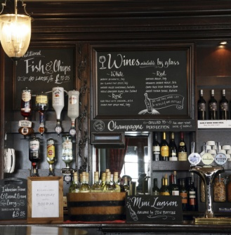
- Lighting adjusted according to the time of day and the establishment style. Lighting is a main way in which ambience is created and the combination of up-lights and down-lights, the use of dimmer and coloured lights all combine to produce a required setting.
Checks must be made to ensure:
- No blown globes
- No flickering fluorescents
- Dimmers are set at the correct setting
- Lights are on or off as required
- A fresh smell. Sometimes it may be necessary to turn on the air conditioning for a short time to clear away stale air and smoke. In some cases the property may use a commercial product to remove bad smells. In some venues, a fresh smell may be achieved by simply opening windows and doors but care needs to be taken to protect against flies etc. coming in!
- Music organised as appropriate. The type of music played must be in accordance with establishment policies, themes, special events and preferences. For example, Irish music on St Patrick’s Day is appropriate
- Volume of the music should be set at a relatively low level at the start of a session and be adjusted upwards as patron noise and cutlery and crockery noise grows during service. The music should aim to:
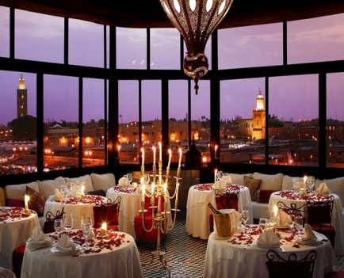
- Provide a background to the dining experience
- Mask conversations of other patrons
- Create atmosphere
In some establishments, quick-tempo music is played to encourage guests to eat quicker thereby increasing the possibility of selling a table more than once per session. In other venues, the music is deliberately chosen to provide a more relaxed and slower-paced environment.
There is no room in venues for you to bring in your favourite CDs and use them as the standard music for the dining room!
- Table decorations and floor displays.
Decorations help create the atmosphere for the room and may be themed to reflect the name of the venue or room, or to reflect the interests of the customers who eat and drink.
Floor displays are used to motivate customers to buy products (food and beverage items such as wines, cocktails or a nominated menu item), or to promote another part of the venue or to promote an upcoming special event in the dining area or bar (such as Mother’s Day, a Seafood Night or Valentine’s Day).
Adjusting the environment during trade
Customers sometimes show signs that they are not comfortable in their surroundings. You need to be aware of the body language being sent by customers. Careful observation will let you know if people are too cold, too hot, or if the music is too loud, or the lights too low.
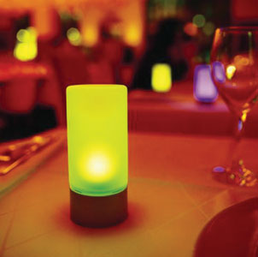
It is a fact of life in dining areas and restaurants that getting the air conditioning or music 100% right for everyone is very difficult, if not impossible.
For someone sitting under an air conditioner outlet the temperature can be too cold, while for someone sitting only a couple of metres away, it can be perfect.
A party of young people may want the music turned up or another style of music played, while an older group may want the music turned down.
Always check with a supervisor before adjusting temperature or music. Some properties will require the set levels to be adhered to at all times, while other rooms may be prepared to alter settings where those requesting the changes are, for example, regular customers or represent the majority of people in the room.

Check and prepare equipment for service
Various pieces of equipment need to be used during the service of a meal shift, and all these should be checked for cleanliness and correct operating efficiency before service sessions commence.
All equipment must be cleaned and used in accordance with the manufacturer’s instructions. Failure to clean or use this equipment as per manufacturer’s instructions can result in expensive damage being done to these items.
Items that are unclean, unsafe or not operating properly should be removed from service.
Coffee machines
The coffee machines should be switched on at least half an hour before service to enable the element to heat up and achieve the required temperature.
The coffee machine should be checked for cleanliness and all required pieces must be in place and fully operational. As mentioned above, the coffee machine must be cleaned and operated in accordance with the manufacturer’s instructions.
Before service, the equipment and ingredients to make coffee should be checked to ensure they are clean and that they are sufficient to last the length of the service session.
Cups and mugs (where appropriate) – all sizes and styles, including saucers:
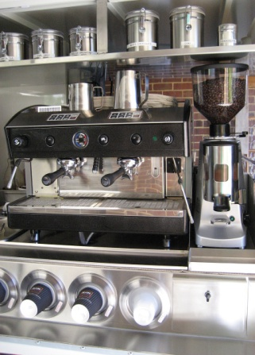
- Teaspoons
- Sugar bowls and sweeteners or sugar substitutes
- Milk and cream jugs – normal and low-fat milk
- Coffee – espresso, instant, decaffeinated
- Plate for after dinner chocolates or cookie biscuits, if applicable
- Napkins and doilies where used
- Espresso-specific items – tamps, knock boxes, steaming jobs and thermometers, espresso preparation brushes, grinders, group handles and, where applicable, take-away cupping supplies.

Tea making facilities
Most hospitality establishments prefer to use tea bags when making tea. However there are still a number of establishments that stay with the more traditional method of serving tea in a pot using tea leaves.
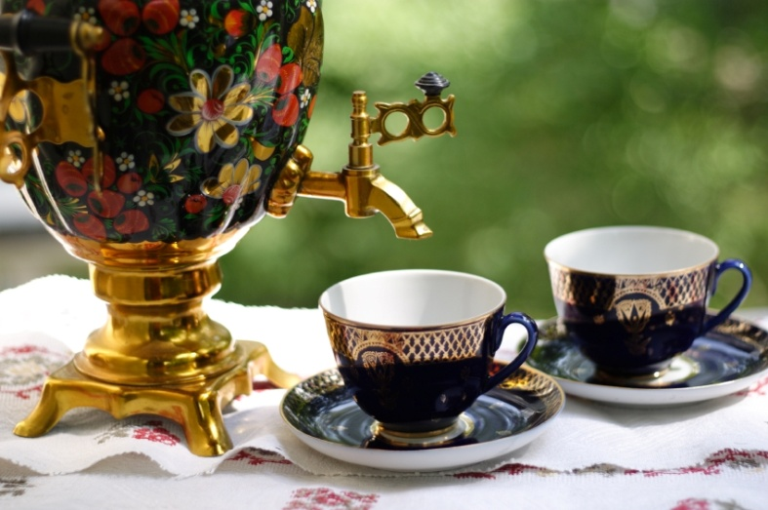
Before service, the equipment and ingredients to make tea should be checked to ensure there are sufficient items to cater for the service session.
Items may include:
- Cups and saucers
- Teaspoons
- Urns for water
- Tea bags or tea leaves – black tea, semi-black tea, blended tea, green tea, scented tea, herbal tea
- Teapots – two and four-cup, including cosies where applicable
- Milk jugs

- Sugar bowls and sweeteners or sugar substitutes – sugar tongs
- Wedges of lemon
- Tea strainer
- Hot water jugs
- Holders or plate for used tea bags.
Bain-maries
The bain-marie is used to keep hot food at the right temperature during the service period. It must keep the hot food at 60°C or above.
It must be cleaned and operated in accordance with the manufacturer instructions, and as the bain-marie is often accessible to customers, or on public view, it should be cleaned with this in mind.
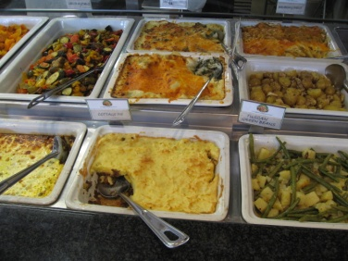
Before service, the bain-marie should be switched on so that the water covering the heating elements can achieve the required temperature. It is the hot water and rising steam that keeps the food hot.
Glass on a bain-marie should be checked for cleanliness, as should the stainless steel casing. Many customers will infer things about the food, from the condition of the bain-marie.
The bain-marie trays must also be clean and may require your attention during the shift. You may be required to cover food as the need arises, replenish it and ensure its eye appeal.

Toasters
Toasters may be used during any shift, but particularly during breakfast.
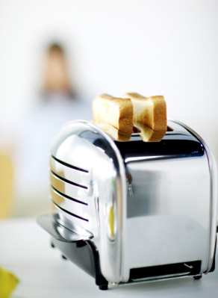
Toasters should be clean and free of crumbs. Crumbs can smoke and may even catch alight causing alarm to customers.
Before service, toasters should be checked that they are in good working order, with special attention paid to electrical cords to ensure they are not frayed or do not have any wires exposed.
Once again, they should not only be clean, but they must look clean, shiny and spotless.
Signage relating to supervision with children using toasters may also be necessary.
Tunnel toasters are usually set at the setting determined as ‘correct’ and there is usually a sign asking customers not to alter that setting.

Prepare cash register station
Depending on the role of food and beverage servers, the setting up of cash register stations may be the responsibility of dedicated cashiers or may be a task undertaken by all staff.
So what tasks are associated with setting up register station?
Receive and accurately check cash float
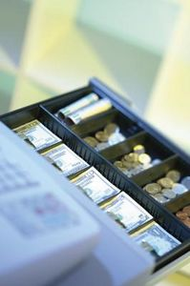
A cash float, also known as ‘the float’ is the amount of money that an establishment has deemed appropriate to commence the day’s trading for a cash register/point-of-sale (POS) terminal.
Found in the cash drawer of the cash register/POS terminal, a cash float is necessary for giving out change when completing a financial transaction, because rarely will a customer provide the exact amount of money to settle an account.
Overnight, most cash floats/cash drawers will be stored in a safe and at the beginning of each shift or day’s trading, the cash float/cash drawer will be removed by management, security, or someone from the Accounts department and either placed into the cash registers or distributed to the appropriate staff members in outlets.
Counting a cash float
When this happens, individual staff members may need to sign for their float to prove they have taken possession of it.
When signing for a float, the staff member needs to be sure the amount said to be in the float is accurate and consistent with the actual amount found in the cash drawer.
It is common practice therefore to count the float before signing for it or immediately after signing for it to ensure its contents. It is too late at the end of the shift to claim the float was short at the start of the day.

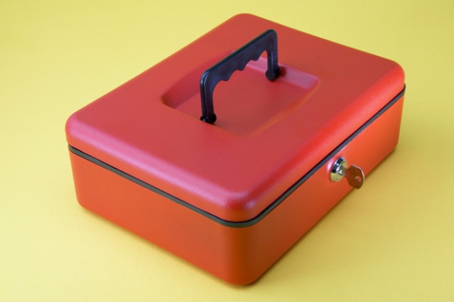
Some properties have two sheets for this process. They require the person handing over the float to count and sign in relation to the float and then the person receiving the float also has to count and sign for it.
Where a discrepancy in the amount in the float is detected, ask the person who delivered the float to double-check it.
Once you have collected your float, it is important to place your float in a secure location. This is normally in a cash drawer in a cash register.
Prepare register station
A cash register is a machine that is used to accurately record transactions – both charges and methods of payments, issue accounts and receipts and to store cash and non-cash payments.
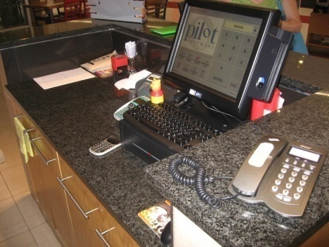
Once the float has been securely stored in the cash register it is important to prepare the register area. Tasks to be performed include ensuring there is an adequate supply of:
- Cash register paper
- Pens
- Receipt paper
- Account folders
- Ink cartridge
- Plastic coin bags
- Sweets or other gifts normally presented with accounts to customers
- Rubbish bins
- Spare paper
- Calculator
- Currency exchange sheet, if foreign currency is permitted to be used for settlement of transactions.
The final task to be performed is to ensure the cash register is ready for use is to undertake a ‘reading’ to ensure that the previous service period transactions have been closed off.
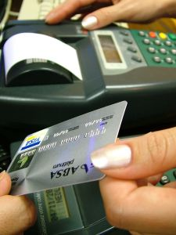
Prepare associated items
Besides the cash register there are other machines that must be checked before the start of the shift. These include:
- ETFPOS machines
- Manual credit card machines
In addition, it is important to have a clear understanding of information that may affect cashiering duties for the day including:
- Function sheets including event items, pricing, contact names and authorisation information.
- Methods of payment for VIP or special groups or customers
- Prices for new menu items, specials of the day or promotions.
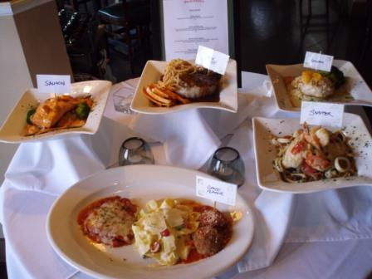
Display food and beverage items
Not all food and beverage outlets display their items but many do, especially where they believe they can use the concept of ‘selling by seeing’ to assist and increase sales.
Where food items are displayed for service, they must be handled in such a way that complies with internal requirements and externally imposed legal obligations.
What’s involved?
Both food and beverage items may be displayed in a service room.
Commonly, wines will be displayed so that customers can browse through what is available before they make their selection. These wines may be displayed in bins, on shelves or feature as the centrepiece of a special display.
Other beverages may simply ‘on display’ almost by default by virtue of where they are stored, such as on shelves behind the bar, or in glass-fronted refrigeration units that are visible to customers.
Food items may be displayed in bain-maries or salad wells as follows:
- As raw food – for example, pre-cut steaks, whole fish or fish fillets, raw hamburgers, boutique sausages and other cuts of meat such as chops, cutlets, loins, rashers etc.
- As cooked, ready-to-eat food in premises that want to offer a fast-food service either cold or hot food
- As foods available to supplement main courses such as salad vegetables, pre-made salads, hot and cold sauces, gravies, hot vegetables, soups and hot and cold desserts.
It is important to note cold food must be kept at 5ºC or below whilst hot food must be kept at 60ºC or above.
Foods and beverage items may also be displayed via trolleys on the dining floor. These trolleys may be used to present, promote or provide the basis of service for:
- Hors d’oeuvres
- Roasts
- Desserts
- Pre-dinner drinks
- After-dinner drinks.
Comply with enterprise requirements
House requirements in relation to the display of food can address issues such as:
- Location of items covering the sequencing of items in displays and the siting of food display units. Some properties elect to maintain a standard layout where items never change their location within the display, and other venues deliberately choose to alter the location of items on a regular basis to introduce ‘something new’ to the display and possibly encourage customers to see, and therefore try/buy, something they haven’t seen or noticed before
- Amount of food displayed – limiting the quantities to be displayed
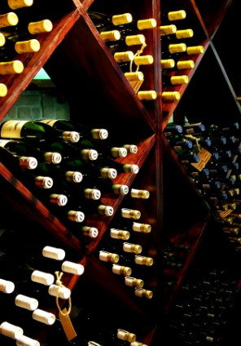
- Re-stocking of items – providing guidelines regarding the stage at which displays are to be replenished
- Need to comply with legal requirements – see below
- Placement of items within nominated locations. A common requirement, for example, with pre-made food items is to only load the display tray half-full but to ensure that the half-full part of the tray is the section that faces the front of the display
- Appearance of individual items. There are usually requirements that all items on display must be attractive, of saleable quality etc. Any item that is sub-standard in this regard, even though it may otherwise be perfectly fit to eat, must be removed from the display and/or thrown out.

1.4 Process incoming reservations to the establishment

Introduction

As tables have been allocated to incoming reservations, it is vital to ensure that the reservations are in fact accurate and that the people are coming.
Given that most food and beverage outlets are generally busy, it is essential that the limited space can be used in the most profitable manner.
In periods of high demand, it is inexcusable to have reserved tables for people who aren’t coming, when there are others who want to dine at your establishment.
Therefore it is vitally important to confirm reservations with customers. This is normally done the day before or earlier on the day of their expected visit to the establishment.
Importance of following up
It is important to follow up with reservations for a number of reasons including:
- Proves to the customer we value their patronage
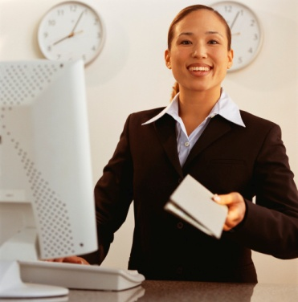
- Reminds the customer that they in fact have a reservation
- Confirms that the reservation is still applicable
- Ensure that people who have made a reservation, do in fact have a space for them when they arrive
- Ensures tables can be resold or released if the customer is not coming anymore
- Information or arrangements regarding the booking can be confirmed
- Payment methods can be collected if required
- Ensures that any changes can be accommodated before the customer arrives
- Where booking charges or penalties are charged for late cancellation are applicable, these can be explained to the customer
- Enables staff to explain parking arrangements to help facilitate their arrival
- If customers wish to cancel their reservation, others on a waiting list can be allocated a table, or other customers can be placed in more desired locations at the establishment. For example a table with a view of the ocean or city lights.
Reservation information to confirm
Some information that may be confirmed with the customer may include:
- Status of the reservation – confirmed or cancelled
- Name of booking
- Number of persons
- Expected time of arrival
- Any special requests
- Confirm existing requests.
Follow up activities
Once reservations have been confirmed or cancelled, there are a number of tasks that need to be performed. These include:
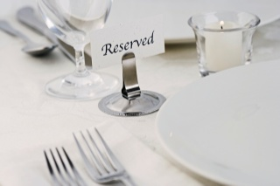
- Placing reserved sign on the table
- Informing waiters of the tables under their responsibility of reservation details and requests
- Informing kitchen of any requests
- Follow up on any requests such as a birthday cake
- Phoning people on the waiting list if the previous reservation is now cancelled
- Processing charges as applicable.
Once we have a clear and accurate understanding of expected trade, it is now time to set the tables accordingly.
This will be discussed in the next section.

Work Projects
It is a requirement of this Unit that you complete Work Projects as advised by your Trainer. You must submit documentation, suitable evidence or other relevant proof of completion of the project to your Trainer by the agreed date.
1.1 To fulfil the requirements of this Work Project you are asked to identify the different requirements to be completed for an upcoming service session
1.2 To fulfil the requirements of this Work Project you are asked to identify what needs to be checked when ensuring cleanliness of the facility prior to service
1.3 To fulfil the requirements of this Work Project you are asked to identify the steps associated with setting up dining area for service
1.4 To fulfil the requirements of this Work Project you are asked to identify importance and steps associated with processing incoming reservations

Summary

Prepare food and beverage environment for service
Check requirements for the upcoming service session
Understanding your role
Understanding the upcoming service session
Checking reservations
Consider anticipated trade
Check menu for the session
Check internal requirements.
Check cleanliness of the facility and conduct spot and makeup cleaning as required
Cleaning and checking the restaurant area
Checking and cleaning customer facilities.
Set up dining area for trading session
Set up furniture
Update floor plan
Customer and service personnel access
Allocating waiting stations to staff
Prepare and adjust the environment
Check and prepare equipment for service
Prepare cash register station
Display food and beverage items.
Process incoming reservations to the establishment
Importance of following up
Reservation information to confirm
Follow up activities.

Element 2:
Set tables

2.1 Match table setting to menu for the session

Introduction
Once the room setting and equipment is set up it is now time to set the tables to meet the expected trade for the meal period.
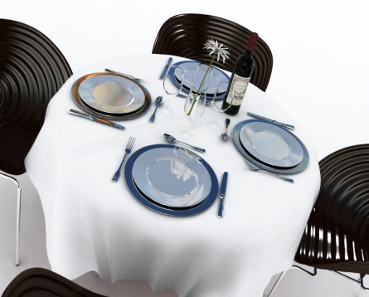
The presentation of a table says a lot to customers about the level of service they can expect to receive in an establishment.
When setting tables it is essential that the settings reflect the covers and menus that are to be served during the upcoming session.
It is also important that all tables are set in accordance with the establishment standards and set up within the timeframes required by the venue.
Cover
A place setting for one guest is commonly known in the industry as a ‘cover’. ‘Cover’ can also be used to indicate the number of guests, as in the phrase “we served 50 covers today”.
The settings for these covers will vary depending on the menu, the reservations and specific customer requests.
A la carte setting
A la carte is the term used for a menu that has individually priced dishes. These dishes are divided into entrées, salads, mains and desserts.
A la carte means ‘from the card/menu’.
This type of setting is popular and usually consists of:
- Main course knife
- Main course fork
- Side plate
- Side knife
- Wine glass
- Napkin
- Centre pieces – salt and pepper shakers, table numbers, vases or tent cards.

Table d’hôte setting
A table d’hôte menu is a menu that has a set price for a number of courses.
‘Table d’hôte’ means ‘table of the host’.
All courses are included in the price and must be paid for by the guests even if they don’t eat every course.
A typical set menu may have two to four choices of an entrée, two to four choices of a main and two choices of a dessert.
The setting for this menu would be:
- Main course gear (cutlery) – this is a term meaning main course knife and fork
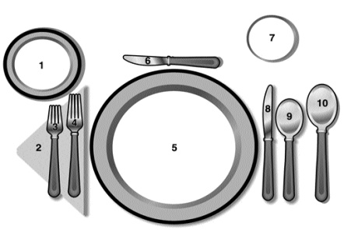
- Entrée gear – entrée knife and fork
- Dessert gear – dessert spoon and fork
- Side plate
- Side knife
- Wine glass
- Napkin
- Centre pieces – salt and pepper shakers, table numbers, vases or tent cards.
If a soup was the first course, a soup spoon would be set instead of the entrée gear.
If a soup was one of the two first course choices, it may or may not be set depending on house policy.
If fish was offered, a fish knife and fork would be included.
Function/Event settings
Settings for functions may be simple working lunches through to elaborate weddings.
The hospitality industry can deliver a range of different function styles for customers including:
- Breakfasts
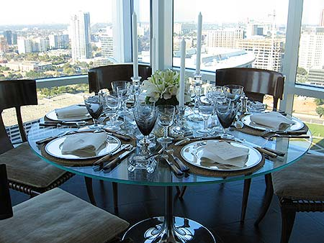
- Lunches
- Dinners
- Seminars, workshops and conferences
- Cocktail parties
- General parties – birthdays, celebrations of various sorts
- Weddings/receptions
- Anniversaries
- 21st birthday parties
- Product launches and distributor functions
- School formal, annual dinners and dinner dances
- Annual general meetings
- Training seminars
- Graduations and award nights
- Press receptions
- Fashion shows
- Special events
- Tradeshows
- Stage productions, including music events.
As you can see, the styles of functions are endless. Whilst many hospitality organisations may offer all of these to potential customers, they may also specialise in order to attract a select or niche market and be seen as the industry leaders for a particular style of function.
House specials
Every food and beverage establishment will have a specific focus in which most or all of its dishes are centred around. This could include specific:
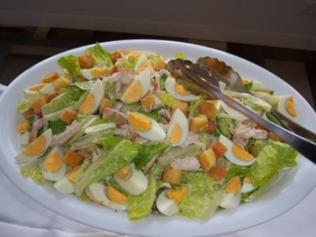
- Themes
- Cuisines
- Specials of the day
- Promotions
- Favourites or popular items.
Naturally the setting selected and range of crockery and cutlery chosen will reflect these dishes.
Meal periods
Naturally each meal period will require different settings, appropriate to what is being served.
The following are some typical examples of the types of menus served in different meal times.
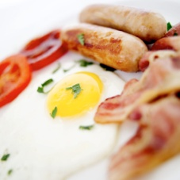
Breakfast
- Continental
- Continental plus selected cooked food items
- Continental plus full cooked food items
- Food platters – fruit and bakery items, intended as finger food
- Beverage items – coffee, tea, juices
- Buffet breakfast for large numbers
- Full breakfast – cereal, juices, cooked main items, toast, tea and coffee served to seated guests.
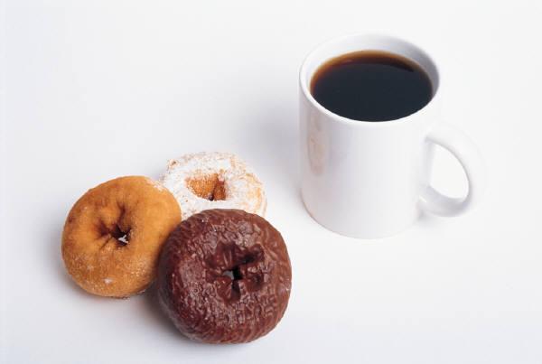
Morning/afternoon teas
- Selection of pastries and bakery items
- Selection of open or closed sandwiches
- Selection of biscuits and cake
- Selection of petits fours
- Beverage items – coffee, tea, juice, water, aerated waters.
Lunch
- Buffet of selected hot and cold items – may include an entrée, main course and dessert, or any combination
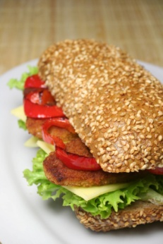
- Set menu (to a specific number of courses) – can be served to seated guests or presented for buffet style service
- Platters of sandwiches, filled rolls – sandwiches and rolls may be open or closed
- Platters of cakes, biscuits, pastries and petit fours
- Platters of fruit, fruit and cheese, cheese and greens
- Beverages – selection of alcoholic and non-alcoholic beverages which may include full bar, selected and minimal liquor, or non-alcoholic beverages only (aerated waters, waters, fruit juices, mocktails)
Dinner
Dinners are traditionally ‘heavier’ meals than lunches. This is because guests are not going to be doing anything after dinner, whereas with lunch there may be a need for guests to pay attention and not nod off to sleep!
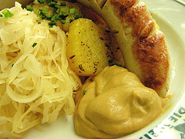
- Set menu (to a specific number of courses). This can be served to seated guests or presented for buffet style service. Dinners are more commonly a seated affair where lunches tend to be buffet style
- Buffet of selected hot and cold items. This may include an entrée, main course and dessert, or any combination. More time is traditionally available for dinners whereas with lunches there tends to be a tighter time frame as people need to return to meetings, groups or activities by a given time
- Beverages. There may be a selection of alcoholic and non-alcoholic beverages.
Seminar/conference
- Usually a selection of light refreshments - small sandwiches and rolls etc. compared to substantial menu items. The idea is not to send the people off to sleep. There is a definite need to include healthy options such as fruit
- Commonly these meals are buffet style or finger food style to keep costs down, and to facilitate the concept of people networking at the function
- Morning and afternoon teas are common with pastries, cakes and biscuits rotating throughout the time of the conference
- Beverages. Alcohol is less common, but not unknown; non-alcoholic beverages include tea and coffee, and water
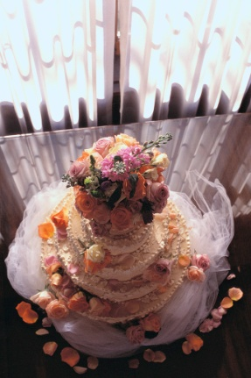
- Tea, coffee, water and pastries may be served to guests on arrival in the morning while people are arriving, registering and mingling.
Wedding
- Commonly a set menu specifying the number of courses to be served, and the style to be used
- Can also feature a buffet of hot and cold food items
- Beverages may be a nominated selection of alcoholic and non-alcoholic beverages, full bar, or guests pay as they go.
Cocktail parties
- Platters of hors d’oeuvre and canapés can be presented in a buffet style, or served by waiting staff
- Beverages are usually a nominated selection of alcoholic and non-alcoholic beverages up to a set dollar figure, or for a given time period.
Promotions and product launches
- Generally features a selection of light refreshments – small sandwiches, rolls, canapés, and other finger food
- There may be a special room to cater for media attendees – reporters, photographers, sound recordists
- Beverages may be dictated by the nature of the promotion or product being launched, but it is common for a nominated selection of alcoholic and non-alcoholic beverages to be available for the entire duration of the function.
Service style
The style of service will also impact on the settings that need to be set up. The following are a number of service styles that are commonly used in a food and beverage outlet. They are often associated with functions and banquets.
Plated service
Plated service is the most common service style where the kitchen plates all the food and the waiting staff carry the plated food to the table.
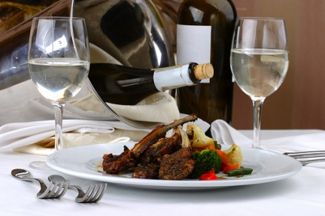
This is a common style of service for most banquets.
The benefits of plated service are:
- Consistency of meals
- Fast service - meals are plated in the kitchen and then delivered quickly to the customer
- Portion control – chefs have a degree of control over portion sizes.

Silver service
Silver service is where food items are prepared and carved or separated into individual portions and placed on platters by kitchen staff. Then waiting staff use spoons and forks to serve food from service platters, and serve sauces to guests on an individual basis from a sauce boat.
Whilst this style of service is not common in many functions due to its labour and time intensive manner, it is most commonly used when serving bread rolls to the customers.
The benefits of silver service are:
- Adds a dimension of ‘entertainment and sophistication’
- Customers can choose what they like without leaving the table.
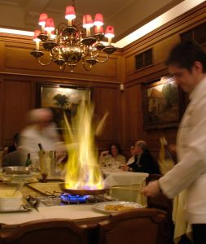
Gueridon service
This is where food is prepared or cooked at the table and served using full silver service techniques. This service style is not common for large banquets and in fact is only suited to intimate situations, whether catering to high end clients or for special occasions such as romantic meals.
The benefits of gueridon service are:
- Is a form of entertainment
- Is interactive
- Allows customers to see the cooking process
- Meals can be prepared to customer’s exact specifications.
Semi-silver service
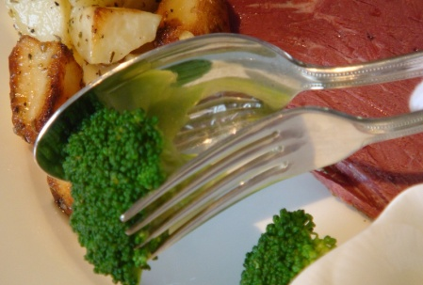
Semi-silver service is where the meals are plated and the sauces are ‘silver served’ or where the meat component of the dish is plated and served, and the vegetables are silver served
The benefits of semi-silver service are:
- Increases options for customer
- Is a more time efficient use of silver service.

Buffet service
This is where food is prepared in kitchens in large quantities and then placed on a buffet or display table. In most buffet situations guests serve themselves and select the items and quantities they desire.
In some situations a staffed buffet may be offered. In this scenario, diners bring their own plate along the buffet line and are given a portion from a server at each station. This method is prevalent at catered meetings where diners are not paying specifically for their meal in an effort to reduce wastage and to have some form of portion control.
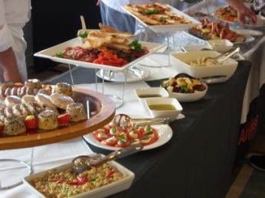
The benefits of buffet service are:
- Customers have greater choice
- They can have small amounts of different items as opposed to having one type of food
- Service is very time efficient
- Labour demands are reduced
- Food can be prepared in advance.
Cocktail service
This style of service is very popular, either as a prelude to a dinner or as a standalone function in its own right. In essence this style of service involves waiters providing a range of finger foods and beverages to customers in a stand up event.
The benefits of cocktail service are:
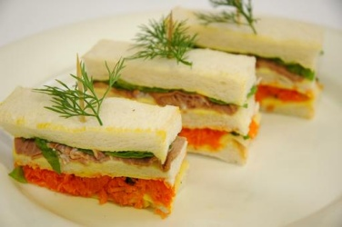
- It has great flexibility in terms of both cost and item options
- It is a cost effective method for clients to provide food and beverage to their participants
- It can be performed within a limited time frame
- It requires only a small space
- Participants can mingle with each other easily.

2.2 Set tables and dress where appropriate

Introduction
One of the most important steps when setting up for service is to ensure that the tables are set up to meet the requirements of the upcoming session.
Now that food and beverage staff have an understanding of what will likely be served for the upcoming session, it is now time to set and dress the table.
Whilst this will normally take up a large percentage of the preparation time, by carefully ensuring all items are present, it can dramatically improve the efficiency and impact when service actually takes place.
For many outlets there are quite a number of items that need to be placed on a table, each serving a very important purpose.
In addition, the table must be aesthetically pleasing as it places a large role in the overall decoration of a room.
Importance of professional table settings
The presentation of a table says a lot to customers about the level of service they can expect to receive in an establishment.
A great deal of work and attention to detail must be applied when setting tables, as they must:
- Have all the necessary tableware, centrepieces, napkins and condiments
- Must be complete
- Must be clean and hygienic
- Must be uniform and consistent throughout the outlet.
Ensuring that the table has all the necessary items that the customer may need, not only makes your job easier during service, but ensures that customers are not left waiting for items that should be close at hand.
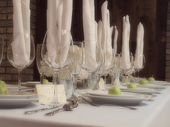
Due to the nature of menu items, there may be many items that accompany them. This does not mean that everything is expected to be placed on the table. In order to assure the comfort of customers, items may need to be prepared and placed away from the table in a suitable location.
Therefore not only must tables be set, but also items placed on waiters stations or placed in fridges and freezers.
This section will explore the range of items that need to be prepared before service, for use by customers.

Prepare napkins
Linen napkins or paper serviettes are commonly used in food outlets.
Remember that napkins cost money, so they should be handled and treated with this in mind.
There are a number of different napkin folds commonly found including:
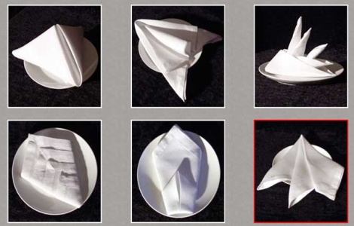
- Cone
- Envelope
- Bishop’s Hat (also called Mitre)
- Fan
- Opera House
- Sail.
It is important that you can fold serviettes as required, because folding serviettes is an activity that can be done during quiet periods.
There may also be times when you have functions for 300 – 400 people, and all staff may be asked to help fold serviettes.
It is important that you can fold serviettes as required, because folding serviettes is an activity that can be done during quiet periods and should not be done once service starts, where possible.
The following diagram and steps apply to only one type of fold:
- Start with napkin open, wrong side up (the seam showing)
- Fold each side lengthways to the centre
- Fold each side in half lengthways again.

Common Napkin Folds
The following are illustrations of common napkin folds.
The Bird Of Paradise Napkin Fold
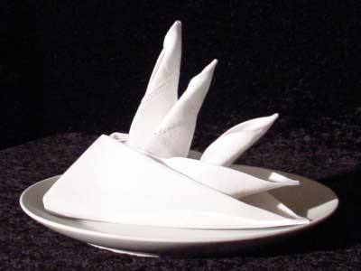 | This is a classic and classy napkin folding technique that requires a stiff napkin. If you do not have any dinner napkins made of stiff linen then a light starching should work well
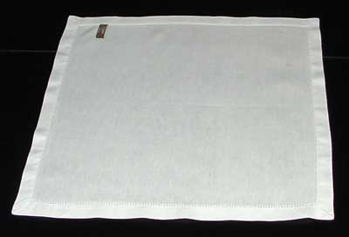 | 1. Lay the napkin face down in front of you.
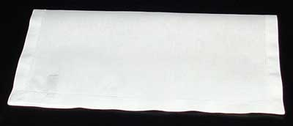 | 2. Fold the napkin in half.
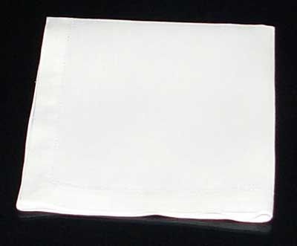 | 3. Fold the napkin in quarters.
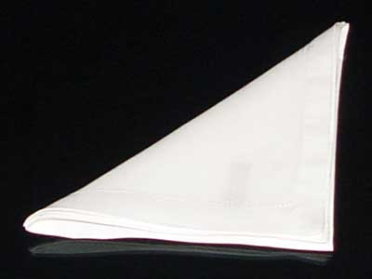 | 4. Fold the napkin in half diagonally, creating a triangle.
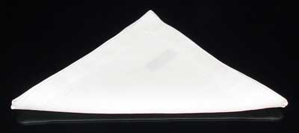 | 5. Orient the triangle so the open tip is facing away from you.
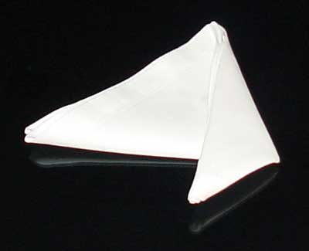 | 6. Fold the right corner diagonally towards you - laying it down along the centreline of the triangle, making a new tip pointing towards you. An iron can make this important fold a whole lot easier.
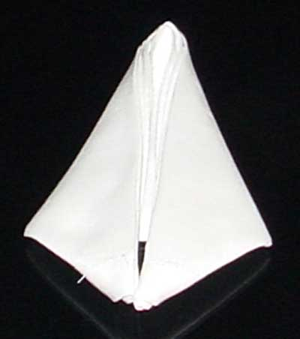 | 7. Do the same with the left corner, fold it diagonally toward you and press it down next to the previous fold. Now you have a diamond.
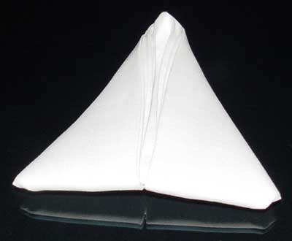 | 8. Fold the two "wings" that you just made in folds 6 and 7 under so that you have your original triangle shape back. Once again an iron can make a world of difference.
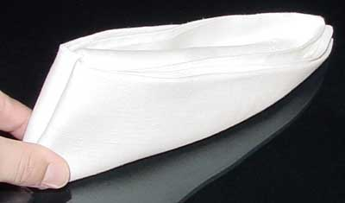 | 9. Fold the triangle in half by bringing the center seam towards you and allowing the ends to fall.
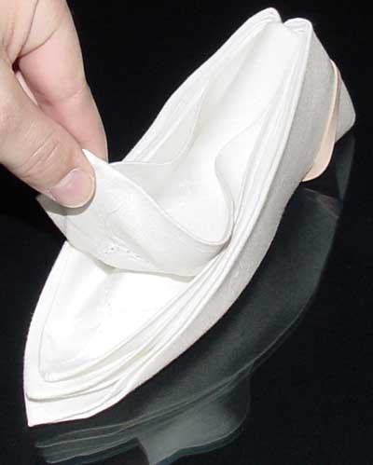 | 10. While holding the base firmly to keep your folds together, pull up the four 'flaps' created by the napkin's corners.
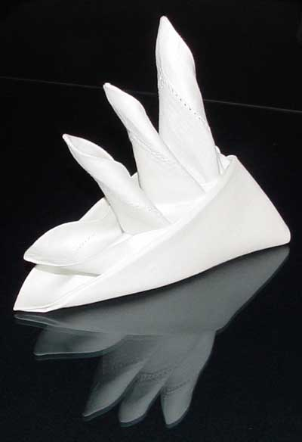 | This fold can be difficult if you don't use an iron or have a fairly stiff napkin so be prepared to put a few minutes into it.

The Rosebud Napkin Fold
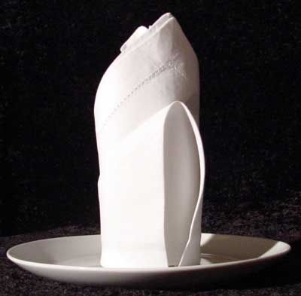 | This sophisticated cloth napkin design benefits from stiff material or light starch. A hot iron will also make it easier to be exact.
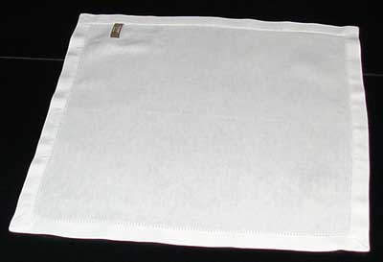 | 1. Lay the napkin face down in front of you.
 | 2. Fold the napkin in half diagonally.
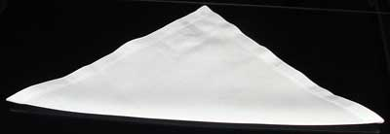 | 3. Orient the napkin so the open end points away from you.
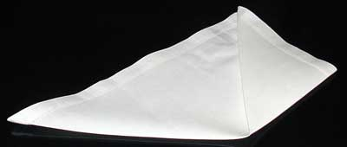 | 4. Fold the far right corner up diagonally so that the point rests on top of the far corner. The edge of this new flap should lay right on the center line.
 | 5. Repeat step four on the other side, bringing the left most corner up to meet the far corner, creating a diamond shape.
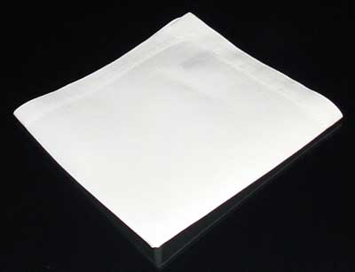 | 6. Flip the napkin over while keeping the open end pointing away from you.
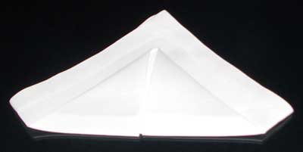 | 7. Fold the bottom of the napkin up about three quarters of the way as shown and press the fold down well.
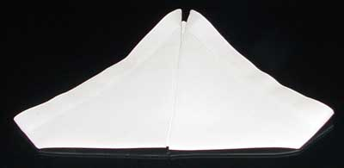 | 8. Flip the napkin over.
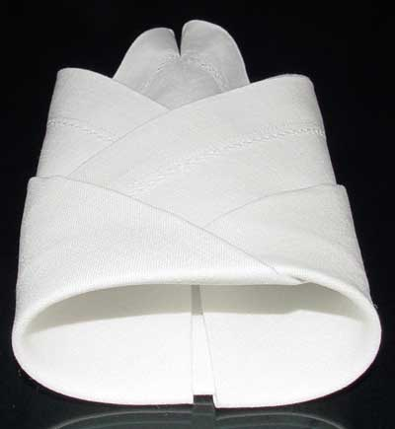 | 9. Curl both sites up so they meet in the middle and tuck one into the other.
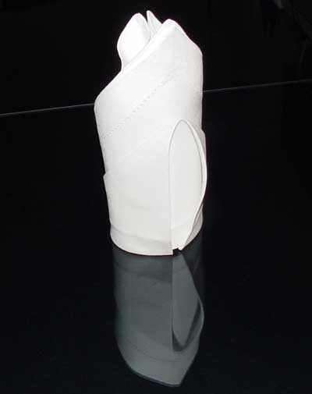 | 10. Stand it up and straighten it out. If you have trouble keeping the points even, break out the iron and back track to the folds that mess up your alignment.

Additional folds
Please see the following websites for more serviette folds:
- http://www.napkinfoldingguide.com/
- http://www.fold-a-napkin.com/
- http://www.delish.com/recipes/napkin-folding/

Prepare cutlery
A wide range of cutlery can be used in a food and beverage facility: the following are commonly used items:
Cutlery Chart
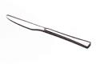 | Large Knife – Main course | 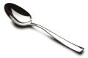 | Large Spoon. – Serving.
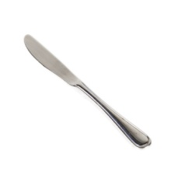 | Small Knife – Entrée course, buttering, pâté, cheese and fruit | 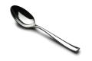 | Medium Spoon – Desserts and pasta.
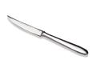 | Steak Knife – Steak | 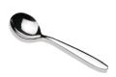 | Soup Spoon (round) – Soup.
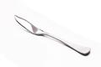 | Fish Knife – Fish (and some seafood items) and lifting delicate items | 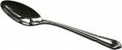 | Small Spoon (tea) – Teas, coffee, prawn cocktails, ice cream, sugar coupes and sorbets.
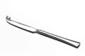 | Cheese Knife | 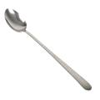 | Parfait Spoon (long handle) – Desserts and ice cream.
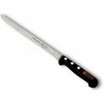 | Carving Knife – Slicing roast and cutting large items | 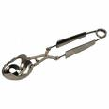 | Escargot Tongs – Snails.
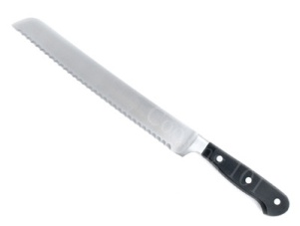 | Bread Knife – Slicing bread and rolls | 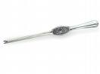 | Lobster Picks – Lobster/crayfish.
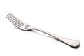 | Large Fork – Main course and serving | 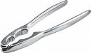 | Lobster Cracker – Lobster/crayfish/
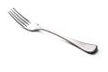 | Small Fork – Entree, pasta, salad, dessert and fruit | 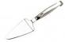 | Gateau Slice – Cakes and flans
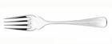 | Fish Fork – Oysters and prawn cocktails | 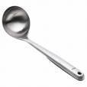 | Ladle – Soup and sauces
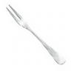 | Long Pronged Fork – Snails (Escargot)
A common procedure to polish cutlery is as follows:
- Separate the cutlery into the different types
- Take a handful of cutlery, holding it by the handles, and dip the ends into a bucket full of hot water and lemon
- Using a clean, lint-free cloth, polish the service end of the cutlery
- Continue this procedure until all cutlery is polished
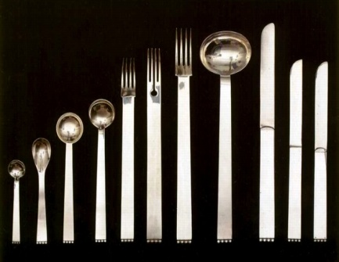
- Place the cutlery, handles up, in the service position, either on a table or at the waiter’s station. Polished cutlery should always be placed on an under-plate to be taken to the table for set up
- Do not touch the top of the item that goes into the customer’s mouth.
Certain cutlery items must be cleaned and polished according to manufacturer’s instructions.

Prepare crockery
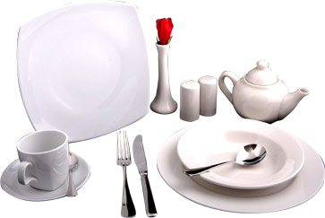
The type of crockery used by an establishment can vary depending on the menu items offered, the style of service provided and the required image the property wishes to create.
Crockery may be ‘badged’ with the name of the venue, or be unbadged.
Traditionally, crockery is white, but many colour options exist that can be used to blend with a theme.
Standard types of crockery are:
Crockery Chart
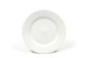 | Side Plate | 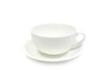 | Cappuccino Set
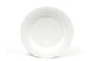 | Fruit Plate | 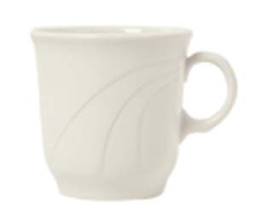 | Tall Tea Cup
 | Dessert Plate | 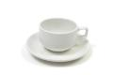 | Stackable Set
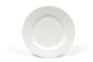 | Entrée Plate | 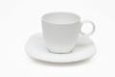 | Coffee Set
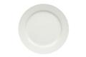 | Main Plate | 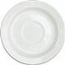 | Saucers
 | Show Plate | 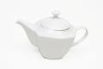 | Tea Pot
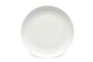 | Platter | 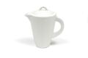 | Coffee Pot
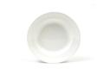 | Soup Bowl | 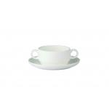 | Consommé Bowl
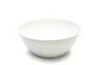 | Breakfast Bowl | 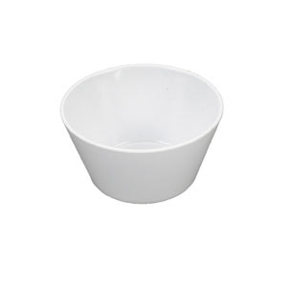 | Bouillon Cup
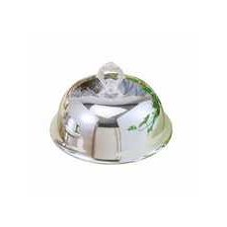 | Cloche/Dome | 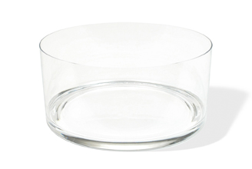 | Salad bowl
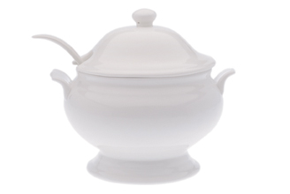 | Soup Tureen | 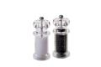 | Salt and Pepper Grinders
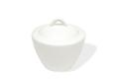 | Sugar Bowl | 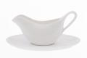 | Sauce Boat
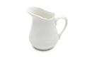 | Milk Jug | 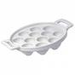 | Escargot Plate
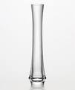 | Bud Vase | 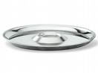 | Oyster Plate

Prepare glassware
Usually, wine glasses and water glasses are set on tables in the room and it may be the waiter’s responsibility to do this, ensuring the glassware is clean of marks, chips, cracks and lipstick.
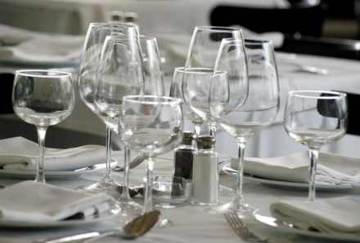
Hold up to light and check for water marks.
The restaurant glassware should be polished before going onto tables. This is achieved by placing a glass over a bucket of hot steaming water and then polishing with a lint-free cloth.
Clean glassware should always be handled by the stem to avoid finger marks on the bowl and placed upright on a tray to be taken to the table for set up.
Many types of glassware exist but it is the responsibility of the bar staff to determine what is used for which drink.
Glass can be plain or decorated. Variations in glass types are available for:
- Beer glasses
- Wine glasses – still and sparkling
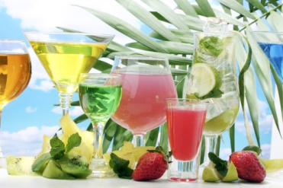
- All-purpose glasses for soft drink, fruit juice, long mixed drinks, short mixed drinks, shots, straight nips/spirits served on ice
- Cocktail glasses
- Liqueur glasses and fortified wine glasses
- Carafes for the service of house wines to table
- Jugs for beer, soft drink and mixed drinks
- Irish coffee/liqueur-spirit coffee mugs.
Prepare salt and pepper shakers
Before each shift, salt and pepper shakers must be checked to ensure they are clean and filled appropriately.

Blocked holes should be unblocked. This can be done with a toothpick.
The exterior of the shakers must be clean, and the tops free from residual salt or pepper. A few uncooked rice grains are sometimes added to salt shakers to absorb any moisture that may get into the salt.
Check the tops of the shakers are firmly in place as some customers take delight in loosening them to the extent that the next person who uses them will find the top comes off and their meal is covered in salt or pepper!

Clothing Techniques
Linen
Many dining rooms hire tablecloths from a linen supplier who supplies and launders the required linen items including napkins and tablecloths.

When hiring linen, the room will be allocated a par stock level of items from the supplier. If any of the stock is lost, too badly spoiled or stained, the room will be invoiced for the replacement cost of that particular item.
When handling linen, it is important to remember that each item costs money to launder. A tablecloth, for example, can cost five times more to launder than linen napkins.
They are also expensive to replace if the property buys and launders their own linen.
For these reasons, it is important never to use linen napkins for cleaning around the bar, or for cleaning up spills that will stain them forever.
Linen should only be used for the purpose it was designed for i.e. to cover a table, or to provide a customer with a cloth serviette.
The cloth serviette may also be used as a ‘service cloth’, carried by service staff who are carrying or handling hot food items, and used to enhance presentation and service of both various food items and wine bottles.
The service cloth is often carried folded over the left arm.
Clothing a table
With clothing a table (that is, laying a tablecloth on a table), it is important that you use the establishment-approved method.
The following points in laying a cloth should be observed:
- Never let the cloth touch the floor, and handle the cloth as little as possible
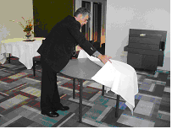
- Make sure the cloth is laid the right side up. Check the hem to identify which is the right side if you are in doubt
- The overhang should be equal all the way around the table. Cloths come in various sizes and you must use the right size cloth for each table
- On large tables it is usual to use more than one cloth. The industry standard is that the overlap of cloths runs away from the main entrance door to enhance presentation by ‘hiding’ the join or overlap
- Creases in clothes should also run away from the door where possible
- Try to use the cloth to cover the legs of the table where possible, making the dining area more attractive.

Dressing tables
On special occasions, or as part of standard operating procedures, tables may need to be dressed.
Dressing takes place as part of the set up and enhances presentation of the table.
It is time consuming, and frequently requires additional items to be used, so it is an uncommon activity, rather than a common one.
Boxing tables
Tables can be boxed to enhance their appearance.
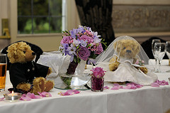
It is usual to box head tables at functions, display tables on the dining floor, and tables that carry name tags of representatives at conferences.
Boxing involves folding a table cloth around the vertical fall of the table so that the sides of the table and the legs are hidden from view.
Many establishments have specially prepared (pleated or plain) boxing sheets that are simply held in place with drawing pins, or fitted exactly to the size of individual tables.
Tips for setting a table
The following provide guidelines that may be adopted when setting a table. Check with individual house requirements and follow those where they differ from the following:
- Use the chair as a guide to centre the cover
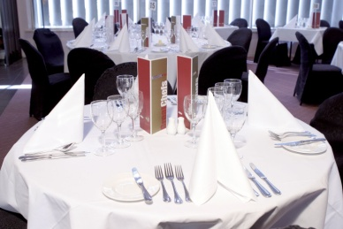
- Side plates should always be placed to the left of the fork
- Knife blades should always face left
- Sufficient space should be left between the knife and fork for the meal to be placed down. This is approximately 25 – 30cms depending on the size and shape of the main course plate
- Entrée cutlery should always be placed on the outside of the main course cutlery
- In a la carte dining, the dessert cutlery should be placed where the main course knife is usually positioned
- Wine glass should be placed directly above the main knife.
After the table setting has been completed, step back and look at the overall impression. It should look attractive, balanced and uniform.
When setting tables ensure that all crockery, cutlery and glassware used on a table are the same. There should never be a ‘mix-and-match’ of items from different canteens of cutlery or patterns of crockery.
For breakfast settings, a coffee cup is placed where the wine glass is usually positioned.
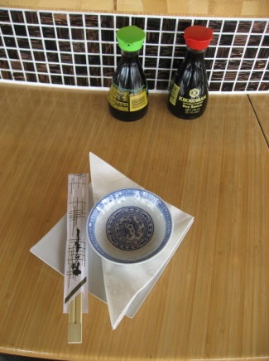
At all times, centre pieces should be kept to a minimum to avoid cluttering a table, unless management or house policy specify otherwise. This may be the case during certain promotional periods, specific celebrations or as part of some other initiative.
Remember, all crockery and cutlery placed onto a table should be clean and match. All cutlery must be placed in a straight and parallel fashion, consistent around the table for each and every setting.
Note: it is standard industry practice for all tables in the room to be set for a service session. If the room seats 100 and you only have bookings for 50, you don’t just set half the room.
Place table accoutrements
‘Accoutrements’ are the items used to fit out the tables.
In some situations you may be required to dress tables with accoutrements such as:
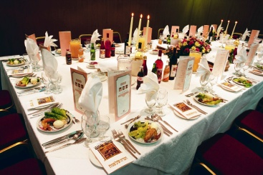
- Candlesticks
- Candelabra
- Bud vases
- Overlays – a second table cloth, smaller than the first, overlaid to provide a contrast in terms of colour or pattern
- Floral arrangements
- Placemats
- Display and promotional material for functions such as product launches etc.
- Printed materials, business cards – as above.
Prepare condiments
Condiments are served with a meal to enhance or complement the flavour.
From the perspective of preparing for food and beverage service, the preparation of condiments is confined to the preparation of ‘proprietary’ condiments. These are the bought-in, pre-prepared condiments that all venues use.
They need to be prepared before service and, where appropriate, covered.
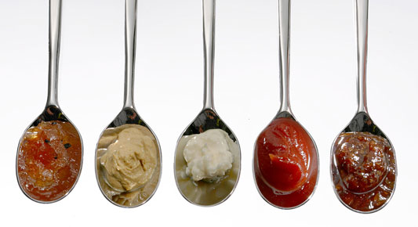
Some establishments prefer to serve their condiments in the original bottle, so it is important for that to be checked for cleanliness as well, especially around the neck and the cap.
Condiments include:
- Tomato and barbecue sauce
- Sweet chilli/ chilli sauce
- Tabasco sauce and mustard
- Soy and fish sauce.
Prepare butter and lemons
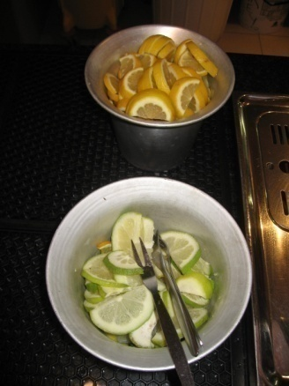
Butter is also a condiment and it is usually the responsibility of waiting staff (not kitchen staff) to prepare the butter for service.
Butter can be served in:
- Cubes
- Curls
- Triangles
- Butter pots.
Some premises use the pre-packed, portion-controlled, foiled rectangles.
Service staff may also be responsible for:
- Slicing lemons for cups of tea or bar drinks
- Making lemon wedges to accompany the service of fish dishes.
Prepare waiter’s station
The main purpose of a waiter’s station is to provide the service staff with a location on the floor from which they can work.
Items commonly found at a waiter’s station will reflect the service to be provided and can be expected to include:
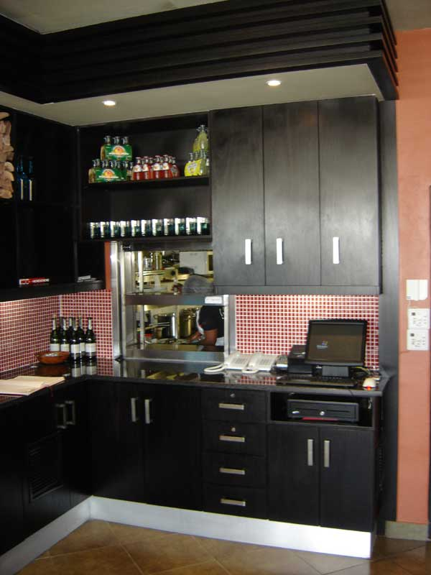
- Menus and wine lists
- All main types of cutlery – usually held in drawers
- Service plates, cups and saucers
- Napkins
- Service trays
- Salt and pepper shakers
- Sugar bowls
- Docket books and pen or electronic equivalents
- Toothpicks
- Condiments – sauces, Tabasco, mustard, extra butter
- Spare glassware.

2.3 Complete final inspection of room and table set ups

Introduction
Now that tables are set for service and the room is clean and tidy it is now time to undertake a final inspection of the room and table set-ups.
This is important to ensure they are complete, clean and look professional.
This section will look at various final inspection activities that should not only be undertaken by supervisors, but also food and beverage staff themselves.
Removing, cleaning or replacing items
Removing unwanted Items
Equipment or items may be required for the breakfast shift, but may no longer be required for lunch or dinner, and vice versa.
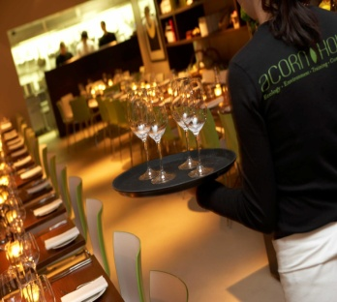
You must know what these items are and remove them from the service areas prior to the next session.
Possibilities include:
- High chairs
- Trestle tables
- Bain-maries
- Coffee urns
- Equipment used only for the breakfast shift – toasters, fruit juice containers, cereal containers, newspapers
- Glassware. Glasses set for breakfast are nearly always different from what is needed at lunch or dinner
- Broken equipment or furniture
- Used customer comment forms
- Stock (food and beverage items) that are no longer required
- Displays
- Mobile trolleys.
It may be the case with some items such as displays, floral arrangements and promotional exhibits, that a ‘refresh’ is required after every session. This is to give the area a new look for every sitting, by removing rubbish, replenishing items and getting rid of any unattractive elements that detract from the visual appeal of the room.

Checking cleanliness and checking tables prior to service
Cleanliness and the condition of the tables and the table items must be checked prior to service to ensure the guests enter a proper and correctly prepared room.
Checking may involve walking around and scanning each table to ensure all is correct. Waiting staff may be required to do this where waiting staff are asked to check the tables of other waiters rather then check their own tables, or it may be the job of the supervisor.
Things to look out for in this process include:
- Crumbs on chairs left from the previous session. Cleaners will clean the floor of the room but rarely be required to clean chairs
- Lop-sided, creased, dirty or otherwise unsuitable tablecloth
- Missing items from the cover or table – crockery, cutlery, centre pieces, glassware, napkins, tent cards
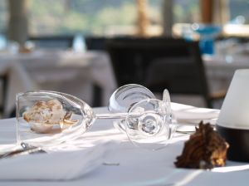
- Missing, damaged or unstable tables and chairs
- Incorrect covers set on a table. The covers must reflect the number of guests for each table as indicated on the floor plan. Where tables exist that do not have bookings, most venues will prepare tables to suit the size of walk-in parties that can be reasonably expected. This means they may set up a number of tables for two, some tables for four people and some for perhaps six or eight people
- That the actual table positions reflect the set floor plan
- Rubbish on the floor, in pot plants etc.
- Flies or insects – alive or dead – with special attention being paid to window ledges.
Establishments always want the dining area set up before the advertised service time, so problems can be sorted out before guests arrive.
Check furniture for stability
Tables and chairs must be checked for stability before customers arrive to ensure that they do not pose a danger to customers, and to ensure they are not annoying when the customers are seated at the table.
Occupational safety and health laws impose a legal requirement on premises to take care of the welfare and safety of their customers.
The common law concept of ‘duty of care’ also requires businesses to take whatever action is necessary to avoid causing foreseeable harm to them.
Checking furniture
Prior to service, tables and table settings must be checked not only for proper location and cleanliness but also for:
- Safety. We need to make sure that chairs are not compromised such that they may collapse when a customer sits on them. We also need to check that the chair does not pose a physical danger to the customer by virtue of a loose part, a projecting piece of wire or component
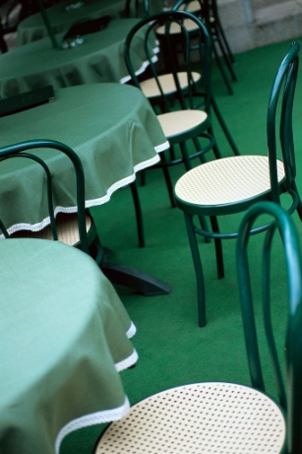
- Stability of chairs so they won’t topple when used
- Stability of tables so that customers are seated at a table that provides a firm surface that doesn’t move or rock when they lean on it.
We need to also physically check the room (entrance area, high traffic areas and the general floor area) to ensure a safe environment. Check to make sure there are:
- No frayed carpet, and nothing for patrons or staff to trip over
- No extension cords on public access areas
- No projections into the area that could harm customers.
What must happen if a problem is detected?
If you identify a problem you must take action to address that issue.
It is not enough to simply know there is a problem – you have to do something about it.
Actions may involve:
- Notifying the supervisor
- Removing the dangerous item from use
- Adjusting the table to make it stable. This can involve adjusting the legs of the table or placing a chock under one or more legs.
Verifying the menu prior to service
Types of menus and wine lists
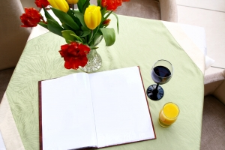
Before and during service sessions, the menu and wine lists should be checked for cleanliness and wiped clean with a damp cloth, if necessary.
Any damaged or badly soiled menus should be removed from service.
Dining areas usually have a single, standard wine list, with enough copies to service every table.

However, there can be a variety of food menus, such as:
A la carte menu

A common style of menu found in the majority of full-service dining areas, its characteristics are:
- Dishes are prepared to order
- Can offer appetisers, entrées, salads, mains, desserts and snacks
- Can offer a large selection of items within each category
- Each item is individually priced – customers pay only for what they eat.
Where an à la carte menu is used, waiting staff will not know what the guest is going to select and therefore the setting is basic, focussing on only the main course knife and fork because we can safely assume that most guests will, at least, partake in a main course.
When the guests select their food, the cover is then adjusted to reflect the menu items they have chosen. This may mean:
- A soup spoon is added if the guest orders a soup
- The main course knife is swapped for a steak knife where the guest orders a steak
- Fish gear is added if the guest orders a fish entrée
- The main course gear is swapped for fish gear if the guest orders a fish main course
- Dessert gear is added if the guest orders a sweet.
Table d’hôte menu
This is a popular and common menu where the guest has the choice of a limited number of dishes or courses for a set price.
The guest pays the full set price regardless of what they choose to eat.
Where a table d’hôte menu is used, the setting will reflect this style of menu. We can safely assume that most people partaking in a table d’hôte will eat every course offered on the menu so the set up reflects that by laying cutlery for each of the courses available.
Once again, the cover is adjusted when the order for the guest has been taken.
This may involve:
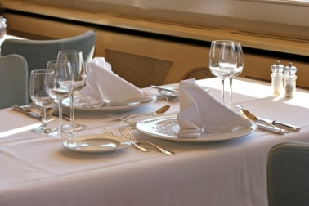
- Removing cutlery if the guest elects not to eat a certain course
- Swapping main course knife for a steak knife where the guest orders a steak
- Swapping main course gear for fish gear if the guest orders a fish main course
- Swapping the entrée gear for a soup spoon if the guest selects a soup as opposed to an entrée.

Buffet/smorgasbord
This menu is very popular in family style restaurants or taverns and hotels, and is often used at functions:
- Items are all prepared in advance and placed on display for customers to view, and make their selection
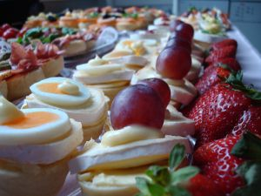
- Menu usually offers all items at the one set price, regardless of how much a person eats. Children may be half-price
- A buffet usually offers a range of soups, cold and hot meats, salads, vegetables, seafood, desserts, and tea and coffee. Sometimes soft drink is included
- Buffets are generally self-service, with waiting staff involved in replenishing dishes, and clearing plates from the buffet and guests’ tables.
Final confirmations
As part of the final check a final confirmation of the following may take place:
- Bookings
- Special requests
- Seating plan
- Station allocations.
Whilst these activities have been discussed previously in this manual, there is no harm in checking these again to not only ensure that everyone knows what they are doing, but to ensure everything that should be prepared and communicated, has done so.

2.4 Identify and report recurring problems with set up to the appropriate person to prevent recurrence

Introduction

Once a final check of the restaurant has been completed, any problems that have been identified can be discussed with the appropriate person, for their prompt action.
Reporting problems
There may be times when service staff identify a problem they cannot rectify, or come across a recurring problem in the room.
When this occurs, it is necessary for the appropriate person to be notified immediately.
The appropriate person will be the supervisor, duty manager, manager or owner.
Reporting these problems by phone or face to face are the preferred options as they enable immediacy. In some instances a written report or special form may need to be completed.
Recurring problems may be:
- A piece of equipment keeps failing
- Refrigeration that fluctuates in temperature or doesn’t reach the required temperature
- Always running out of crockery, cutlery or glassware
- Always running out of forms or pens
- Delays in production
- Miscommunication between customer and wait staff
- Circuit breakers constantly cutting in and cutting off power
- Heating or cooling that doesn’t seem to respond to thermostats
- The floor plan always gets lost
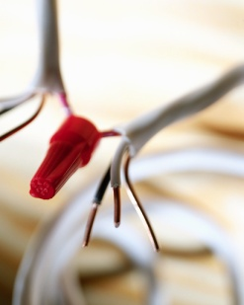
- The need for a new piece of equipment to complete a specific task more efficiently. Perhaps the present method could be too slow and may not keep up with the demands of increased trade
- Any health and safety issue
- Always running out of a particular product
- Always running out of ice for the ice buckets or beverage service
- Always running out of menus or wine lists
- Need for more cleaning items and equipment.

Work Projects
It is a requirement of this Unit that you complete Work Projects as advised by your Trainer. You must submit documentation, suitable evidence or other relevant proof of completion of the project to your Trainer by the agreed date.
2.1 To fulfil the requirements of this Work Project you are asked to identify considerations when matching table settings to menus for an upcoming session
2.2. To fulfil the requirements of this Work Project you are asked to identify activities associated with setting and dressing tables
2.3. To fulfil the requirements of this Work Project you are asked to identify the importance of and activities associated with completing final inspection of room and table set ups
2.4. To fulfil the requirements of this Work Project you are asked to explain how to identify and report recurring problems associated with set up

Summary

Set tables
Match table setting to menu for the session
Cover
A la carte setting
Table d’hôte setting
Function settings
House specials
Meal periods
Service style.
Set tables and dress where appropriate
Importance of professional table settings
Prepare napkins
Prepare cutlery
Prepare crockery
Prepare glassware
Prepare salt and pepper shakers
Clothing techniques
Dressing tables
Tips for setting a table
Place table accoutrements
Prepare condiments
Prepare butter and lemons
Prepare waiter’s station.
Complete final inspection of room and table set ups
Removing, cleaning or replacing items
Checking cleanliness and checking tables prior to service
Check furniture for stability
Verifying the menu prior to service
Final confirmations.
Identify and report recurring problems with set up to the appropriate person to prevent recurrence
Reporting problems.

Element 3:
Meet and greet guests

3.1 Welcome guests on arrival

Introduction
When customers arrive, it is the responsibility of the service staff to promptly meet them. This normally includes a smile and an appropriate greeting at the door.
Remember that customers like to feel important and they should always be treated accordingly. Besides, first impressions count and as they say “You only get one chance to make a first impression”.
Greet and check reservations
When guests arrive in your dining area, the first two steps should be:
- To greet or welcome them
- To enquire whether or not they have a reservation or booking.
Check at your workplace to see if this is Standard Operating Procedure or not.
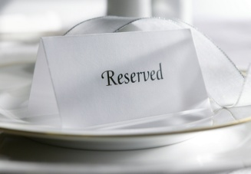
Where guests say that they have a reservation, you should confirm this in your reservations book, to identify the table they have been allocated on the table/floor plan.
Check with them the number of guests expected. Often there can be an extra one, and sometimes there are one or two who will be cancellations. Where there are cancellations, the chair and cover should be removed from the table so that the table is not embarrassed by empty places.
Where an extra person has presented with the booking, staff should immediately set another place and add a chair where possible, or another table should be quickly identified for the party. The key is to ensure that guests do not feel, in either case, that they have done the wrong thing, or inconvenienced us.
When confirming the reservation, also confirm any details that may be written against that booking – “And you’re off to the cinema, so you’d like to be away by 8.30, is that right?”, “And you requested a high chair, I believe?”
Where there is a note that a birthday cake, or similar, has been arranged, this should also be discreetly checked with the host, either at the table or elsewhere.
A visit to the table informing the host that there is a phone call at reception for them can aid in getting them away from the table. If the guest has no reservation, check the floor plan to see if they can be accommodated

Be alert to the opportunity to maximise sales
For instance, by asking someone who comes in at 6:30 PM without a booking, whether they could be finished by 7:45 PM, so that you can strip their table and re-set it for the 8:00 PM booking.
Using a table for two seatings per session – a 50-seat restaurant can quite easily serve 70 – 80 covers per session.
There are some people who will breeze in to a restaurant, claiming they have booked when in fact they never made one. If you have a vacancy, then this really isn’t a problem, but where no vacancy exists, the potential for trouble exists.
All you can do is apologise profusely, and offer another session.
Your house policy may dictate some other form of additional gratuity (a discount voucher, voucher for a free item or a free drink), but many establishments adopt the stance that says ‘If we can’t find your booking, you didn’t make one’
If the situation looks like getting out of hand, call your supervisor or the duty manager.
The greeting on arrival
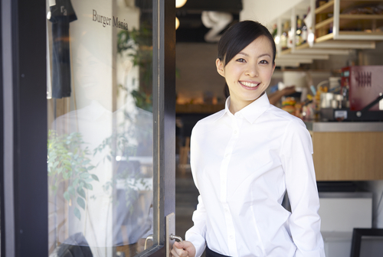
What you say by way of welcome to your guests may be determined by house policy with certain required statements and facts to be covered, or you may simply be expected to use your common sense and good judgement on a person by person or party by party basis as indicated by:
- The weather – a genuine comment: “Isn’t it cold today?” – can be a great ice-breaker and help strike up a conversation
- Sporting events – “Did you watch the game today?”
- Special events – “Happy Festival Day”
- The season – “Isn’t it getting dark early these days?”
- A special in-house event – “Welcome to our Grand Winery Tour Dinner, it will be a night to remember!”
In some establishments, guests may be able to leave their overcoats, umbrellas etc. at the reception area. If this is the case, ask the guests if they would like you to take their coat etc.
Greeting guests on arrival and accompanying them to their table to seat them is known in the industry as ‘greet and seat’.

Special needs customers
Some guests may have special needs and simple observation will identify many of these: don’t wait to be asked if you think there is a special need. Get proactive and offer:

- Alternative easy access to their table because of a disability
- A high chair for infants
- Warming of a bottle for babies
- Appropriate food for those with special dietary needs as indicated in the reservations book
- Privacy for romantic couples, and business people to the best extent possible given other bookings
- Room on a table to spread out where business looks as if it is going to be conducted
- A table near the door for someone with a walking stick.
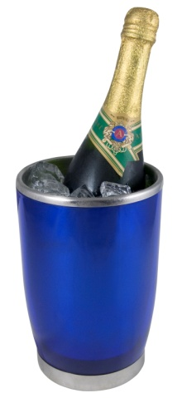
Sometimes special offers have been made or vouchers will be used by guests to pay for their meal. It is a usual condition that guests notify you of this on arrival so that you know what billing process to use, and what other services or products they are entitled to. This could include a free glass of champagne, the set menu only, a choice of entrée and main or main and sweets, and so on.
Extra effort must be made with guests who are using vouchers or participating in deals. Many expect to be treated as second class and get quite snaky when this happens. So treat them with even extra care, respect and high quality service!
And finally, when greeting guests, it is likely that you will know their name. They will either tell you, or you can get it from their room number/key, or the reservation book. It is quite simply music to their ears to hear the sound of their own name and it shows civility, manners and an individual orientation to them as honoured guests.

3.2 Seat guests at nominated or designated tables

Introduction
Once an appropriate greeting has been provided, it is now time to escort and seat customers at their table.
Escorting and seating customers
Greeting and seating guests
The following steps are industry acceptable standards for greeting and seating guests.
Of course, house rules should take precedence where they differ from the following.
- Promptly acknowledge the guests and welcome them with a greeting. An example of this may be: “Good morning, welcome to Jack’s Bar and Grill”
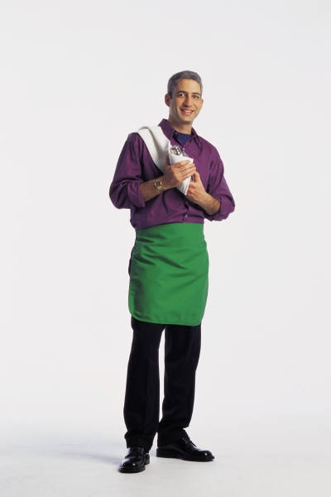
- Establish if the customer has a reservation. A number of customers don’t have a booking – they are called ‘walk-ins’. To accept a walk in, make sure that there is a table available. If the guests do have a reservation, check the number of guests to determine if a table is available
- Hats, coats, umbrellas or parcels and presents should be taken from the customer if this is standard house policy, or if guests request they are
- Show guests to their table, while walking at a rate that would be comfortable for the guests to keep up with. It may be appropriate to engage them in some form of light conversation while doing this
- At the table, pull out one chair to signal to the guests that they are free to claim a seat and sit. Assist guests with being seated, and pushing in chairs.
Further action
After the guests have been seated, various other rituals are observed.
An accepted sequence is:
- Lap napkins if required – from the right-hand side, remove the napkin that has been provided as part of the setting and unfold it. Re-fold it into a triangular shape and drape it across the guest’s lap, pointed side facing away from them. Note that some guests will prefer to place their own napkin, so be aware of the guest’s body language at all times, and certainly don’t force this service on anyone. A comment such as “Excuse me, sir” may be appropriate
- Ensure any special needs are taken care of such as a high chair for children
- In some establishments, the greeter or establishment host or ‘head waiter’ will at this stage return to the reception desk to seat further guests. A service staff member then takes over the table to complete the next few steps, courteously introducing themselves and engaging in some small talk, if appropriate.

3.3 Offer pre-meal services

Introduction
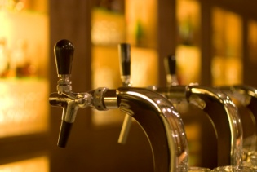
In some cases, when a customer arrives, their table may not be ready. It is just as important that they are suitably looked after until their table becomes available.
Given that some customers may simply choose not to wait and look for alternative dining options, being pro-active in providing in-house options not only helps an establishment keep their business, it also helps to generate additional sales and to ensure their experience is an enjoyable one.
Offering pre-meal services
As and when circumstances dictate, or opportunities present themselves, pre-meal services can be offered to guests;
These services include:
- Bar service. It may be appropriate to offer guests the services of your bar before they go to their table. Especially where the bar has a special feature or aspect, this can be a valuable service to offer
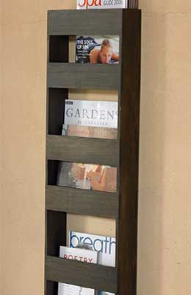
- Lounge and waiting areas. Where your guests are part of a larger party and they are the first ones to arrive, they may be pleased to be offered the benefits of waiting in a lounge area or a special waiting area, rather than being made to sit alone at their dining table
- This saves your guests possible embarrassment demonstrates excellent customer service and indicates that you are tuned in to individual needs. You can offer the customer:
- Reading materials
- Free refreshments
- Telephone services
- Business related services
- Valet services. These services can embrace almost anything, and are often a variation of the concierge desk. Common services for diners include valet parking and car retrieval, booking theatre or other tickets, arranging for taxis or limousine hire, and even secretarial services for business people. It is not uncommon to be asked to send a fax, or email if these services are offered, especially by people who are out of their home city
- Participation in special displays or promotions where the venue is conducting an in-house competition, or survey, or other promotional activity it is wise to at least notify your guests of what is happening.

3.4 Present menus and wine/drink lists

Introduction
Once guests have been seated it is now time to present menus and drink lists to customers.
This is a fairly straightforward activity but it needs to be done in a timely manner.
Presenting menus and drinks lists
When distributing menus and drink lists to customers there are a number of tips to remember:
- Ensure there are adequate menus for everyone to read
- Provide menus suitable for the customers. For example you may wish to provide menus in different languages or a children’s menu as appropriate
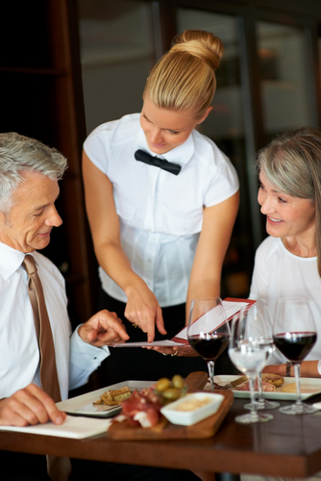
- If there are limited menus, you may request that customers share them until others become available
- Distribute menus to the guests from their right-hand side
- Leave the wine list with the host or place in the centre of the table
- The wine list is often presented after guests have decided what they want to eat, but many establishments present the menu and the wine list together so that guests can better match their food and wine combinations
- Ask customers if they would like any starters, if applicable and according to available menu items
- Serve any complimentary starters if appropriate
- Point or direct customers to other menus that may be applicable. This can include fixed menus on walls, daily specials or tent card displays on tables
- You may tell customers you will be back in a minute to discuss the menu.
The next section will discuss how to explain the menu including the making of reservations.

3.5 Provide service advice and information to guests

Introduction
Most customers who visit a food and beverage establishment will not have the same level of knowledge about the menu offering as staff. Therefore they may not be aware of what is available or what are the specialty items, either for the day and on or off the menu.
Given that some menus may have endless choices, customers may become overwhelmed and simply may ask for the suggestions or advice of staff.
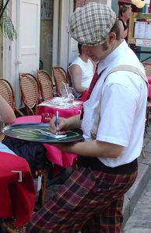
Most customers will rely on you to provide them with information about the meal, the choices available, prices, service styles and/or any waiting times that can be expected.
It is part of the standard service by any outlet for staff to help customers choose a food or beverage item that will suit both their preferences and match appropriately with what they are eating or drinking.
Combinations of foods and food and beverages may relate to:
- Customer preferences
- Traditional combinations of foods, and food and beverages
- Balance of textures, colour and nutrition.
Asking questions
There is a need to ask questions before advising customers about food and beverage selections, and there is a need to ask questions before making recommendations or suggestions for drinks to accompany food.
Basic food questions
Basic questions that may need to be asked include:
- Do they want a light meal, snack or something substantial?
- What type of food are they looking for?
- Is there anything they want to try – local or international?
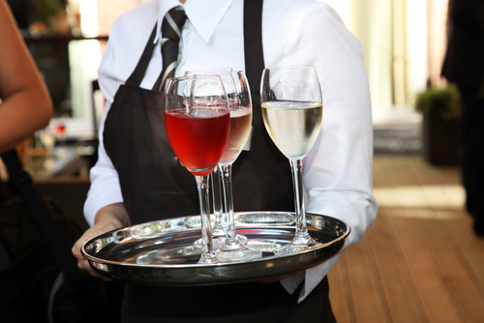
Basic beverage questions
Basic questions that may need to be asked include:
- Do they want an alcoholic or non-alcoholic drink?
- Do they want a beverage that they can share with others?
- If they want wine, do they prefer red or white? Still or sparkling?
- What have they selected in the way of food?
- Do they want to try something local?
- Are they looking for a new experience or do they want to stick with something they know they like?

Giving general information
In general terms, the most common form of assistance to be provided will evolve around helping to clarify:
- Compatibility of food and wine choices
- Interpretation of menu items.
It should be your aim to provide assistance to customers at every opportunity.
When doing so, all information should be provided clearly and accurately.
Remember to make sure you speak clearly, confidently and audibly.
Often, customers will ask you for this help, but frequently, whether by observing customers or listening to what they are saying. You can offer assistance before they ask for it, thus providing outstanding customer service.
Remember, not all those who need help will ask for it. It is part of your professionalism to be proactive in offering it!
If you are ever in doubt about whether to offer assistance ask the customer if they would like some help.
Never hold back on offering assistance simply because you are unsure about whether it’s wanted or not.
You must bear in mind that some people are too ‘frightened’ to ask. They may be in a strange town, they may in a different culture or they may be amongst people who are speaking a different language, to name but a few scenarios.
Giving information on food
Product knowledge is a fundamental necessity in nearly every aspect of customer service in hospitality and when assisting guests it is vital you know everything about all the dishes you have for sale – ingredients, cooking process, time to prepare, whether it is fresh or frozen, if it has MSG or not, the way it tastes, the size of the serve, its texture and specific aromas.
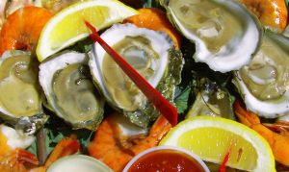
You also need to know, for example:
- Which entrées can be served as mains
- Which mains can be served as entrées
- What sort of fish the ‘Fish of the Day’ is
- If the beef is grain fed
- What cut of meat the roast is
- Which dishes are spicy
- The dishes suitable for different diets and cultures
- Which dishes are ready-cooked and which ones are cooked to order. This helps provide quick service to those who are in a hurry
- Whether the pasta sauces are pre-prepared ‘convenience foods’ or whether they really are home-made recipes produced on the premises from fresh ingredients.
When describing items, make sure you make them sound appealing by using descriptive words like succulent, delicious, fresh this morning, made fresh this afternoon but make sure you are not misleading in what you say.
If you know the steak is tough, then don’t describe it as “juicy and succulent, melt in the mouth”.
Quite often you will need to describe to customers:
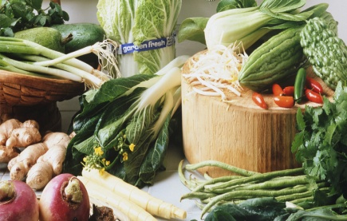
- Ingredients in dishes
- Cooking/preparation times
- Whether things like MSG, sugar, and flour are present in dishes
- Serve sizes
- Whether items are fresh, frozen, canned, etc.
- Why a certain dish has the name it does
- What different cooking styles mean
- Menu and cooking terminology.
Giving information on beverages
Assistance may need to be given when:
- Customers are unsure about what they would like. Sometimes regular customers come in and they are just bored with their normal selection, and want something a bit different
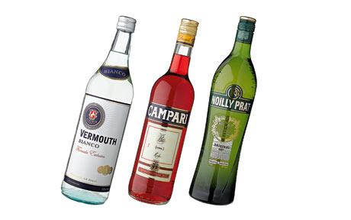
- The drink or brand that they have ordered is unavailable. After apologising you must be able to recommend an intelligent alternative
- It’s a special occasion. Maybe they’ve just won a promotion, had a baby or are celebrating a birthday. You may suggest a special beverage item that would help the customer enjoy this time of celebration
- You have a new product in stock – let the customers know. Tell them what it’s like, what it goes with, how much it costs, how strong it is etc.
- The customer is feeling ‘off colour’ or a bit low. You may want to suggest something light or refreshing.
The type of general information about alcoholic beverages that you may need to pass on to customers includes:
- Which ones are suitable drinks for pre-dinner drinks/‘aperitifs’?
- Which ones are suitable for drinking after a meal?
Suggested basic wine and food combinations:
- What they taste like, look like, smell like and where they come from
- What their alcoholic strength is
- Whether they are domestic or imported beverages – including identification of the country of origin
- Information specific to wines – details relating to wine makers, wine styles, wine growing areas, grape varieties, wine characteristics and information relating to wine shows and the wine industry
- Size of serves, bottles, cans and glasses
- The variety of ways in which different liquors can be served
- How it may be consumed. Give the customers some options about how they can experience the beverage. Can it be served over crushed ice? Can it be mixed with a fruit juice or aerated water? Can it be made into a cocktail?
- Any special points about it. Mention any awards it may have won, mention things like the worm in certain tequilas, any special advertising campaigns that may be running for it or any competitions that are running if people buy it.
Describe specials
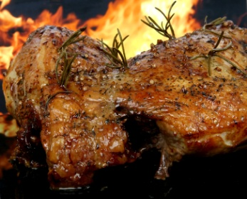
Your next task is to inform the customers of the ‘Specials of the Day’ and any alterations or deletions to the menu.
Items that may need to be covered include:
- Soup of the day
- Fish of the day
- Roast of day
- The vegetables for the session and how they are cooked
- Any other specials that are available.
Making recommendations
Many guests will be able to work out what they want to eat, but there are usually some who have difficulty deciding and ask the predictable question, “What do you recommend?”
When this occurs, you have four basic options:
- Recommend what it is you like. This can be less than useful because this may not suit them or be to their liking
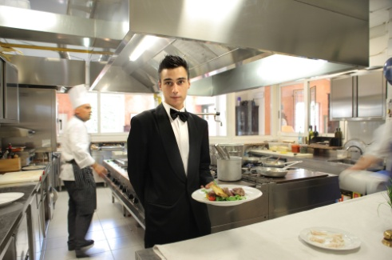
- Recommend what is popular. Again they may not like this style of dish but the benefit of this approach is that you know it is popular with a large cross-section of diners
- Recommend whatever it is that the kitchen have asked you to push. Again, this may not suit them but will benefit the venue
- Ask some questions first to determine whether they are after a big meal or a snack etc. and then recommend an appropriate dish that complies with their responses.

Additional information
In some dining experiences you may also be required to provide additional information such as:
- Entertainment to accompany meals
- Location of buffets

- Location of customer facilities within the venue such as telephones, toilets, car parking, the gaming room, reception etc.
- Information about the local area including points of interest, tourist attractions, local facts and statistics.
Many venues, especially those where guests are also in-house guests staying in rooms in the property, management may require all their customer-contact staff to actively promote the local area to guests.

The idea behind this is that if the staff can convince the guest to see more of the local area and attractions this will increase the likelihood that they will stay an extra day or two at the property. Naturally this increases revenue for the business.
In these situations it is useful to engage guests in conversation that includes questions such as “What did you do today?’ or “What did you see today?”
This allows you to work out what they have seen and what they haven’t yet seen or visited. You them share the experiences they have had, and use this knowledge to recommend they also go and see, whatever they haven’t seen.
Leave table
After all information has been passed on to the table, you should retire from the table while guests browse the menu and make their selection.
Keep an eye on them for cues that they are ready to order. These clues may include menus closed or put down on the table, guests looking around and trying to catch your eye.

Work Projects
It is a requirement of this Unit that you complete Work Projects as advised by your Trainer. You must submit documentation, suitable evidence or other relevant proof of completion of the project to your Trainer by the agreed date.
3.1 To fulfil the requirements of this Work Project you are asked to explain how to welcome guests on arrival
3.2 To fulfil the requirements of this Work Project you are asked to identify steps to seating guests at nominated or designated tables
3.3 To fulfil the requirements of this Work Project you are asked to identify the range of pre-meal services that are available to customers
3.4 To fulfil the requirements of this Work Project you are asked to identify how to present menus and wine and drink lists
3.5 To fulfil the requirements of this Work Project you are asked to identify types of service advice and information that can be given to customers

Summary

Meet and greet guests
Welcome guests on arrival
Greet and check reservations
Be alert to the opportunity to maximise sales
The greeting on arrival
Special needs customers.
Seat guests at nominated or designated tables
Escorting and seating customers.
Offer pre-meal services
Offering pre-meal services.
Present menus and wine/drink lists
Presenting menus and drinks lists.
Provide service advice and information to guests
Asking questions
Giving general information
Giving information on food
Giving information on beverages
Describe specials
Making recommendations
Food and wine combinations
Additional information
Leave table.

Element 4:
Take food and beverage orders

4.1 Take beverage orders and food orders


Introduction
Customer orders need to be taken accurately.
Various formats exist for the taking and recording of orders and these must be adhered to in accordance with establishment or department requirements and forwarded quickly to the kitchen or bar so that the order can be processed.
Taking orders options
The method of taking orders may vary from establishment to establishment, and can vary within the one business.
Staff may be required to:
- Remember orders relying solely on their memory, as is the case at most bars and in some restaurants
- Record orders on paper-based order forms such as waiter’s dockets and order pads
- Record orders using electronic means such as small hand-held computers (PDAs – Personal Digital Assistants) which also send the orders to the kitchen or bar and interface with point-of-sale registers to facilitate account tracking, processing and payment.
The role of the order
The order serves four different purposes:
- Informs the kitchen or bar staff of the order so that they can produce the items required by the customers
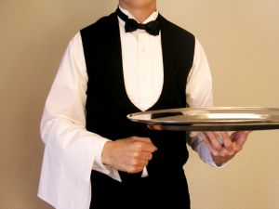
- Informs the service staff of any changes needed to the cutlery. Some may need to removed, some may need to be added or exchanged
- Identifies who is eating or drinking the items ordered so that the right item can be served to the correct guest
- Provides the basis from which an account can be made up and presented to the customer at the end of the dining experience.
Whatever the method used, orders should be taken promptly and accurately with minimal disruption to the customers. You need to pay attention to what is being said, and use positive body language and verbal communication when taking the order.
Guidelines for taking the order
There are a number of rules you should try to follow when taking and recording an order:
- Be aware of signs given by the guests that they are ready to order - guests looking around for attention, guests who have closed their menus, guests looking anxious
- Ensure all orders are recorded accurately and legibly using the appropriate terminology and abbreviations and making sure that the written order does not:
- Omit any important parts of the order such as how the steak is to be cooked (see below), whether the main course is to be entrée size or the fact that the main meal is to be served with mash potato rather than French fries
- Confuse the person reading or having to interpret it. There is no point requesting ‘two fish’ from the kitchen if there are three fish dishes on the menu. Similarly, just asking the bar for ‘a beer’ doesn’t tell them the size, brand, style, or whether the beer is to be packaged one or a draught one
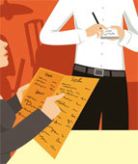
- Orders should be taken with minimal disruption and interruption to guests. There needs to be sensitivity in how the table and the customers are approached so that they don’t feel they are being pressured or their private conversations are being listened to
- Recommendations or suggestions are made to the customers to assist them with drink and meal selections. Even where you have provided assistance when the menu or drink list was presented, there can often be a need when it comes to actually taking the order that guests need extra help or need you to repeat information previously given
- Service staff should always take the guest’s order from the right. This is an industry standard but check to see what applies where you work. This obviously can’t happen in situations where:
- There is an obstruction such as a wall that prevents you standing to the guest’s right-hand side
- The guests are involved in conversation or looking at something between them that would make it impractical, rude or otherwise difficult to take the order
- Guest should be numbered. The host of the party or table or some other person, as identified by you as being Guest No 1, becomes number one and the numbering is worked clockwise around the table allocating every person who orders a number.
Doing this and getting this right is important as it guides both the adjustment of covers to reflect what they have ordered, and the actual delivery of meals and drinks to the correct person without having to ask “Now, who’s having the veal?”
The Number One person may be the guest who is sitting closest to the front entrance, or they may be sitting closest to the central pillar in the restaurant. It’s up to you to:
- Leave adequate space on hand-written food dockets, between the entrées and mains, to clearly define the break in the order. Note that dessert orders are usually taken after the mains have been served and cleared away, unless otherwise stipulated
- Repeat the order to the guest to ensure you have got it right. Always ask for clarification if unsure of a particular order.

Check customer preferences

As part of the ordering process, customers will identify which item they desire and a preferred preparation style, be it a food or beverage item.
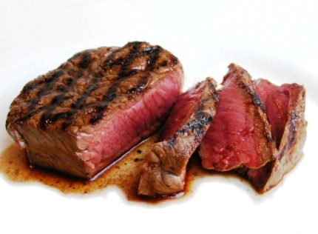
Food preferences
Degrees of ‘doneness’ of steaks
It is important to note on the order how the guest wants their steak cooked.
Degrees of doneness are:
- Blue - steak is seared on both sides then served
- Rare - steak is served when browned on both sides, and meat still contains blood
- Medium rare - steak has less blood than a rare steak, though blood is still just present
- Medium to well-done - steak is cooked all the way through, no sign of blood
- Well-done: steak is cooked very well – a little burnt on the outside and definitely no sign of blood.
Beverage preferences
Most food items will be specifically identified on a menu, however many people will order a drink without referring to a menu.

At times customers will indicate a specific drink in a generic manner. For example, they may ask for a ‘gin and tonic’ without specifying a particular brand.
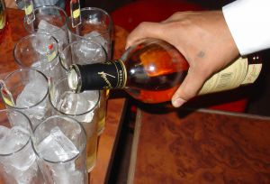
As can be seen in this picture, there is a wide selection of gin products.
There are many different products and brands available, with more coming onto the market seemingly every day.
It makes good sense and excellent customer service, to check with the guest regarding their preference.
Personal preference
Some people are devoted to a certain brand and simply won’t drink anything else. Examples may be Jim Beam bourbon, Gordon’s gin and a diverse range of Scotches.
Some people consider the price and are happy to drink a cheaper, domestic brand if one is available. They will appreciate you pointing this out to them.
Pour and call brands
Behind the bar, most venues stock a ‘pour’ brand, as well as several ‘call’ brands. You must know what these are in order to answer customer questions, and to provide the drink that satisfies their identified need and preference.
A ‘pour’ brand, sometimes referred to as a ‘house’ brand, is the brand of beverage that will be poured if someone doesn’t specify a brand name.
If the customer simply asks for a ‘Scotch’, then they haven’t indicated a preference for one particular brand, so it doesn’t matter what brand you pour them just so long as it is Scotch. In these cases the ‘pour brand’ will be supplied.
Usually pour brands are cheaper alternatives to recognised national brands, but sometimes they are the better known, better quality, premium national brands.
A ‘call’ brand is the brand ’called out’ by the customer.
Instead of just asking for a Scotch, the customer would ask for a specific brand, perhaps a ‘Dewar’s’ or ‘Chivas Regal’. Most bars will stock a range of call brands, but no bar can stock them all.
You need to become familiar with the ones you stock so that you can accept an order straightaway, or inform the customer that you don’t stock their preferred brand.
Always be alert to the possibility to up sell the customer to a more expensive brand.
Where you don’t have the call brand that the customer asks for you should:
- Apologise for not having the brand asked for
- Offer an alternative.
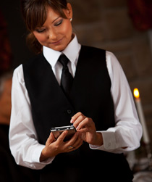
Operate the ordering system according to enterprise procedures
The ordering system in operation where you work must be used in accordance with enterprise procedures and, where appropriate, in compliance with manufacturer’s instructions.
Most employers will provide training in how to take orders and operate their system even if the system is a paper-based system.
Where the system is electronic, there will definitely be in-house training (unless you have indicated you have experience with that system on your job application or at the job interview).
Operating ordering systems
All transactions should be undertaken within establishment guidelines relating to:
- Honesty and integrity. These address not charging for items that were not delivered or not charging person X for something that person Y received
- Accuracy. This means checking all entries, extensions, additions and other calculations to make sure that the customer isn’t overcharged and that the venue captures all the revenue to which it is legitimately entitled
- Speed. Ensuring that accounts are compiled and presented in a timely manner consistent with honesty and accuracy. Never sacrifice accuracy for speed
- Explanation and description of charges. Fully detailing the nature of all charges so that no confusion or suspicion about charges exists
- Customer service. Treating customers with the courtesy they merit in relation to the taking of the order, processing of the order and presentation of the account for payment.
The manual system
Dining order systems can vary greatly.
The type used largely depends on individual establishment’s preferences based on matters such as:
- Their previous experience with using an ordering system including evaluation of how existing systems are performing
- The number of orders processed. Bigger numbers may encourage the establishment to use an electronic system
- Skills of staff and the availability of skilled staff. Most premises dislike having to train staff, but will do so where they have to.
For educational purposes, the following explains how to write a manual food order. Check what applies where you work and stick to establishment procedures where they differ from what is presented.
Below is an example of an easy to read food docket. Note how each person has been numbered to identify their meal selections.
Date | Time | Table | Number | Server
7/5 | 7:30 | 6 | 6 | Mary
Qty | Item |  |  | Cover No
2x | Garlic Bread
2x | D/F Calamari |  |  | 1, 3
1X | Beef Kebabs |  |  | 2
2X | W-Chicken Salad |  |  | 4, 5
1X | S.O.D. |  |  | 6
1X | Seafood Basket |  |  | 1
2X | Spaghetti Mar |  |  | 2, 3
1X | Chick-Avocado |  |  | 4
1X | Calamari (Ent) |  |  | 5
1X | Scot-Steak M/R-No Sauce |  |  | 6
Points to note about this order
- The writing is clear and legible to avoid any costly mistakes
- The time allows monitoring of service
- The inclusion of the server’s name allows the chef to know who placed the order if issues arise and questions need to be asked
- The number at the table allows cross-referencing with the number of items ordered
- The chef can clearly read the quantities of each menu item
- Additional requirements have been noted
- Abbreviations have been used
- Guests have been numbered to immediately identify who is having which meal and that changes to the cover may be necessary
- There is a sufficient gap separating the entrées from the main meals for the kitchen to see clearly the break between the courses.
Appropriate software applications
To repeat other notes there are various software applications in the workplace, many of which have been designed and developed for the hospitality industry, with some specialising in sectors such as accommodation and restaurants.
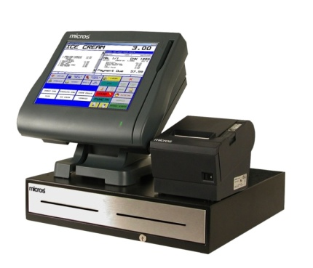
The sector-specific options contain many features, some of which are brilliant, but many of which are not used.
Without doubt, the best advice is to read the manual.
There is so much variation between this software that general statements are difficult to make. Ask your supervisor to show you the system, explain what it does, and arrange for some down-time training before you go ‘live’.
Some systems have a dedicated ‘training’ option enabling you to practice on the actual equipment during working hours without interfering with the working orders.
Software applications
This computerised system enables electronic management of food and beverage orders.
A main terminal enables data to be input to the system. This data comprises the menus for all the restaurants hooked up to the system, along with prices of each item. This information could be input by the F & B Manager or receptionist.
Each outlet has its own terminal that displays the menu. This is a touch screen as there is no keyboard like a normal computer. Printers are an integral part of the system and they are present in each of the food outlets, as well as in the kitchen.
Hand-held electronic order pads
These, as the name suggests, are small hand-held ordering devices (PDAs) that waiters take to tables instead of using hand-written order pads.
A pointer is used to navigate the screen and ‘key in’ the order which is then communicated to a printer:
- In the kitchen to let the kitchen staff know what is required
- To a point-of-sale terminal to generate the account for the customer.
These devices integrate with other establishment systems such as the POS register and kitchen and bar printers and may:
- Reduce the errors that occur when orders are taken
- Improve customer service levels
- Increase service speed.

4.2 Sell menu items and drinks proactively

Introduction
As a food and beverage attendant it is your role to make the eating experience as enjoyable as possible. Quite often customers experience indecision and any helpful suggestions or recommendations from you could be beneficial.
Customers do not have the same in depth menu knowledge as you do so try to put yourself in the customer’s shoes and make recommendations based on what you think they would like.
Don’t be shy about asking probing questions to help with your recommendation.
Sale of additional items
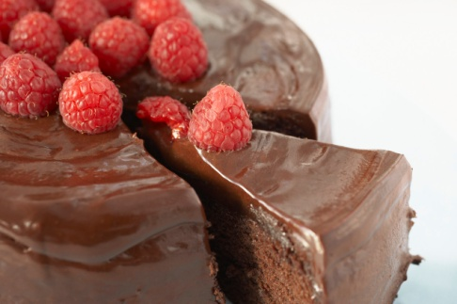
It is your role to increase revenue for the outlet and the organization as a whole. When customers are ordering food, don’t be shy about suggesting an additional item that would complement the meal. Some examples include:
- Side salads, vegetables or French fries
- Starch foods like wedges, fries, rice or other potato formats
- Beverages to compliment meals
- Additional sauces or condiments
- Desserts.
Upsizing/upgrading meals
Many food companies now sell different sizes of the same item to offer a greater choice. With the incentive of a larger meal for a small increase in price, many customers like this option.
Package meal deals
Many popular fast food companies employ this concept where for a set price you get three or more food and beverage items. Not only does this make ordering and preparing food easier, it also guarantees a minimum of three items being sold.
Suggestive selling
In addition if customers are sure about a certain meal (e.g. chicken) but aren’t sure of a specific dish, whilst you may not directly suggest the highest price dish, many attendants know of items that have a higher profit margin, which they may be trained to suggestive sell.

Considerations

When selling menu items it is important that your efforts:
- Align with sales endeavours with kitchen and management priorities
- Adhere to enterprise policies and procedures regarding implementation of selling techniques
- Maintain honesty, accuracy and professional ethics in the use of sales techniques.

4.3 Recommend wines and drinks to accompany selected foods
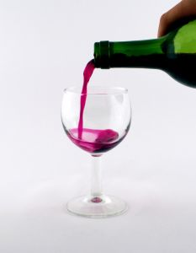
Introduction
In section 4.1 of this manual providing information and recommendations in regards to both food and beverage were identified and discussed.
This section will explore how to recommend wines to accompany food, as one of the most common requests for advice is in regards to matching a wine to accompany their meals.
Food and wine combinations
Some basic suggestions include:
Food | Wine
Salads | Chenin blanc, verdelho, chardonnay, riesling
Antipasto | Chardonnay, rosé
Seafood | Semillon, sauvignon blanc, Riesling
Game | Cabernet sauvignon, shiraz, chardonnay, semillon
Red meat | Cabernet merlot, cabernet sauvignon, shiraz, malbec
Poultry | Chardonnay, chenin blanc, Verdelho
Pasta | Chardonnay, riesling, shiraz
Cheese platters | Cabernet merlot
Desserts | Dessert wines

You should also be sufficiently familiar with the wines on the drink list to make intelligent recommendations to compliment the food.
One way of choosing wines to go with food is the ‘Complement or contrast’ approach as follows.
Wine to complement food
When complementing food with wine, try to select wines that will harmonise well with the dishes and their ingredients general guidelines are:
- Whites with fish, chicken, veal and pork
- Reds with dark meat
- Reds with cheese
- Delicate wines with delicate food
- Full-bodied wines with full-bodied food
- Sweet wines with sweet food
- Champagne can generally go with anything and with any course.

Wine to contrast with food
‘Contrasting’ relates to selecting a wine that stands distinctly on its own when compared to the food being eaten and is viewed as a separate taste experience.
It’s best to stick with the idea that a style of wine goes well with a style of food and then fine tune your selection from that point, taste-testing dishes and wines, and taking professional advice from wine experts.

4.4 Respond to guest queries regarding menu items and drink choices

Introduction

A major part of the service staff’s role is to respond to guest questions regarding menu items. Doing this provides not only an opportunity to be of service but also to promote items in line with the kitchen’s advice.
In sections 4.1 and 4.3 of this manual different ways to identify customer requests and provide information and recommendations were discussed.
In many cases though, customers will have specific questions about menu items that need to be clarified.
A high level of product knowledge is needed to answer guest questions, and as discussed, in the majority of cases, you will need to ask questions yourself to make sure you have the necessary information to pass on to customers and guests.
All information provided to guests in response to their questions must be truthful and conveyed in a courteous manner.
Common customer enquires
Common customer enquiries include:
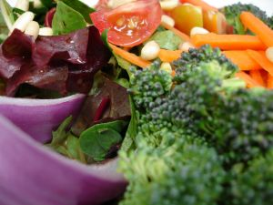
- Dish ingredients
- Cooking/preparation time
- MSG and flavourings
- Serving sizes
- Freshness of ingredients (seafood)
- Cooking styles
- Meat or meat stocks
- Menu and cookery terminology
- Side dishes
- Calorie/fat content.
This information is vital in enabling you to effectively promote dishes and respond to questions from customers.

Handling questions where you don’t know the answer
However, regardless of how much work and research you do there will always be occasions when you are asked a question you can’t answer. When this happens, don’t get upset, annoyed or embarrassed, treat it as a learning experience and:
- Apologise to the guest
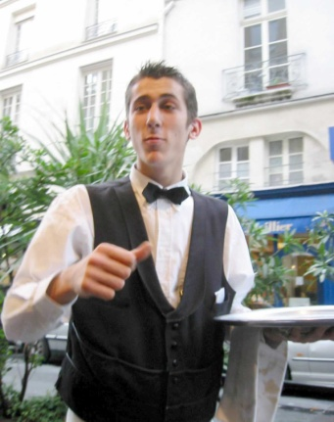
- Tell them you don’t know the answer to their question
- Tell them you will go and find out, ask the kitchen etc.
Go back to the guest and pass on what you have found out. As well as giving information to the kitchen and bar, you will be required occasionally to pass on information from the kitchen and bar to patrons.
This information can be:
- Finding out from the kitchen, answers to questions asked by guests such as the ingredients in a certain dish
- Clarifying cooking methods, temperatures, side dishes or sauces that were not recorded on an order
- Passing on to guests the bad news that their mains will be delayed
- Letting the guests know that unfortunately all of a certain item has been sold out, and that they need to order something different.
Dietary considerations

It is extremely important to make sure that special requests that relate to dietary issues receive extra attention and care as there can be severe medical consequences if dietary needs are not met.
These consequences include the possibility of anaphylactic shock, increased blood sugar levels and other reactions that diners may have to various foods or substances and can result in the property being sued.
Remember that all properties have a common law duty of care towards their patrons and this obligation definitely extends to situations where customers have asked for a certain meal or food and are served something that does not comply with their stated requests and when this results in injury to those persons.
The keys in relation to this situation are:
- Always check with management or the kitchen to determine whether or not a specific stated dietary request can be accommodated or not
- Make doubly sure that those preparing the dish know the specific dietary requirements that have been requested
- Never assume that the kitchen can accommodate dietary needs of patrons even if you have accommodated similar requests in the past
- Double check with the kitchen when you pick up a dish for service to the table ask them if they have prepared the food as requested and obtain positive confirmation before taking the dish to the table
- Ensure appropriate emergency procedures are in place to manage situations where customers are adversely affected by foodstuffs while on the premises. These procedures may be included in the Emergency Management Plan for the premises.
Types of special dietary needs
- Vegetarian requests. This is probably the most common dietary-related request
- Lacto-ova vegetarians/Ova-lacto vegetarians. These are the majority of ‘vegetarians’. They eat dairy products and eggs but not meat of any kind including red and white meat, poultry or fish
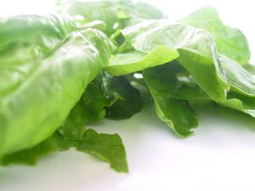
- Lacto-vegetarians. They don’t eat meat, poultry or fish. They don’t eat eggs but they eat dairy products
- Pescatarians. These are people who don’t eat meat, poultry or animal flesh but do eat fish
- Vegan. This definition is open to various definitions so it is best to check exactly what the diner means when they say they are a ‘vegan’. Generally a vegan can be seen as anyone who doesn’t eat meat, poultry, fish, eggs or dairy products and doesn’t eat foods derived from animals such as gelatine. The person may also stipulate that they are served only raw/unprocessed foods, or foods that have not reached a temperature of above 46ºC (because they believe foods above this temperature have had some of their dietary goodness removed or may be harmful to the human body)
- Requests for low-salt meals
- Requests for low-sugar or no sugar meals for diabetics
- Requests for lactose-reduced milk for those who are lactose intolerant
- Requests for gluten-free food from patrons who have celiac disease
- Requests for a macrobiotic diet for those who are especially health-focussed they will request unprocessed vegan foods, no oil and no sugar.
Regardless of the request, the accuracy of recording and delivering customer meal requests is a key element of a successful dining experience for the customer.

4.5 Transfer orders to service and preparation points

Introduction
As discussed in section 4.1, many orders will go directly to the kitchen or bar through the use of a software system. Regardless of whether or not an electronic or manual ordering system is used to take an order, there are many times when waiter staff will need to speak directly to the person preparing items, normally the chef or bartender, to explain special requests and to clarify the order.
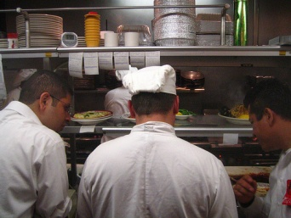
Relaying information manually
In the event that a manual system is used, it is imperative that:
- Orders are given directly to the person responsible for its preparation
- Ensure they receive the order
- Ensure they understand the order
- Explain any special requests relating to an order – see below.
Relay information about any special requests or dietary or cultural requirements
Where customers make special requests in relation to the dining requirements, whether these are based on personal preference, dietary needs or cultural requirements, it is important that these special requests are communicated clearly to the relevant person.
The relevant person may be:
- The head waiter – to determine whether or not the special requests can be accommodated
- The head chef – to inform them of the specifics relating to the food order that is being placed
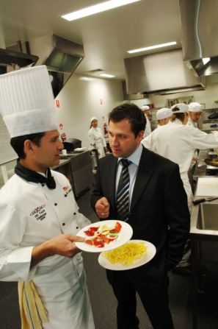
- The bar manager or a nominated bar attendant – to clarify the order.
Relaying information
When delivering the order to the kitchen or bar, details about any special orders must be passed on to the appropriate person quickly and unambiguously.
You need to bear in mind that the person you will be speaking to will have more staff than you to deal with; you are likely to be just one of many. For this reason you have to take the time and make the effort to get your message across correctly, first time, every time.

To achieve this you need to make sure you:
- Have got their full attention when relaying the order. The kitchen may require you to say ‘Ordering chef’ or ‘Order in’ when placing the order
- Point out the special request on the actual docket, physically locating the written information that you have put on the docket. It is standard practice in establishments using a manual ordering system for special requests to be circled on the docket to highlight them
- Verbally describe what is needed – clearly and accurately. A response should be heard from the chef after you have placed the order. If no response is heard, repeat the order.
If possible get them to repeat it back to you to verify they have understood what is required!
While you need to ensure that your special order is understood, you must be sensitive to the other things that are going on. It may pay you to hold off for 30 seconds or a minute while the kitchen person clears some meals that are ready, helps with plating a large order, or remedies an immediate problem. Remember that team work, not individual plays, are the key to overall service success.
The same applies at the bar. Take a moment to see if the person you want to speak to is realistically able to listen to what you have to say. If they can’t, then wait for a minute.
What information may need to be relayed?
Information that may need to be relayed involves:
- Timing issues. You may need to inform the kitchen/bar of those who are in a hurry, or those who want to stretch their meal out over several hours
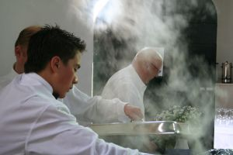
- Co-ordination of service. Tell the bar about the food that a table has ordered so that wines selected to accompany certain dishes can be presented, opened and served before the food has been served. It is very annoying and disappointing for a guest to choose a special wine to accompany their fish main course only to find that wine is served when they are half-way through that dish
- Cultural issues. Notify the kitchen/bar of cultural food and drink needs. Sometimes patrons expect you to know what these needs are, but in other instances individuals will advise you of what they want
- Dietary requirements
- Special requests in relation to serve size, additions or deletions or a special way of cooking that is not listed on the menu
- How steaks are to be cooked
- Entrees required as main courses or vice versa
- Explanation of tables and their orders. For example a table of six people where four are having entrees, and three are having soup and two are not having soup or entrees, what is required and when.

4.6 Adjust settings/covers to reflect menu items selected

Introduction
After the order has been taken and a copy transferred to the kitchen, either manually or electronically, the service staff will have to make any necessary changes to the cover to reflect the dishes that diners have ordered.
It is now time to adjust the setting with certain items of cutlery, glassware and service wear depending on the dishes and drinks they have ordered.
Adjusting cutlery
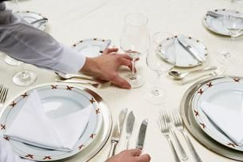
Always remember that cutlery should be carried to and from the table on a clothed service plate. Cutlery may only be carried in the hand if it is an establishment requirement.
It is a requirement that all covers are adjusted before any menu items are delivered to the table. Note however that some establishments require that dessert cutlery is only adjusted after the guests have completed their main course, and some establishments have a standard requirement that covers are not adjusted at all. If the guest doesn’t order a certain course, the cutlery stays on the cover until the table is cleared.
Your copy of the order for the table provides the basis for determining what needs to be adjusted for each diner.
Adjusting the cover may mean you have to:
- Remove cutlery for courses that have not been ordered
- Exchange cutlery where necessary such as swapping the main course knife for a steak knife where steak has been ordered and swapping the main course gear for fish gear where fish has been ordered
- Add cutlery for dishes that have been ordered where no suitable cutlery has been set. For example, if the cover did not include a soup spoon and the guest ordered soup, there would be a need to adjust the cover by adding a soup spoon.
Adjusting glassware
Most table set ups will include standard wine glasses, with many establishments also setting water glasses.
Where the guests order certain drinks and the correct glassware is not already set this will require you to:
- Remove the glassware that is not needed
- Replace it with the appropriate glasses.
It is standard industry practice that all glasses be removed from a table, and carried to a table on a tray. Glasses should be removed and set/re-set from the guest’s right-hand side.
Practical examples of the need to adjust glasses may include:
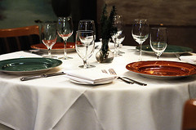
- Removing all wine glasses where guests elect not to order any bottles of wine
- Removing the white wine glass that was set and replacing it with a larger red wine glass if the guest orders red wine
- Adding a red wine glass if only a white wine glass was set and the table has ordered both red and white wine
- Removing the set glasses and replacing them with champagne flutes where a sparkling wine is ordered.
Adjusting service wear
Depending on the dishes ordered and the style of service being used, there can be a need to provide various items of service wear to individual tables.
Service wear may need to be provided as follows:
- Where the service style presents, for example, the vegetables to the entire table, as opposed to plating vegetables onto individual guest plates in the kitchen, there will be a need to use service platters
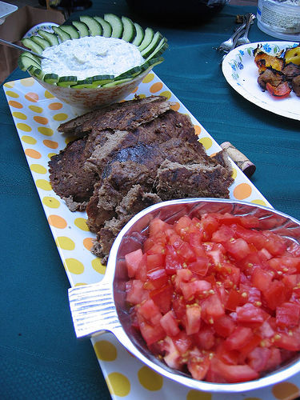
- Where customers order sauces or gravy there may be a need to provide sauce boats
- Where the guest has brought in their own cake or arranged for the venue to supply one, there may be a need to use a cake stand
- Where guests order snails there will be a need to provide snail forks and tongs
- Where guests order lobster there may be a need to provide lobster picks and crackers
- Where a soup is served to the entire table, a soup tureen may be required.
Process for adjusting settings
The process requires you to:
- Identify what needs to be removed from each cover
- Identify what needs to be added to each cover
- Obtain the necessary items, which should be stored in your waiter’s station
- Load them onto a clothed service plate ready for carrying to the table
- Carry the clothed plate with all the required items to the table
- On arrival at the table, begin adjusting the items by starting at the Number One guest, working clockwise around the table. Change the knife first, then the fork, and don’t forget to place the cutlery down on the table so that it is parallel with all others
- The knives should be removed or replaced from the right-hand side of the guest, and the forks from their left-hand side. Never place cutlery by leaning across in front of a guest. Always handle cutlery by the handles.

4.7 Liaise with other staff regarding intended service delivery

Introduction
Communication with colleagues is different to that provided to customers. However the objective is the same which is to ensure each customer has an enjoyable experience at your establishment.
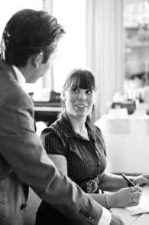
Communication amongst colleagues is extremely important. Teamwork and understanding of each other’s needs is vital. The saying ‘a team is only as strong as its weakest link’ is very true. A customer does not see all the staff involved in the provision of products and services. They only see the end result. Therefore if a problem exists, it doesn’t matter who is to blame, a problem still exists.
Communication between staff members in any organisation is essential, and this is no different in food and beverage.
As mentioned, the customer does not care who provides different aspects of their experience. Their only concern is that the offering matches their expectations.
The tasks and activities within a food and beverage outlet are extremely interlinked with the duties performed by one person directly impacting those of another.
Therefore clear and concise communication is a must.

Common communication channels
Whilst a large majority of communication takes place during a service shift, there are many opportunities for food and beverage staff to liaise with each other including:
- In meetings, whether at a departmental or senior management level
- In staff briefings at the start of a shift
- During a shift as needs arise
- In staff debriefings at the end of a shift
- Through comments in handover documents between shifts
- Through emails, memos and telephone calls.

Staff involved in provision of a food and beverage experience
Whilst waiters may have a responsibility for certain tables, they cannot provide the entire food and beverage experience all alone. There are a number of people who help provide and co-ordinate the final experience for customers. This includes those who directly prepare and provide food and beverage and those who provide support and auxiliary services.
This includes, but is certainly not limited to:
- Management and supervisors
- Hosts
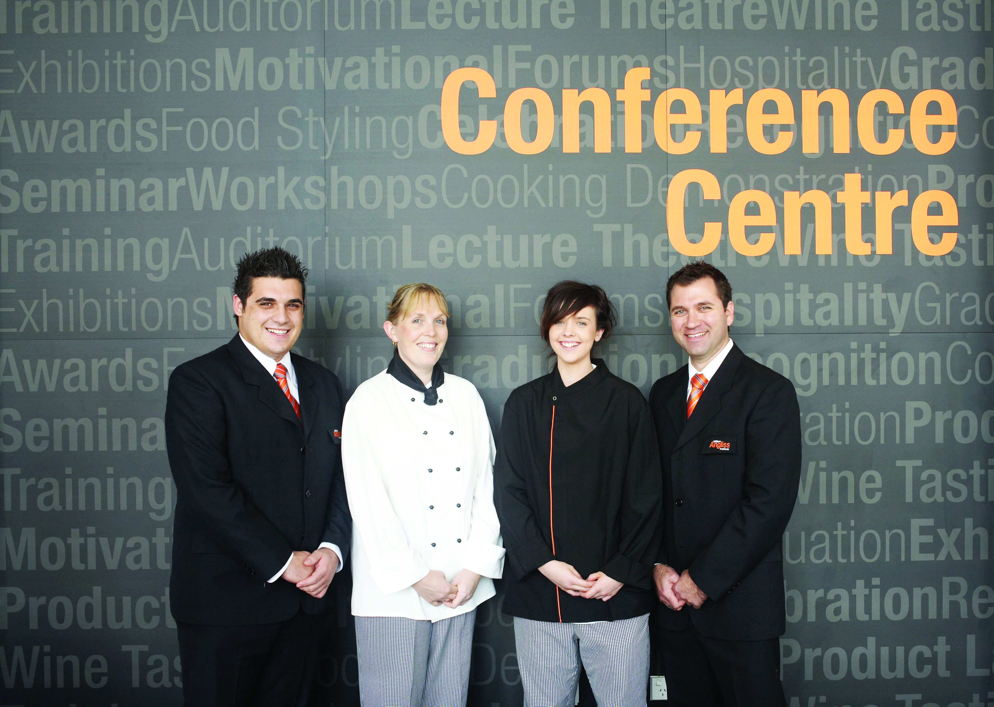
- Cashiers
- Chefs
- Bartenders
- Cleaning staff
- Stewards
- Security
- DJ
- Purchasing department
- Valets and car park attendants.
Like with customers, all communication with colleagues should be conducted in an open, polite, professional and friendly manner. The information provided must be clear and concise.
Examples of communication
There are endless examples of communication that takes place in a food and beverage outlet. However some common examples include:
- Ordering special menu items with kitchen or purchasing department to meet customer requests
- Explaining requests and variations to menu items
- Notifying bar staff of timely and coordinated food and beverage and wine service
- Arranging for assistance in the service of food and beverages to large groups
- Organising support staff to assist in the delivery of silver service, semi-silver service, gueridon service and plated service as the need dictates
- Coordinating with cashier to ensure guest account is created, updated and made ready for presentation
- Coordinating the transfer or collection of customer cars with the valet
- Notifying security or management where guests are presenting in an anti-social, argumentative, aggressive, intimidating, harassing, or otherwise unacceptable manner.

Providing assistance
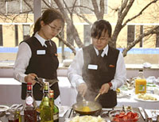
One of the most common types of communication between food and beverage staff is when assistance is required.
Normally assistance is required when:
- A large amount of customers arrive at one time
- A large number of meals or drinks need to be delivered to a table
- A customer has a question or complaints which cannot be resolved by a staff member
- Customers require the bill.
As can be seen, there are a number of reasons why communication is so important in a food and beverage outlet.

Work Projects
It is a requirement of this Unit that you complete Work Projects as advised by your Trainer. You must submit documentation, suitable evidence or other relevant proof of completion of the project to your Trainer by the agreed date.
4.1 To fulfil the requirements of this Work Project you are asked to identify how to take beverage orders and food orders
4.2. To fulfil the requirements of this Work Project you are asked to identify how to sell menu items and drinks proactively
4.3. To fulfil the requirements of this Work Project you are asked to identify methods to recommend wines and drinks to accompany selected foods
4.4. To fulfil the requirements of this Work Project you are asked to identify how to respond to guest queries regarding menu items and drink choices
4.5. To fulfil the requirements of this Work Project you are asked to identify importance of transferring orders to service and preparation points
4.6 To fulfil the requirements of this Work Project you are asked to identify considerations when adjusting settings/covers to reflect menu items selected
4.7 To fulfil the requirements of this Work Project you are asked to identify different staff members you may liaise with regarding intended service delivery

Summary

Take food and beverage orders
Take beverage orders and food orders
Taking orders options
The role of the order
Guidelines for taking the order
Check customer preferences
Operate the ordering system according to enterprise procedures.
Sell menu items and drinks proactively
Sale of additional items
Considerations.
Recommend wines and drinks to accompany selected foods
Food and wine combinations.
Respond to guest queries regarding menu items and drink choices
Common customer enquires
Handling questions where you don’t know the answer
Dietary considerations.
Transfer orders to service and preparation points
Relaying information manually
Relay information about any special requests or dietary or cultural requirements.
Adjust settings/covers to reflect menu items selected
Adjusting cutlery
Adjusting glassware
Adjusting service wear
Process for adjusting settings.
Liaise with other staff regarding intended service delivery
Common communication channels
Staff involved in provision of a food and beverage experience
Examples of communication
Providing assistance.

Element 5:
Serve food

5.1 Serve bread rolls at table

Introduction
No one likes to wait in everyday life and this is the same when enjoying a dining experience.
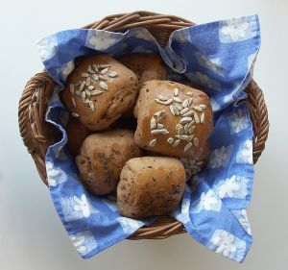
Each dining experience is different. In casual meals such as lunch, we want to eat quickly. When eating dinner at a restaurant, we are not in a rush and often wish to pace ourselves.
In most eating experiences in a restaurant, bread is often provided to customers.
There is an old saying that when customers arrive and are seated at a table they want to be doing something, whether:
- Reading
- Eating
- Drinking.
Naturally we give customers a menu (reading) so that they can choose food (eating) and beverage (drinking).
In the time between orders having been taken and food and beverage delivered, bread is often served to customers.
Purpose of serving bread
Commonly bread is served once the orders have been taken.

The reason for serving bread has a number of purposes:
- Takes away hunger pains that customers may have whilst waiting for meals
- Is an added element of service to a meal
- Is seen as added value in the eyes of the customer
- Can be used to accompany menu items to ‘soak, mop or scoop’ items
- Often to accompany entrees or starters
- It is a cheap ‘additional course’
- May be charged and therefore is a method to increase revenue.

Ways to serve bread
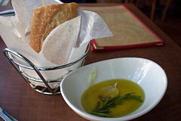
There are a number of ways to present bread to customers, depending on the service style used in the outlet including:
- Served in baskets or silver served from a basket where customers get the choice
- Can come in the form of individual rolls of various types and makes, in loaf format or simply sliced
- Commonly served with butter, an appropriate complimentary dip, tasting plate or simply with oil and balsamic vinegar.
Alternatives to serving bread
Not all restaurants will serve bread at the start of the meal. Depending on the cuisine offered at an establishment another cheap menu item may be served. Regardless of the item served, the purpose remains the same.
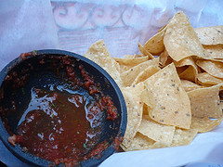
Common alternatives include, but are certainly not limited to:
- Nuts
- Chips
- Vegetable sticks (crudités) and dip
- Corn chips and salsa
- Soup tasters
- Sorbet – to cleanse the palate.
Whilst bread may be a simple dish, for most people there is nothing better than fresh crusty warm bread served with smooth butter to start a meal.

5.2 Serve dishes as ordered by guests

Introduction
The need to collect ordered items from the kitchen as soon as they are ready for service cannot be stressed too strongly.
Prompt collection of food enhances customer service in two primary ways:
- It reduces guest waiting time. Most customers prefer to receive their food as soon as possible consistent with not being rushed or pressured
- It gets the product to the guest in the best possible condition. Menu items don’t improve while they stand waiting to be served.
Collecting food
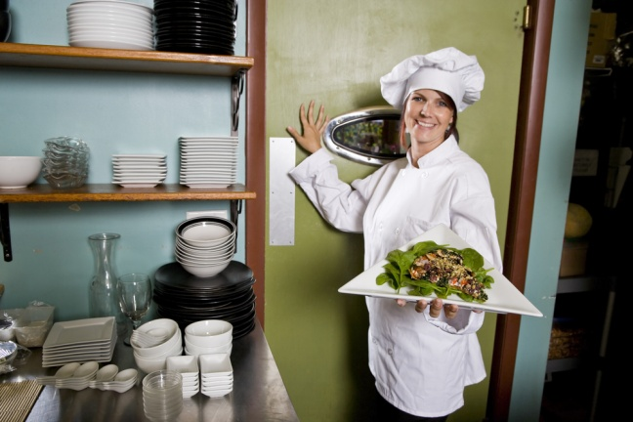
The two service areas – cold larder and hot section – must be attended and monitored at all times to ensure prompt pick up of food.
If food is not picked up promptly the following may apply:
- Hot food could go cold and spoil
- Cold food could lose its chill factor
- Risk of food contamination increases
- Customers have an unnecessary wait
- Room to place down newly prepared items becomes restricted.
Before any food is taken out to the table it must be checked in the same way that drinks are checked prior to be taken and served.
Checks should include:
- Checking that the right meal has been prepared and any requested preferences have been accommodated. Dishes must reflect the order that was taken at table and given to the kitchen
- Checking the plate to make sure there are no marks, spills or drips. Advise the chef and ask for the plate to be cleaned where these are identified
- Checking the quality of the item
- Checking with the chef to identify how a particular item has been cooked which is the medium steak and which is the medium rare?
- Checking if special condiments need to go with the order
- Checking to make sure there is uniformity between dishes. If three people on a table are having the same menu item then all three plates should look the same
- Ensuring correct temperature of the dish. Hot dishes should be hot, and cold dishes must be cold.

Delivering food items to the table
Carrying plates to a table
Commonly, plates may be carried in the hands using various plate carrying techniques.
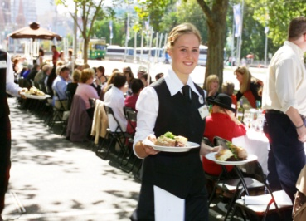
Alternatively, plates may be loaded onto rectangular food trays which are carried to the waiter’s station where they are either unloaded into the hot box or delivered straight to the table.
All items should be carried in such a way that prevents contamination by making sure:
- You don’t put your fingers onto food
- You don’t place your fingers around the top of glasses
- Long hair is appropriately tied back or controlled.
Serving food
The actual food that the guests consume is only part of the total dining experience.
The service of those items is another vital part of the experience.
It is often the service provided to guests that separates one venue from another and is the determining factor about whether or not those people will return and tell their friends about us.
Two keys when serving food and beverage are:
- Do it quickly without giving the guest they are being rushed or you are in a hurry
- Do it professionally. Serve the correct items to the correct diners, be polite, identify items as they are served, communicate and interact with guests, smile, answer any questions that are asked, check that the items presented are acceptable to the guests.
Placing the food onto the guest’s table
Always serve the meal from the guest’s right (the same side that beverages are served from) and announce the meal as it is being placed down. Consistency in service is important.
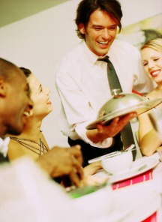
Make sure the dish is placed down so the main item on the dish – the steak, the slices of meat, the piece of fish, the chicken breast – is closest to the guest (at the 4 o’clock – 8 o’clock position).
Where a steak is being served, the kitchen should have presented the steak on the plate with the fat toward the centre of the plate, and not facing the guest so they have to cut through the fat to get to the meat.
It is professional to place the right meal down in front of the right person, without having to ask, “Who’s having the chicken?” The guest numbering system comes into play when identifying which meal is to be placed in front of a particular guest. It is usual practice to announce each guest to confirm that each diner is receiving what they ordered. For example, “The Grand T-Bone, rare with extra chips. Enjoy!”
Place the dishes onto the table in such a way that the noise made by contact with the table is minimised.
Serving Food
One of the most important skills a waiter can master is the art of carrying plates.
There are two methods to choose from and proficiency in using either method can only be gained in the same way as gaining competency in carrying a drinks tray – practice, practice, practice.
Three Plate Carrying
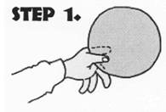 | Hold the first plate between your thumb, index finger and the middle finger
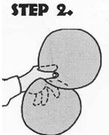 | Place the second plate into the crease of the palm of your left hand under the edge of the first plate, supporting it by your ring and little fingers
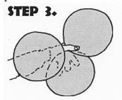 | Carry the third plate on the flat of your forearm and rim of the second plate. A fourth plate can be carried in the right hand
Plate carrying techniques
Two Plate Carrying
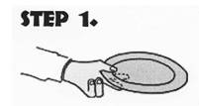 | Hold the first plate between your thumb, index finger and the middle finger
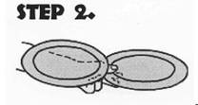 | Place the second plate above the first plate, supporting it by your fourth finger, your little finger and the base of your thumb and forearm. A third plate can be carried in the right hand

5.3 Check guest satisfaction as part of service delivery

Introduction
All service staff must monitor patrons during service for signs of dissatisfaction. This means keeping alert for non-verbal cues that indicate displeasure, and listening for negative comments that can be overheard.
Checking customer satisfaction must apply to both food and beverages.
The 3-minute check
When a meal has been served to the customer, it is important for service staff to revisit the table a few minutes later to check that the meals are to the customer’s satisfaction.
This is commonly known as the ‘three-minute check’.
It involves approaching the table approximately 3 minutes after the last meal was placed on the table and making an enquiry along the lines of “Is everything to your satisfaction?” or “How are your meals?” Individual venues may have standard statements for you to use when making this 3-minute check so check with your supervisor and adhere to specific enterprise requirements.
It is assumed that after three minutes, a customer will know if they are satisfied with their food.
Providing additional items
The service of additional items should be in accord with normal service practices. There should not be a lesser standard of service simply because the items are ‘additional’.
Items may include the service of condiments and side dishes such as:
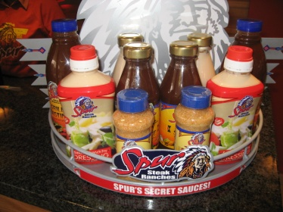
- Tomato sauce
- Tabasco sauce
- Fish sauce
- Soya sauce
- Chilli
- Mustards
- Tartare sauce
- More butter
- More bread or rolls
- Side salad
- Bowl of fries
- Onion rings
- Rice.

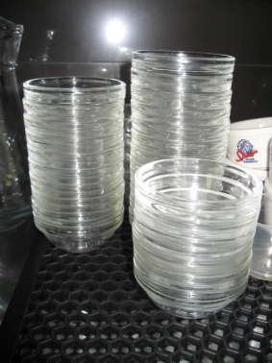
Some additional equipment items that may need to be provided can include:
- Extra cutlery – to replace items that guests may have dropped on the floor
- Extra crockery
- Extra glassware
- More serviettes
- A finger bowl
- A scrap bowl – depending on the menu item being served.
Taking re-orders
Your three-minute check also presents guests with an opportunity to order or re-order.
This may not fit in with the plans or the timing you have predetermined for your station, but these orders must be taken, or dealt with, politely and promptly.
You may be the food waiter, but the three-minute check may well result in a drink order being given. It is totally unacceptable for you to say “I’m sorry; I’m the food waiter, not the drink waiter”.
You should take the order and pass it on to the appropriate person. If there is some confusion on your part about exactly what the order is, let them know this and they can follow it up.
Offering additional food and beverage
Throughout the meal the opportunity arises to offer additional food and beverages.
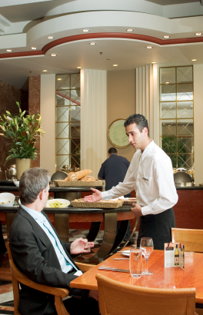
Selling additional items is what the employer expects you to do, and providing these items can also meet customer expectations in terms of service needs.
Offering and providing additional items that are not being sold is part of the service provision that creates customer satisfaction and meets expectations in terms of high levels of service delivery.
Additional items should be offered at appropriate times such as:
- The three-minute check
- When glasses are nearly empty
- When bottles are nearly empty
- When most bread or rolls on the table have all been consumed.
Compliments to the chef
It is commonplace for guests to respond positively to your enquiries about their meal at the 3-minute check and this is great.
Where you get such feedback, you should feed it back to the kitchen:
- “Table 7 say the roast is superb”
- “Everyone loves the lasagne”
- “Lady with the big party wants the recipe for the duck sauce!”

5.4 Take remedial action in the event of guest dissatisfaction

Introduction
Whilst most customers will be happy, naturally some customers will have a problem with their food or beverage item.
If they are dissatisfied, then they can tell waiting staff and a course of action can be set in place to rectify the problem.
Remember, if you are going to ask guests whether or not they are satisfied, you have to be prepared for those who tell you they aren’t!
Handling problems
Don’t treat these guests as ‘complainers’, but view the situation as an opportunity to turn a problem into a positive service experience. Listen to their complaint, apologise and act quickly to fix the problem.
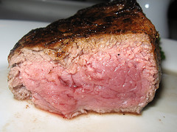
Problems may include:
- The steak is tough
- The meal is cold
- The steak is not cooked as ordered
- Special requests have not been met.
When you replace the ‘problem’ meal, apologise again and implement another three-minute check to ensure that the replacement meal is to the guest’s satisfaction.
Speed is very important, especially where the guest is part of a group, as we do not want one diner eating their meal long after their fellow guests have finished. This can be embarrassing for them, and is a very public indication that we have got something very wrong.
Offer alternatives
If a customer is not happy with their dish and it appears that any requested changes will take a long time, you may wish to provide the customer with a number of options so that they are not left with nothing to do, whilst everyone else is eating.
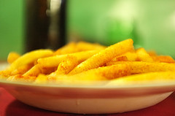
Possible options include:
- Replace meal quickly
- Allowing them to take some items from the buffet whilst they are waiting
- Providing a plate of snacks including rice, salad, bread or fries
- Suggesting fast cook items to that a dish will be ready when others are also eating.

5.5 Clear table at appropriate times throughout meal and on completion of meal

Introduction
Once meals have been completed it is now time to clear the table.

Used and unwanted items should be removed from tables throughout the meal.
It is never acceptable to allow used or unwanted items to build up on the table and clear the table only at the end of the meal.
Removing items progressively throughout the meal provides expected customer service, and maintains a clear ‘work surface’ to allow food and beverages to be more easily placed on the table.
When guests place their knife and fork together in the centre of the plate this is the usual sign that they have finished their meal.
Of course, not all customers will do this, so you must be aware of other signs. The most obvious being an empty plate.
Before clearing any plates away, ask the customer if they have finished to ensure the plate can actually be cleared away. A simple question such as “May I take your plate, madam?” or “Have you finished, sir?” is all that is required.
Traditionally, with tables of up to eight people, all guests should have finished their meal before the table is cleared. This is to avoid some guests feeling they have to rush to finish their meals just because others around them may have already finished.
With tables of eight people or more, plates are traditionally cleared randomly as the guests finish their meal.
Naturally all clearing of plates must be done in accordance with establishment standards and practices, with minimal disruption to customers. If you are unsure about what applies at your workplace, then ask your supervisor.
Steps to clearing a table
The following protocols commonly apply when clearing a table:
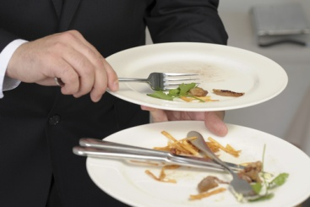
- Try to start with the guest who has the most scraps left on their plate. This will act as the base plate for clearing
- Always clear from the right of the guest – the same side that you should have served from
- Pick up the first plate, complete with cutlery, with your right hand and transfer and secure it in your left hand
- Secure the end of the fork handle under your thumb
- Slide the knife, cutting end first, under the fork to secure it and stop it from sliding away
- Moving clockwise around the table, clear the next guest’s plate. Make sure the left hand is held back to avoid being too close to the customer, especially their head and shoulders
- Secure the second plate into position over the wrist, and scrape any food scraps onto the base plate (plate positioning will be as previously described in the ‘two-plate serving method’)
- Secure the knife by sliding it under the securing fork
- Place the second fork parallel to the securing fork
- Continue this procedure until all the plates and cutlery are cleared for that particular course.
Tips when clearing a table
- Clearing must be done at the appropriate time (see above for guidelines) and with minimal disruption to the customers. Clearing should be ‘part of the process’ and not an interruption to it
- Clear away all unwanted or unused cutlery when removing matching course plates. If a guest has not used their main course knife for instance, it must be cleared when the main course plate is cleared
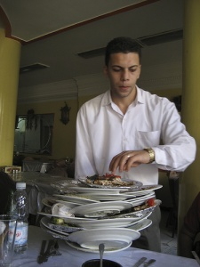
- Clear away the side plate and the side knife when clearing away the main meal plate. This is cleared from the guest’s left-hand side so as not to reach across in front of the guest
- Clear away anything that is unwanted or unused on the table at that stage
- Clear away any condiments associated with the course that is being cleared. The salt and pepper shakers, butter dish and bread basket should be cleared when the main course items are being cleared. You may however, elect to clear away breadboards or baskets as soon as bread has been consumed. Check house practice and adhere to that
- Clear away unused or dirty glassware as and when no longer required. Don’t let them build up
- Clear away all items in accordance with the establishment’s standards and policies. This may include directions regarding whether a tray should be used to carry these items to the waiter’s stations, or whether a clothed service plate is to be used, and whether or not items should be cleared to the waiter’s station or directly to the kitchen or bar.

Work Projects
It is a requirement of this Unit that you complete Work Projects as advised by your Trainer. You must submit documentation, suitable evidence or other relevant proof of completion of the project to your Trainer by the agreed date.
5.1 To fulfil the requirements of this Work Project you are asked to identify steps associated with serving bread rolls at table
5.2. To fulfil the requirements of this Work Project you are asked to identify the correct method to serve dishes as ordered by guests
5.3. To fulfil the requirements of this Work Project you are asked to identify ways to check guest satisfaction as part of service delivery
5.4. To fulfil the requirements of this Work Project you are asked to identify how to take remedial action in the event of guest dissatisfaction
5.5 To fulfil the requirements of this Work Project you are asked to identify the correct way to clear a table at appropriate times throughout meal and on completion of meal

Summary

Serve food
Serve bread rolls at table
Purpose of serving bread
Ways to serve bread
Alternatives to serving bread.
Serve dishes as ordered by guests
Collecting food
Delivering food items to the table
Serving food.
Check guest satisfaction as part of service delivery
The 3-minute check
Providing additional items
Taking re-orders
Offering additional food and beverage
Compliments to the chef.
Take remedial action in the event of guest dissatisfaction
Handling problems
Offer alternatives.
Clear table at appropriate times throughout meal and on completion of meal
Steps to clearing a table
Tips when clearing a table.

Element 6:
Serve drinks

6.1 Serve pre-dinner drinks to table

Introduction
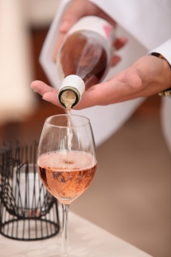
Traditionally a drink is the first thing to be served to the guests.
Your standard practice must be to get the first drink in front of the guests as soon as possible. This helps them settle in, and lets them know they are actually being served.
Do not simply give the order to the bar and then wander off to do something else for 10 minutes. By all means go and do something else, but only do something that will take 1 or 2 minutes at most.
Collecting beverages
When picking up the drinks to put on the tray to take to the table, make sure:
- They are what was ordered. Check correct wines (vintage, brand, grape varieties), no ice where requested, long glass where ordered etc.
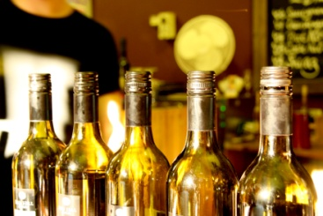
- Correct number have been supplied in terms of actual drinks, and empty glasses for wine
- They are suitably presented
- The correct glassware is used
- Garnishes are appropriate
- Glasses aren’t overflowing such that they will drip down the front of guests’ clothes when being consumed
- Where the drinks are not as required, you should politely point this out to the bar person who prepared the drinks and make sure the issues are rectified before taking the drinks to the table.
Loading a drinks tray
Regardless of whether you are left or right-handed, trays should be carried in the left hand, and the drinks served from it with the right hand.
Some premises allow left-handed people to reverse this but many do not because when left-handed people pour a bottle using their left-hand, the left-hand will cover the label of the bottle.
Trays should not be held by their rim and they should not be held with two hands. Your left hand should be held under the tray.
When loading the tray, secure the tray on your left hand. Your hand should be flat and your fingers should be spread out with only the tips of your fingers raised to support the base of the tray.
Other points include:
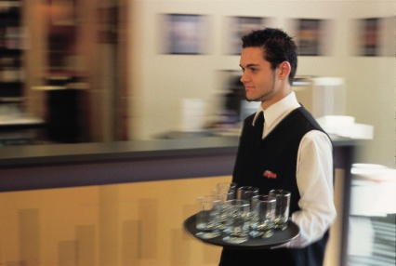
- Trays are carried on the palm of the left hand with the tips of the fingers slightly raised. Do not hold the tray by its edges
- Drink trays are usually held on the left hand so that the right hand is free to serve the drinks
- If the tray does not have a non-slip surface, then a tray liner or mat should be used to prevent glassware from slipping. The tray mat may be kept in place by smearing a few drops of water on the tray’s surface
- Service staff should handle glassware by the base or the stem. Never handle glasses by their rims and never put fingers in the glasses
- Trays are usually loaded with the heaviest glass in the centre, and the lighter glasses placed around the outside. In most cases, the last drink on the tray should be the first drink off
- Trays should be carried at waist level through the room walking with a straight back and shoulders. Don’t carry the tray above your head!
- Trays should be carried close to, and ‘within’, the body - to avoid knocking into someone or something.
Load the tray so that:
- The tallest glasses are nearest to your body
- The heaviest glasses are in the centre of the tray
- The smaller, lighter glasses are around the tray’s edge
- The placement of the drinks on the tray facilitates their service at the table. In practice some of the above rules may not apply because it would make it too hard for you to take the drinks off the tray.

Carrying the drinks tray
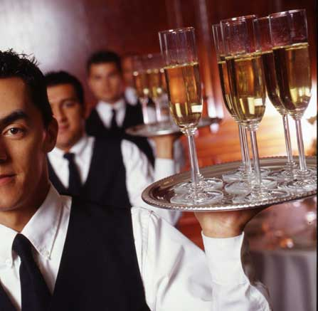
The right hand can assist in balancing the tray, especially when walking to the table, or when waiting for someone to move past you where there is the potential for them to knock either you or the tray.
Try to keep the tray at waist level and close to your body. This will help to avoid knocking into passing traffic and improves your control over tray.
Even though carrying the drinks tray high above the head with one hand looks quite spectacular, this method is not recommended as the risk of disaster is quite high.
When carrying a tray, always look where you are going, not at the tray.
Placing beverages on table
There are a number of points to note when serving drinks.
Always serve to the right of the seated customer, unless this is obviously impossible.
It may be impossible to serve from the guest’s right-hand side if two people are talking intimately head to head, or if there is something such as a pillar or plant in the way to the guest’s right.
- When unloading trays, you may have to slightly twist your body with the tray positioned slightly away from your side. This is to enable the right arm and hand to reach in towards the table and safely position the customer’s drink
- All drinks should be announced when being placed on the table. This provides an element of customer service as well as providing the guest with an opportunity to check that they are being served the drink they ordered. “Excuse me sir, your Whisky and Coke. Thank you.”
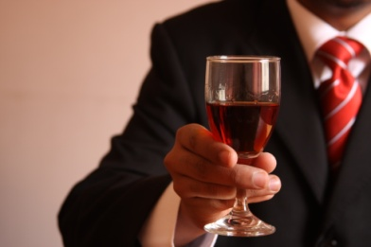
- Remember to bend your knees when serving from a tray
- Work anti-clockwise around the table, repeating the above procedures until the last drink is served
- Drink waiters should work anti-clockwise around the table, and food waiters should work in a clockwise direction. This means that they will only cross paths once at the table, saving service time and reducing the potential for accidents between staff
- Use coasters or napkins under drinks when and where required.

Checking satisfaction with beverages
Commonly there are fewer complaints about drinks than there are with meals.
Nonetheless, there can be occasions when drinks are less than acceptable so you need to be alert to the need to keep an eye on customers to identify when they have a problem with their drinks.
Common problems may relate to:
- The beer or white wine is warm
- The wrong mixed drink has been served – the ‘rum and coke’ is actually ‘brandy and coke’
- The wine tastes ‘off’.
In practice, the 3-minute check provides an opportunity for diners to complain about beverages as well as the food but the monitoring of drinks needs to be more frequent than just this one check.
Tips on checking customer satisfaction with drinks include:
- Monitoring the non-verbal language of drinkers. This involves being alert to facial expressions that indicate something is wrong and being tuned in to customers who beckon you to their table
- Making eye contact with people when at or passing their tables to encourage them to speak to you if there is a problem
- Making verbal statements. In some ways this is similar to the 3-minute check concept, about their beverages, such as “How’s the cocktail?”

6.2 Serve wines to table

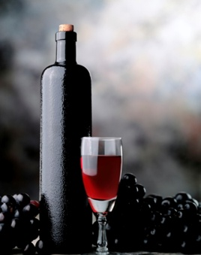
Introduction
Besides the service of pre-dinner drinks, common drinks often served to accompany a meal include sparkling and table wine.
This section will look at the steps associated with the service of wine at the table, so that it is done in a professional manner.
Check bottle condition

When selecting wine for service, it must be checked to ensure it is presentable and that it is at the correct temperature.
All bottles should be checked to ensure they are in good condition before being served to a guest.
This may include checking:
- Label – legible and intact
- Top near the cork/seal – intact and entire
- Bottle top - clean and not leaking
- Nothing floating in solution – as best as can be identified
- Overall condition of the glass – not cracked, not leaking.
Any bottles not reaching the establishment’s standard should be immediately removed from the service point and placed aside for the appropriate person to collect.
Checking the selection
With most bottled beverages, particularly wine, it is important to check the item with the customer before opening and serving the bottled product.
The following example is how to present a bottle of wine to a customer at their table.
- Present the wine to the person who ordered the bottle
- Announce the brand name, style and vintage
- Wait for the customer to confirm it is the right product.

Select appropriate glassware and equipment
Wines and glasses
Each establishment will have its own glasses selected from an enormous range of commercially available options.
Waiting staff must ensure that the correct glass is used for the correct wine, and that uniformity throughout the dining room is maintained.
In general terms, a larger glass is used for the service of red wines than for whites.
This is due to the fact that white wines need to be consumed chilled, and a smaller glass will help keep the wine colder than a bigger one would.

Also, the aromas of a red will be more easily appreciated by the extra volume that a larger glass gives.
Drink trays
These come in a variety of shapes and are usually made out of stainless steel.
Many trays have non-slip tray mats or non-slip surfaces.
Waiter’s friend
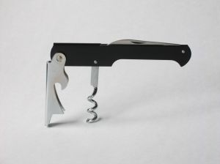
The main purpose of a waiter’s friend is to assist in opening wine bottles and extracting corks at the table.
The waiter’s friend has three parts. These are a:
- Blade
- Corkscrew (worm)
- Lever.
All bar staff and waiters should carry a waiter’s friend. It is really an industry pre-requisite.
Make sure you have one, check it to make sure the blade is sharp, the corkscrew (or ‘worm’) is sharp and not bent, that it opens easily, and operates safely.
There is no need for a waiter’s friend where all the wines are Stelvin seals.
Ice bucket
An ice bucket is used for chilling wine and may be presented in a tripod stand.
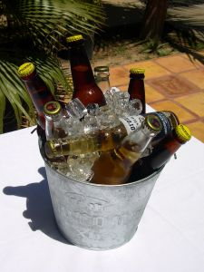
The stand may be located beside the guest’s table. However some venues prefer not to do this as is can get in the way when waiters try to serve or clear a table. In these cases the stand is kept at the waiter’s station, requiring the waiter to keep a keen eye on the glasses to make sure guests don’t run out!
Fill the bucket with about one-quarter of cold water, then add half to two-thirds full of ice. The combination of ice and water enables the bottle to settle fully among the ice. Trying to push a bottle into a bucket with ice only, can be difficult to impossible.
Ice buckets can also be table-top models made from transparent plastic. Ice is not required for this style of bucket but may be added if house practice demands.
Ice buckets should always be kept clean and well maintained.

Service cloth
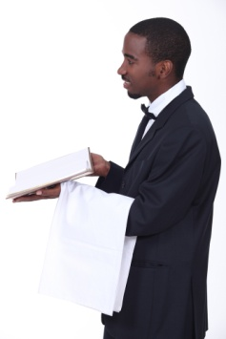
A service cloth (a folded linen serviette), also known as a waiter’s cloth, is used in the table service of wine.
They are used to present wine at the table. The cloth is folded behind the bottle to provide a background, while the wine is announced.

They are also folded lengthwise to a quarter their area and draped over the left arm and used to wipe drips from bottle necks, and to wipe moisture off white wine bottles, as necessary.
Additionally, some establishments fold a napkin around the neck of wine bottles as a decoration and to catch any drips of wine which may run down the neck of the bottle.

Some establishments only use this fold for red wines, inserting the cork from the wine into the folded napkin as a method of presenting the wine and the cork.
Carafes
These are used for the service of house wines to table, and for the service of decanted wines.
They come in a variety of sizes such as 500 mls, 1 litre and 2 litres.
Decanting equipment
Where there is a need to decant wine for genuine service reasons such as to remove sediment or simply to enhance presentation, the venue may use specialist decanting equipment.
This can include a candle, a carafe and a basket or container to contain the wine bottle
Wine baskets

Wine baskets are usually cane baskets used to present wine, and in some cases, to assist in service of the wine at the table.

Presenting wine
Bottles of wine are traditionally presented to customers prior to service.
Where this part of the traditional wine service process, known as ‘the ritual of wine service’, is required by your employer it should be adhered to for both red and white wines.
Why present the bottle?
Presenting wine is done for three reasons:
- It provides an opportunity for the guest to check the wine they have ordered to ensure it is the one they really want. Sometimes guests will see the bottle or wine label and realise they have made a mistake with their selection
- It allows the guest to check that the waiter has brought the bottle that was ordered. This helps avoids situations where the waiter may have misheard the order
- It is part of the service ritual for wine that many guests expect.

Presenting wine
When the bar attendant has given you the bottle of wine that has been ordered, check it to see that it is in fact what has been ordered and then take it to the table.
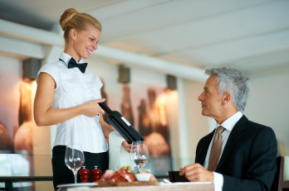
You should, depending on house policy, place a waiter’s cloth, folded and draped over the left forearm and carry the bottle in the right hand.
The wine may be wrapped in a service cloth that acts as a background to it, or it may be carried in a wine basket.
On reaching the guests’ table the procedure is to:
- Excuse yourself
- Present the unopened bottle of wine, label first, to the person who ordered it. Note that this may not necessarily be the host for the party
- ‘Announce’ the wine by describing it as follows “Madam, your 1997 Wolf Blass Grey Label Cabernet Sauvignon, Shiraz”.
When the guest agrees that it is the bottle that has been ordered, it is then opened.
You never present a wine that has already been opened.
If a guest wants you to open a bottle of wine prior to their meal to allow it to breathe, the bottle is presented before it is opened and not before it is poured.
Open and serve wine
Open and serve beverages correctly, safely and without spillage
Opening of bottles presents a slight danger of cutting yourself so all bottles must be opened carefully and safely.
All beverages must be served at the table without spillage because spills:
- Waste the customer’s valuable drink
- Create a mess on the guest’s table that is visually displeasing.
Opening wine – bottles with corks
In some establishments, after the bottle has been approved by the customer, the cork is drawn at the table.
In other venues the waiter withdraws to the waiter’s station and removes the cork there in full view of the table that ordered it.
Yet again, some premises return the bottle to the bar and the bar attendant opens it.
A waiter’s friend should be used to open wines at the table.
Wines should be opened quietly, and no noise should be audible when the cork is withdrawn.
The corks of red wines can be presented on a dollied saucer to the person who ordered the wine, to allow them to inspect it for signs of soundness or problems. This is part of the ritual of wine service.
Corks for white wines are not traditionally presented after having been drawn.
Any wine that smells obviously ‘off’ must not be served but discarded and another bottle obtained.
Opening sparkling wine
The ‘ritual’ for opening champagne or sparkling wines is:
- Present the bottle to the host using a service cloth
- Announce the wine by brand, style and vintage to the host to confirm the correct selection of the bottle
- Remove the foil around the cork of the bottle. Place the foil into your pocket
- Untwist the wire cage around the cork and remove it. Place the wire cage into your pocket. From this point on keep your thumb on the cork, just in case it pops out unexpectedly
- Hold the bottle firmly
- Twist the bottle to loosen the cork, keeping the pressure on the cork to ensure it does not pop. Do not twist the cork, twist the bottle
- Allow the cork to come out slowly without a large pop sound. You may need to use your thumb to work the cork out of a stubborn bottle
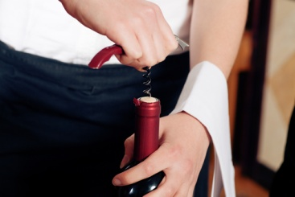
- Hold the now open bottle at an angle of 45º to help reduce the likelihood of wine escaping or foaming from the bottle. Holding the bottle at a 45º angle creates a much larger wine surface area at the top of the bottle providing more space for gas and wine to escape.
Steps to removing a cork
After presenting the bottle:
- Cut the seal with the knife on the waiter’s friend. Take care not to cut yourself
- Maintain a firm grip on the bottle while cutting the seal to make sure you don’t drop the bottle
- Once the top of the seal is cut off, place the loose piece into your pocket
- Place the very tip of the waiter’s friend into the centre of the cork then apply pressure onto the handle and twist the corkscrew in parallel to the glass neck of the bottle
- Twist the corkscrew until only two twists on the corkscrew are left visible. If you twist the worm too far, the point of the corkscrew will push through the cork and send little pieces of cork into the wine
- Secure the lever to the lip of the bottle. Support the lever firmly using pressure from your wrist with your index finger or thumb
- Pull the body of the waiter’s friend towards you, ensuring your thumb continues to apply pressure to the hooked lever against the bottle.
- Keep pulling until the cork is 3/4 way out of the bottle
- Using your index finger and thumb, twist the cork out of the bottle. Make sure you do not ‘pop’ the cork but remove it gently
- Remove the cork from the corkscrew
- Red wine corks may be presented to the guest. White wine corks may be put in the pocket of your trousers or jacket
- The waiter’s friend can be likewise placed in the pocket of your trousers or jacket or left at the waiter’s station or bar.

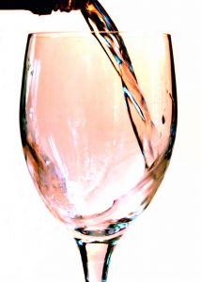
Pouring wine
Pouring table wine
There are a number of points to remember when pouring wine:
- Always pour about 60mls into the glass of the guest who ordered the wine for them to taste it. Once the guest gives their approval, move on to the next person’s glass, which would be to the orderer’s right-hand side. This enables the wine waiter to work anti-clockwise around the table
- Remember that the person who ordered the wine gets the first taste but their glass is not filled until all the other guests at the table have had their glasses filled
- Pour the wine slowly so there is no ‘glug-glug’ sound as the wine and air meet in the bottle’s neck. Hold the bottle so that the label of the bottle is visible to the person whose glass is being filled. This allows them to read the bottle while their glass is being filled
- Fill white wine glasses 2/3 full
- Fill red wine glasses to the halfway mark. Extra room is left in red wine glasses to allow the development of the bouquet from the red wine
- Always serve customers from the right
- Never let the bottle touch the rim of the glass while pouring
- Lift and twist the bottle on completion of the pour to eliminate drips from the bottle. A waiter’s cloth should also be held in the left hand to wipe the neck of the bottle between servings
- White wine should rest in an iced ice bucket in a stand on the floor, or in a cooler on the table
- Red wine should remain on the table. A napkin may be wrapped around the neck for presentation purposes. The bottle can be left standing on the table or resting in a wine basket
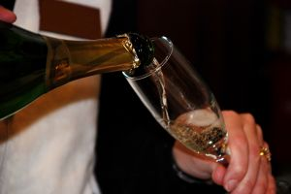
- Some establishments have a ‘high tide’ line on their glasses, and others have a policy of 100 – 120 mls only.
Pouring sparkling wine
After the sparkling wine has been opened, the following tips apply to pouring it at the table:
- Always pour about 60mls into the flute of the guest who ordered the wine for them to taste it
- Once the guest gives their approval, move straight onto the next person’s glass, which would be to the orderer’s right. Remember that the person who ordered the wine gets the first taste, but their glass is not filled to the required level until all the other guests at the table have had their glasses filled.
- Pour the wine slowly to avoid foaming the wine in the glass. Hold the bottle so that the label of the bottle is visible to the person whose glass is being filled
- Fill champagne flute to the 2/3 level
- Always serve customers from their right-hand side
- Never let the bottle hit the glass
- Sparkling wine should rest in an iced ice bucket or a cooler.

6.3 Serve after-meal drinks to table

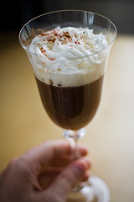
Introduction
There are a number of wines that are traditionally served after the main courses, either as a standalone item or to accompany desserts.
This section will explore a range of traditional drinks that are served near the conclusion of the dining experience.
Speciality coffees
As a specialty, various spirits and liqueurs can be combined with hot coffee and fresh double cream to make a dessert in its own right, to accompany a dessert or to conclude a meal.
Specialty coffees can be prepared in front of the customer so that they can appreciate the skills in the process. Techniques such as this are a great aid to sales promotion. Common specialty coffees include:
Common liqueur/coffee recipes
Common spirit/liqueur coffees are:
- Jamaican – Tia Maria
- Calypso – Tia Maria
- Seville – Cointreau
- Italian – Ameretto
- Mexican – Kahlua: note that some establishments use Tequila instead
- Roman – Galliano
- Café Royale – Brandy
- Café Monte Carlo – Brandy
- French – Brandy
- Normandy – Calvados
- Caribbean - Rum
- Café de menthe – Crème de menthe
- Highlander coffee – Scotch whisky
- Gaelic – Scotch whisky
- Irish coffee –Irish whiskey.
Simply put, most specialty coffees are prepared by adding hot black coffee to the alcoholic base with fresh double cream floated on top of the drink.
It may also be served with an accompanying item such as a biscuit.

Preparing liqueur coffees
The main difference between liqueur coffees and spirit coffees, is that liqueur coffees don’t have added sugar (the liqueur itself is sweet enough), but spirit coffees have sugar added.
Method for preparation is:
- Ready the glass or mug that the coffee will be served in
- Prepare good-quality, strong, black coffee
- Put 30 ml of the required spirit or liqueur into the glass/mug
- Add sugar if required – sugar is optional
- Pour in coffee – stir to disperse liquor and/or melt sugar
- Float fresh cream on top. Shaking the cream in a cocktail shaker and then pouring it into the face of a spoon which is held on top of the coffee will stop the cream sinking to the bottom of the mug and then rising back to the surface
- Serve immediately to establishment standard perhaps on a dollied saucer with teaspoon, after-dinner mint, and serviette.
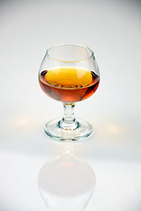
Spirits and liqueurs
In some cases customers may wish to have a spirit or liqueur at the end of a meal or to accompany a dessert. These normally consist of:
- Cognac
- Armagnac
- Calvados
- Liqueurs
- Port.
Ports
Ports are an after-dinner drink: serve size is 60 mls.
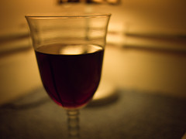
Different types of port include:
- White port
- Ruby port
- Tawny port
- Vintage port
- Liqueur port.

Muscat
Muscat is an after-dinner drink: serve size = 60 mls.
The name can refer to either grapes, or to the wine they make.
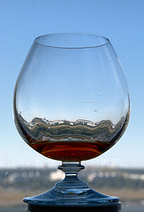
Tokay
Tokay is an after-dinner drink: serve size = 60 mls.
Cognac
The most famous brandy is Cognac made in the Cognac region of France.
When drinking cognac, a nip is poured into a balloon glass of moderate size. The hand is cupped around the balloon and the cognac gently swirled, warming it and releasing its bouquet.
Use drink trolley to promote after-dinner drinks
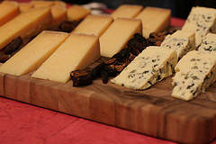
Many food and beverage outlets use trolleys to promote menu items. Promotion may take place as meals are being prepared and cooked via gueridon trolleys, or in its final state through display trolleys.
When using trolleys it is essential they look appealing so as to have the greatest possible impact.
Display trolleys should be placed in a location which will catch the eye of the customer and hopefully tempt them to make a purchase.
In many cases desserts may be showcased by themselves or with desserts and cheeses to accompany them.
Timing of trolleys
Timing of trolley displays is also critical.
Normally the trolley on display, whether in a highly visual location or moved between tables in a portable format, should reflect the course being served in the establishment.
For example after dinner drinks should be served at the same time as desserts or as they are being cleared.
This enables the customer time to think about a possible purchase.

6.4 Coordinate timing of beverage service to match courses/menu items being served

Introduction
The timing of beverage service in many cases may not be dependent on delivery times of food items. In fact most beverages are served before meals are placed on the table or at times where refills are required.
Quite often more drinks are delivered and ordered than food for most customers.
The timing of beverage service is still vital though.
Timing of beverage service
The required timeframes for the service of most beverages is ‘as soon as possible’, which can be translated into ‘immediately’ in most cases.
Serving drinks ‘immediately’ achieves the following quality factors:
- Maintenance of the service of beverages as they are intended to be. Customers get cold drinks that are cold and hot drinks that are hot
- Delivery of high levels of customer service. Where the drinks are part of a takeaway service, a prime requirement for these takeaway customers is speed of service as well as taste, value for money etc.
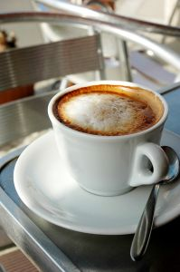
In limited circumstances, there may be a need to synchronise the service of drinks with other items, such as the service of non-alcoholic drinks prepared by waiters with alcoholic drinks and the service of food. That said however, most customers are content with receiving their beverages at a separate time from other drinks or their food. The guiding requirement should be the answer to the question ‘What is best for the customer?’
Some questions which you can ask yourself include:
- Are they seeking a drink straightaway to quench their thirst?
- Has the drink been ordered to accompany a pastry?
- Are they drinking with other people and looking for their drink to be part of that social interaction?

Synchronised food and beverage service situations
There are a number of times where the timing of food and beverages is quite important.
These include, but are not limited to:
- In bar situations where snacks are provided with drinks, such as nuts, chips etc.
- Initial service of drinks should come quickly
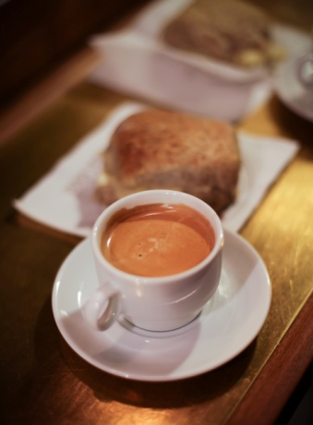
- Refills of drinks to coincide with next food courses
- Coffees and cakes are often served together
- Where beverages compliment the meal, such as:
- Wines to accompany courses - Where a pre-dinner drink has been ordered to precede a bottle of wine to accompany the entrée or the main course, the wine must be served prior to the service of the food whether or not the pre-dinner drinks are finished
- Dessert wines or coffee that is served with dessert
- Ports and cheese
- Champagne and birthday cakes or other celebrations.
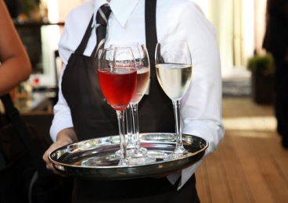
Co-ordination with other staff
Regardless of the reason for synchronised food and beverage service, co-ordination with food service staff, the kitchen or bar staff is a must. Communication is the key.
In most situations it is up to the food and beverage server to keep up to date on timing as they are the only people who have a clear view of the table and their timing needs.
Any advanced warning that may be given will certainly help to ensure any food and beverage items that are to be served together are done so in a timely and appropriate manner.

6.5 Clear glasses and beverage items

Introduction
Similar to the service of beverages, the timely clearance of both used and unused glasses is important.
When a glass is empty on a table it should either be refilled or removed.
In theory and practice, there should never be an empty glass on a table in front of a guest.
No customer likes to have dirty or unused glasses on the table if they can help it. Not only does it look unpleasant, especially when used glasses remain on the table, but it takes up space, which is already limited.
Removing unused glassware
Where the cover has included glassware, these glasses must be cleared when guests indicate they will not be using those glasses.
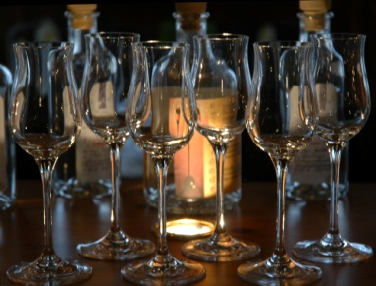
For example, if a red and white wine glass were set on the cover and the guests ordered only white wine, the red wine glasses must be removed.
Where guests order a drink that is not catered for by the glasses that have been set, the glasses that have been set must be removed and exchanged for the correct glasses.
For example, if glasses for still table wines were set and the guests ordered champagne the wine glasses would have to be swapped for champagne flutes.
Removing used glassware
Where there is wine or beer still in the bottle, this should be offered before glasses are cleared.
Where a guest refuses the offer of the drink that is left in the bottle, staff should ask if the customer would like the bottle and their glasses taken.
If you are unsure whether or not a guest has finished with their glass, whether or not it is empty or still has some drink still in it, then politely ask the guest whether or not they have finished.
Where a table orders a second bottle of wine of the same brand, type, style and year, fresh glasses should be offered, although this offer may well be refused, or guests may wonder why it is being done.
Where a table orders another bottle of wine different to what they have previously been served, fresh glassware must be set before the wine is presented, even though this may add to the glassware already on the table.

All glassware taken from the table, used or unused, must be transported on a drinks tray. Glasses must be held by their stem or base. Never put fingers inside glasses, whether it is used or unused.
Timing of clearing
Constant observation of guests’ tables will indicate when clearing of glasses and bottles is required.
Drink waiting staff should remember that their job does not finish after the initial service and pouring of a bottle. Attention should be paid to topping up glasses as required, and clearing empty bottles and glasses.
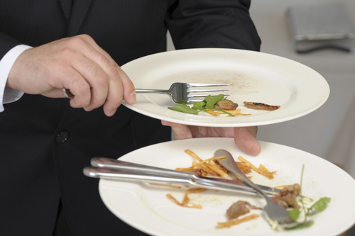
When a bottle is emptied it should be removed, and the guests offered the drink list to encourage a further sale. Staff must guard against being ‘pushy’, but must also try to provide service and maximise sales.
When removing glasses, the same rules apply as for placing them on the table. Re-balance the tray, do not hold the glass by the rim, or place fingers inside the glass.
Work Projects
It is a requirement of this Unit that you complete Work Projects as advised by your Trainer. You must submit documentation, suitable evidence or other relevant proof of completion of the project to your Trainer by the agreed date.
6.1 To fulfil the requirements of this Work Project you are asked to identify different types of pre-dinner drinks and how they can be served
6.2. To fulfil the requirements of this Work Project you are asked to explain how to serve wines to table
6.3. To fulfil the requirements of this Work Project you are asked to identify different types of after-meal drinks and how they can be served
6.4. To fulfil the requirements of this Work Project you are asked to identify examples of when coordinated timing of beverage service to match courses/menu is required
6.5 To fulfil the requirements of this Work Project you are asked to explain when is the best time to clear glasses and beverage items

Summary

Serve drinks
Serve pre-dinner drinks to table
Collecting beverages
Loading a drinks tray
Carrying the drinks tray
Placing beverages on table
Checking satisfaction with beverages.
Serve wines to table
Check bottle condition
Checking the selection
Select appropriate glassware and equipment
Presenting wine
Open and serve wine
Pouring wine.
Serve after-meal drinks to table
Speciality coffees
Spirits and liqueurs
Use drink trolley to promote after-dinner drinks.
Coordinate timing of beverage service to match courses/menu items being served
Timing of beverage service
Synchronised food and beverage service situations
Co-ordination with other staff.
Clear glasses and beverage items
Removing unused glassware
Removing used glassware
Timing of clearing.

Element 7:
Present account to guest

7.1 Compile guest account ready for presentation

Introduction
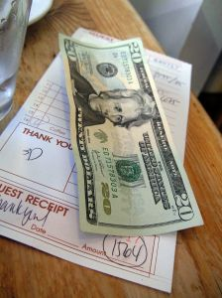
Food and beverage attendants may be required to establish and manage accounts for meals and drinks purchased by customers.
At all times the house rules and standard procedures for processing these transactions must be strictly adhered to. These will vary between properties so it is vital to determine what applies where you work.
It is also important to remember to optimise customer service at this point so the guest enjoys a positive experience when they are paying for what they have bought.

Prepare customer accounts
General procedures for processing accounts
Processing a customer account refers to:
- Creating an account for the customer or table
- Updating the account as items are ordered or purchased
- Finalising the account by accepting payment.
The following procedures must be adhered to:
- When using an electronic system to process an account always make sure you follow manufacturer’s instructions. Obtain in-house training before using the system
- Review supporting dockets received to verify table/customer, make sure the dockets are legible and can be understood/interpreted, and ensure only the items ordered are charged for
- Post charges (see below) promptly to ensure the account is ready when needed and to make sure money for all items bought by the customer is recovered when the account is paid
- Update the account balance or verify the updated account balance where this occurs automatically making sure all entries are accurate and all charges have been correctly entered and processed
- Produce the final account or bill when requested by waiting staff or customer. It is important to continually update accounts during service so there is minimum waiting time at this stage.

Posting charges
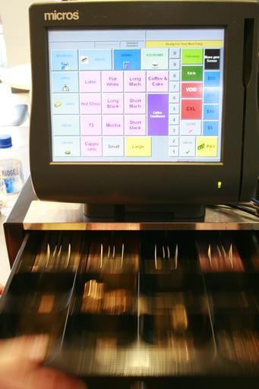
Posting charges is the process of recording transactions on a customer account. It is a term normally used where an electronic system is in use.
A ‘posting’ can be one of two types:
- A ‘debit posting’. This increases the customer’s debt/ or liability to the property. It occurs when the customer has used a facility or purchased a product or service and the charges for that are added (or ‘debited’) to the customer’s account
- A ‘credit posting’. This reduces the guest’s debt or liability to the property. It occurs when a customer pays their account, partially settles their account, is given a refund or discount, or provides a deposit (such as a deposit for a booking or function). The money paid by the guest reduces their total owing and is said to have been ‘credited’ to their account.
When posting to an account (debit or credit postings) ensure:
- Speed and accuracy
- Double-check the correct account (guest, room, table, function etc.) has been updated.
By ensuring the correct charges are placed on the guest account, it makes for a smooth ending to the customer experience.

7.2 Present account to guest

Introduction

Once the account has been prepared it is now time to give it to the customer.
Depending on the type of food and beverage establishment, the process will vary. Regardless, it is important that organisational policies and procedures are followed when presenting and handling accounts.

Produce customer account and present for payment
Cash registers
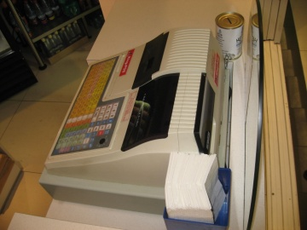
- Once the charges have been processed it should be given to the customer in a timely manner
- In take away outlets, the charges are processed in a cash register with payment requested immediately before any food or beverage is provided
- Please ensure the customer can see the register display to see charges are correctly added and the amount due displayed. In most organisations the issuing of a receipt is a standard practice and enables customers to quickly see if an account in accurate.
Account folders
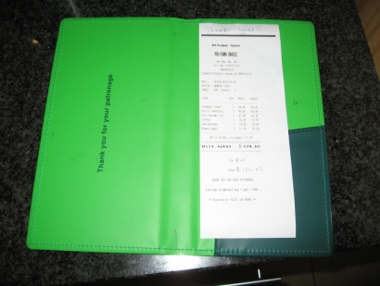
In restaurants, it is standard practice for the account to be presented to the customer at their table. In this instance accounts must be presented in an account folder and presented with a pen.
If you are not the person who has prepared the account, it is wise to review it to ensure that it is correct from your understanding.
When the account folder is presented to the customer move away from the table. However it is advisable to remain in close proximity to answer any questions or to speed up the payment process, as many customers like to leave quickly.

7.3 Accept payment for account

Introduction
Once the customer has indicated that the account is ready for processing, it is essential this is done in a timely manner.
No customer wants to wait around for a long period of time not only trying to get the account, but also trying to settle it.
Whilst this is a small step in the whole service cycle it is incredibly important for the organisation as it is the main reason for providing food and beverage service in the first place.
There is no doubt that the settlement of accounts is a priority for the organisation.
Keep a watchful eye

Food and beverage service staff must keep a watchful eye over tables with accounts at this time for a number of reasons:
- Customers may wish to query the account. You must be close by to help clarify the account and any questions they may have
- Some customers may simply pay cash and leave. It is essential that the money is collected to reduce the chance of theft and to ensure that the correct amount has been settled
- Customers may want to sign to their room. When a customer signs an account with their name, room number and signature provided, this information must be protected. In the wrong hands, this information can be used for others to charge items to the room without the guest’s permission
- Customers seeking to pay by card will need staff to bring portable credit or debit card machines.
Use cash registers correctly
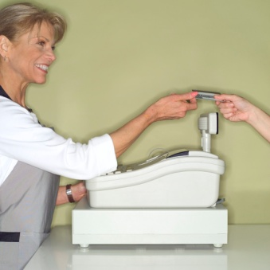
Whilst the process of using cash registers may seem like a simple process, not needing further explanation, it is important that any money or documents taken be properly secured.
During a service period you will receive large amounts of money and credit card slips through the processing of large amounts of transactions.
Theft of money and personal information from credit card slips is common throughout the world, and this is no less true in food and beverage outlets.
In your role there may be many tasks that you will perform, with processing accounts and handling money only one aspect of your day. However it is vital that security is foremost in your mind.

Secure money and documentation during trade
The following are helpful tips to employ to increase the security of cash and non-cash payments:
- Try not to share cash registers
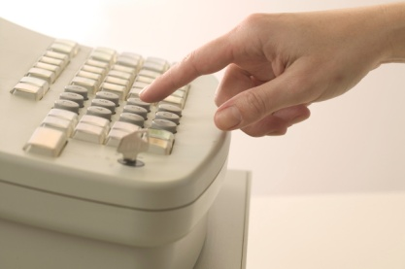
- Never leave a cash register open when unattended
- Keep cash registers out of the reach of customers
- Lock cash registers when not in use
- Keep the original note on display whilst a transaction is taking place. This reduces any discrepancies that may arise as to what monetary value the customer has given the staff member at the start of the transaction
- Regularly store large notes under the cash till, out of display of customers
- Regularly arrange for cash registers to be cleared.

7.4 Process payment of account

Introduction
There are a number of ways in which a customer account may be settled. This section will explore these different ways.
Regardless of the method used, it must be done accurately to ensure that the correct charges are posted and that the correct payments are made.
This ensures that both the organisation and the customer are both happy.
Account settlement options
Depending on the services and facilities provided by your organisation customers commonly settle their account by:
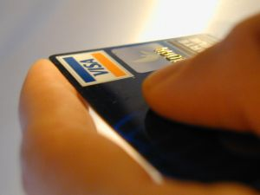
- Paying cash
- Paying via credit card through using a manual or electronic system
- Using EFTPOS facilities – ‘Electronic Funds Transfer at Point Of Sale’.
In selected situations customers may settle their accounts by:
- Charging to their room
- Charging a house account – used for functions or corporate events
- Presenting vouchers – for nominated amounts and/or items/services
- Paying by check – either a personal check or traveller’s check.
Regardless of which option a customer uses to settle their account:
- Always thank them for their patronage
- Never show annoyance if their preferred method of settlement causes additional work or effort.

Accepting cash payment
When the customer offers cash to settle an account the following will apply:
- Verify the amount tendered will cover the total of the account

- Thank customer
- Place cash on register shelf. Do not put money into cash register drawer at this point
- Register the sale (account total). This should automatically produce a receipt
- Calculate change and remove change and receipt from register
- Give change and receipt to customer. Count the change out to the customer
- When customer has accepted their change without query, remove tendered cash from register shelf and place into register drawer.
Using Debit Cards (EFTPOS)
Many outlets have EFTPOS (Electronic Funds Transfer at Point Of Sale) terminals to accept payments (this is the same system that is used to electronically process credit card payments).
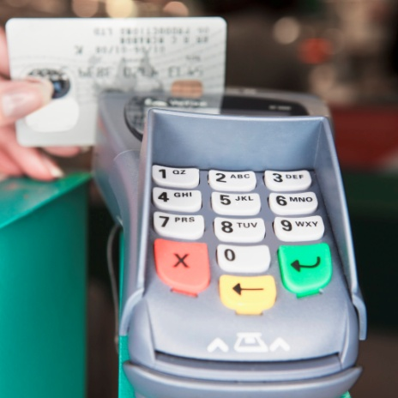
The Debit Card or EFTPOS system offers a banking service of deducting money from a customer’s savings or check account and depositing it into the establishment’s account.
When using this system to pay their account, the customer must present a relevant bank card and then enter a 4 to 6-digit PIN (Personal Identification Number) into the system for verification purposes.
Once the payment has been approved, the customer will be issued with a receipt.
With this system, the customer may have the option of having ‘Debit Card Cash Back” or ‘Cash Out’. This means the customer can withdraw additional funds from their account over and above the amount required to settle the restaurant/bar account.
Before using a Debit Card or EFTPOS terminal, make sure you read the instructions for the equipment and system. Familiarise yourself with its operation, and get someone to show you how to use it.

Process non-cash transactions
Paying via credit card
Credit card payments are processed using either a manual system or an imprint machine.
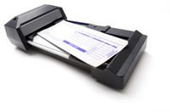
Manual system
Whilst this system is not a common procedure, it is still important to know, especially in areas where electrical problems are a regular occurrence.
The process to take manual credit card payments is as follows:
- Confirm your establishment accepts the card
- Check card’s expiry date is still valid
- Check card against ‘Warning Bulletins’ issued by credit card companies to alert establishments of stolen or cancelled cards
- Insert the credit card into the imprint machine
- Insert the appropriate credit card slip into the imprint machine covering the card
- Take an imprint of the card
- Confirm details are legible on the credit card slip
- Complete credit card slip with relevant details and charges, date etc.
- If the account’s total amount is over the establishment’s ‘floor limit’, call the credit card company to receive an authorization number, which must be written on the slip
- Present completed credit card slip to the customer for their signature
- Compare signature on slip to that on card
- Present customer with their receipt (middle section of credit card slip)
- Place remaining copies of slip into the cash drawer.
Electronic system
The process to use the Debit Card or EFTPOS system to process credit card payments is as follows:

- The customer’s card is swiped at the terminal
- The account balance is then entered into the keypad. You should refer to individual operator instructional manual for more details on this step
- The system then processes the card payment
- Once payment has been ‘approved’, the guest either signs for the transaction or enters their PIN (Personal Identification Number)
- When signatures or PIN have been verified, the guest is issued with their receipt and a copy of the slip or print-out is placed into the cash drawer of the register.

Process non common transactions
Paying by voucher
Some properties accept vouchers in full or part-payment for food and beverage items or services purchased by the customer.
Vouchers are common in some food and beverage outlets that may be attached to hotels or other products and services where package deals that include meals and drinks have been negotiated.
The customer presents their vouchers to settle or partially settle their account.
When accepting payment by vouchers it is important you make sure the voucher is valid and is being used in accordance with any conditions that may apply. For example, ‘dinner only’, ‘food only’, ‘redeemable only in the dining room’.
Note:
- Customers do not receive cash as change if they do not use the full value of their voucher. The voucher is fully surrendered when tendered as payment
- Customers are required to pay for all items purchased above the value of their voucher
- Customers are required to pay for all items not covered by the voucher.
Paying by personal cheque
Every property will have their own policy about accepting personal cheques.
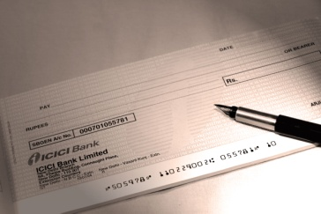
Generally, most properties will not accept personal or business cheques as payment unless prior arrangement has been made. This allows management to ensure the person or business has sufficient funds to cover the cheque, and enables them to decide if they will ‘take the risk’.
Accepting payment by cheque may expose the property to loss if the cheque is dishonoured by the bank.
Some establishments will accept payment by cheque from regular customers. Management will usually know where these people live or where they work to enable recovery of the debt if the cheque is dishonoured.
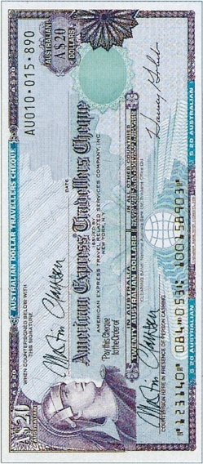
Paying by traveller’s cheque (or ‘check’)
Properties accepting traveller’s cheques usually advertise the fact that they do so. Properties are not legally obliged to accept payment via traveller’s cheque.
If your property does accept traveller’s cheque, it is critical the second signature is placed on the cheque while you watch. Compare this to the first signature that already exists on the cheque.
Any traveller’s cheque presented to you with two signatures already on it must be refused.


Foreign currency
Some properties are prepared to accept payment via foreign currency.
Agreement must occur regarding the conversion rate before this method of payment is accepted.
Generally the customer is required to convert the cash to local currency and settle their account as per cash settlement.

Process gratuities
Customers may leave a tip for service staff in appreciation of good service.
Tips are also known as ‘gratuities’.
Most properties have internal rules dictating how tips are dealt with. Two basic options exist:
- Individual staff keep all tips they receive – there is no sharing of tips with other staff
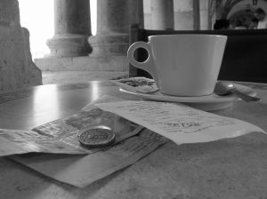
- All tips are pooled into a central pool of money and then shared amongst all staff according to a pre-determined percentage. In this option kitchen staff and beverage attendants may share in tips given to food and beverage attendants.

Issue change and receipts
When dealing with money it is extremely important to manage the process in a professional and ethical manner.
For some customers from foreign countries, they may not be familiar with the currency itself, service charges, taxes and tipping guidelines which may be straightforward for a local resident.
As an ethical staff member it is important to:
- To charge the correct amount for a sale
- To return change automatically. It is at the discretion of the customer if a gratuity is given.
- Provide a receipt and explanation of charges if required
- Remind customers to collect their change
- To accurately record all transactions and store money securely.

Work Projects
It is a requirement of this Unit that you complete Work Projects as advised by your Trainer. You must submit documentation, suitable evidence or other relevant proof of completion of the project to your Trainer by the agreed date.
7.1 To fulfil the requirements of this Work Project you are asked to identify how to compile a guest account ready for presentation
7.2. To fulfil the requirements of this Work Project you are asked to identify how to present the account to a guest
7.3. To fulfil the requirements of this Work Project you are asked to identify how to accept payment for the account
7.4. To fulfil the requirements of this Work Project you are asked to identify how to process payment of the account

Summary

Present account to guest
Compile guest account ready for presentation
Prepare customer accounts
Posting charges.
Present account to guest
Produce customer account and present for payment.
Accept payment for account
Keep a watchful eye
Use cash registers correctly
Secure money and documentation during trade.
Process payment of account
Account settlement options
Accepting cash payment
Process non-cash transactions
Process non common transactions
Process gratuities
Issue change and receipts.

Element 8:
Provide departure services

8.1 Assist guest in leaving table

Introduction
Once the customer has settled the account it is now time to ensure they leave the premises in a helpful manner.
Whilst this may seem like a simple process, there are a number of things to keep in mind.
Providing assistance to customer leaving table
When customers are leaving the table a couple of things to remember include:
- Pull back chairs for customers
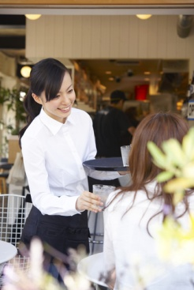
- Get wheelchairs or other aids as required
- Thank customer for their patronage
- Arrange any take-away containers
- Where permitted, place corks back in unfinished wine bottles for easier transportation for customer
- Arrange toothpicks
- Remind customers to collect any bags, clothes and other personal items left on table, seat of floor
- Arrange balloons or gift packs or other children’s gifts
- Help them with putting on coats and jackets
- Remind customer to collect change, credit card or receipt
- Escort the customers to the door
- Once the customer is at the door, there are a number of ‘end of service’ assistance activities that can be provided. These will be explained in the next section.

8.2 Provide end-of-service assistance, as required

Introduction
As mentioned in the previous section, once the customer is at the door, there are a number of ‘end of service’ assistance activities that can be provided.
It is essential that at this time, customers are provided with necessary assistance to ensure they can continue to their next destination in a smooth manner.
Types of end of service assistance
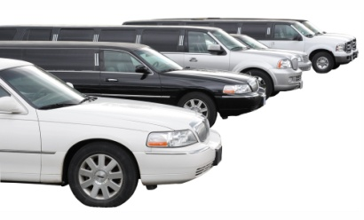
End of service assistance may include:
- Obtaining a taxi or other transport for guests
- Retrieving items that have been placed into safe keeping
- Offering umbrellas
- Accompanying guests to cars
- Making reservations on their behalf
- Directing them to their next destination including shops, cultural, tourism or sporting areas of interest
- Offering a seat, paper or complimentary coffee while the weather clears.
Each organisation will have special ‘touches’ to help ensure the end of the customer experience is a positive one.

8.3 Farewell guests

Introduction
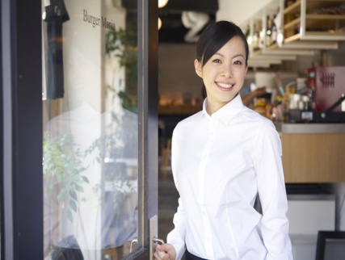
All food and beverage guests should be thanked and farewelled courteously.
This applies to regulars and visitors, big-spenders and the customer who just drinks a pot of beer or squash and eats an entrée.
We must give all drinkers and diners the respect they and their patronage deserve: without these customers you don’t have a job!
Thank and farewell customers courteously
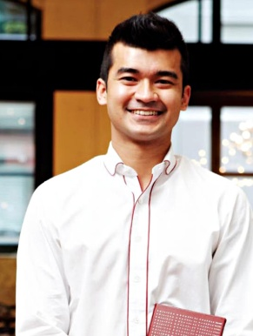
The farewelling of customers is an important part of the service cycle and one that is arguably more important than the greeting the customer receives because the farewell is often the last thing they have to remember us by.
You should also bear in mind that many customers who leave a hospitality venue, leave with nothing but have paid money for that privilege!
To illustrate this, it means that most people leave a property after having slept there, eaten there, drank there or after attending a function or entertainment event. This is totally different to most retail situations where customers leave having paid for an item they take with them and can use at home.
It is important to remember that the customers may have just spent a substantial amount of money, and then leave with nothing to show for it, except perhaps a full stomach. These facts underline the importance of a good farewell.
All guests should be farewelled in accordance with establishment standards and policies.
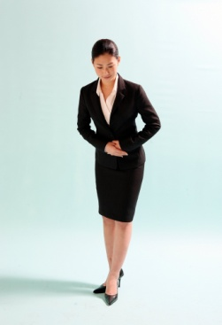
Some establishments may require their staff to walk the customers to the entrance and hold the door open, before thanking them and bidding them farewell.
Other establishments may require a more casual approach such as a smile, a wave and a simple “Thanks very much” to the guests as they are departing.
It may be standard practice to wish them “Good day” or “Good night” and “We look forward to seeing you again”, or some similar phrase.

Whatever the standard or policy, guests should be acknowledged when they leave. Their final experience with you must be a positive one.
Work Projects
It is a requirement of this Unit that you complete Work Projects as advised by your Trainer. You must submit documentation, suitable evidence or other relevant proof of completion of the project to your Trainer by the agreed date.
8.1 To fulfil the requirements of this Work Project you are asked to identify how to assist guest in leaving table
8.2 To fulfil the requirements of this Work Project you are asked to identify types of end of service assistance that can be provided to customers
8.3 To fulfil the requirements of this Work Project you are asked to identify activities associated with farewelling guests

Summary

Provide departure services
Assist guest in leaving table
Providing assistance to customer leaving table.
Provide end of service assistance, as required
Types of end of service assistance.
Farewell guests
Thank and farewell customers courteously.

Element 9:
Conduct shut down activities

9.1 Turn off electrical and service-related equipment, where appropriate

Introduction
At the end of service the room must be serviced to make it (partially) ready for the next shift.
The procedures can include:
- Clearing, cleaning, tidying, dismantling equipment, storing furniture and turning various items of equipment off
- Reading the registers/POS terminals and reconciling the takings as well as securing the takings and all relevant documentation
- Preparing the area for the next session by setting up for the next service which may including ordering stock and stowing stock away as required ready for the next session
- Holding a debriefing session to review and evaluate the service session that has just been finalised
- Handing over the room to the next shift.
Storing and preparing equipment
As previously mentioned, there are various pieces of equipment and different service items that must be prepared, cleaned, maintained and attended to before and during a shift.
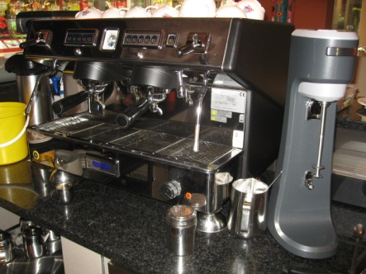
At the end of the shift, specific and regular tasks may be required. These pieces of equipment and items may need to be:
- Cleaned and left out ready for the next shift
- Cleaned and stored away ready for use some time in the future
- Turning off specified electrical items or adjusting them in line with house requirements.

Equipment and other items that may require such attention include:
Service areas
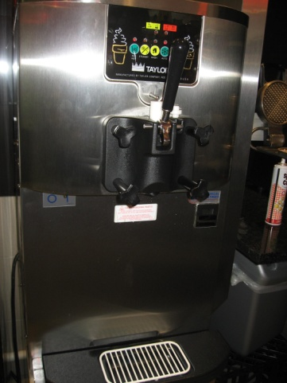
- Coffee machines
- Tea making facilities
- Bain-maries
- Toasters
- Menus and wine lists
- Condiments and sauces
- Cutlery
- Crockery
- Glassware
- Linen.
Kitchen and food display areas
- Kitchen stoves and ovens
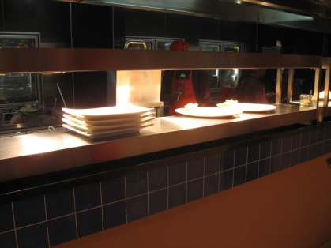
- Exhaust fans
- Blenders and food processors
- Dishwashing machine
- Heat lamps
- Hot plates
- Hot food storage displays
- Light displays
- Promotional displays.
Bars
- Promotional displays
- Cigarette machines
- Blenders and beverage processors
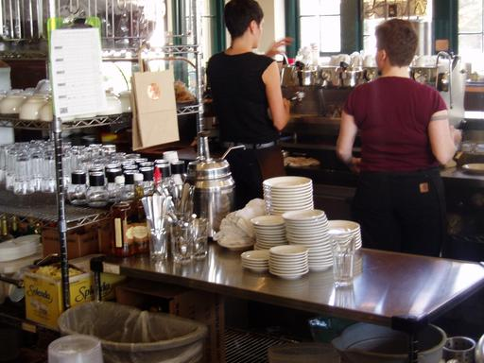
- Coffee machines
- Urns.
Front of house areas
- External lights not required
- Music
- Air conditioning
- Non-essential lighting including overhead lights, lamps
- Public rest room lights.

9.2 Remove used linen items for laundering

Introduction
Once all the tables have been cleared, it is now time to pay attention to handling linen items. Whilst many hotels will own their own linen, some may hire these items as part of standard procedure or to cater for a particular theme or specific event requirement.
Collect, sort and count linen
Regardless of whether linen is owned or hired by the hotel it must be:
- Collected. they are normally collected and placed in one location, central to all tables

- Sorted into different types of linen including:
- Napkins
- Table linen
- Service cloths
- Cleaning cloths
- Checked. As part of the sorting process any linen deemed to be damaged or requiring special cleaning will be identified
- Counted. Once items have been separated by category, they must be counted to ensure that they are all there. It is quite common for some linen to be thrown away or used by staff for general cleaning
- Separated. Linen that is owned by the hotel must be separated from that which has been hired for the occasion
- Forwarded to the appropriate location, whether an internal laundry or a secure waiting area for external companies to collect.

Linen is very expensive and therefore great effort needs to be taken to ensure that it is accounted for and handled in the correct manner.
9.3 Store, stock and replenish, where necessary, for next service session

Introduction
Once all equipment has been cleaned, it is now time to store and restock items.
Storing in accordance with instructions and regulations
All storage must occur in accordance with establishment standards which may include:
- Ensuring staff and equipment safety in accordance with identified risk management procedures and OSH responsibilities
- Ensuring all items are cleaned before storage. No item should be stored in an unclean condition. This can attract pests, delay the use of the item when it is needed and make it harder to clean at a later date
- Ensuring that food-related items are protected from contamination
- Making sure items are returned to their nominated locations so that other staff will know where they are when these items are needed
- Checking individual items as part of the storage process. Where you identify an item that is unsafe, not working properly or is damaged, you should notify your supervisor.
Replenishing items
Not only is it important to clean and store items, it is also essential that some items are replenished in their correct amounts and located in easy to reach areas. This includes:
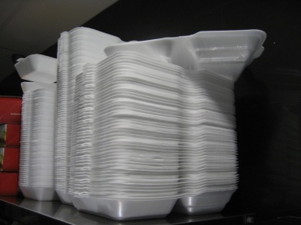
- Condiments and sauces
- Cutlery
- Crockery
- Glassware
- Linen
- Salt and pepper shakers
- Drinking straw containers
- Tooth pick containers
- Take away containers.

Reordering stock and supplies
One of the last tasks you will be required to do at the end of a shift is to check the supplies that exist in the food and beverage outlet.
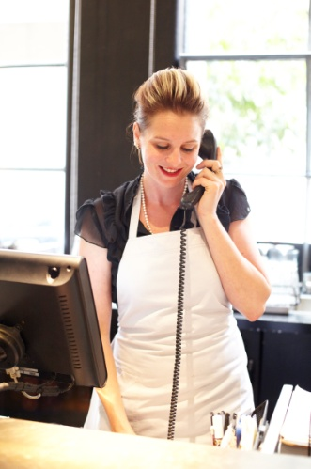
You may be required to order extra supplies, or replenish them.
Your experience coupled with any management guidelines relating to the levels of stock to be kept in a food and beverage outlet will assist in determining whether or not stock or supplies need to be ordered.
The aim of maintaining stock and supplies is that you never run out of anything but you don’t overstock.
Service cupboards and waiters stations can be stocked at the beginning or end of each shift, but it is preferable that they are fully re-stocked at the end of the day’s work, so they are prepared for the next shift, and so that missing items are able to be bought in before the next shift.
When supplies run low, further supplies can be requested from some form of central store. These however cannot get accessed on demand, but are typically ordered once a week or at selected times, unless in emergency situations.
When requesting supplies you may be required to complete a requisition form.
The requisition form is an internal stock ordering form that you fill in and give to the outlet supervisor or other nominated person.
It will identify:
- Person requesting the items
- Type of items needed
- Quantity
- Date.
The majority of food and beverage outlets will have a standard order or requisition form.
Requisition forms that are completed and forwarded to the supervisor at the end of shift today, should result in the supplies that have been ordered or ‘requisitioned’ being supplied to the outlet later that day or early the next day before the next shift starts work.

Items to reorder
In short, ‘everything’.
A food and beverage outlet often contains a multitude of items that are used by all food and beverage servers.
Common items that need to be ordered include, but are certainly not limited to:
- Food and beverage items
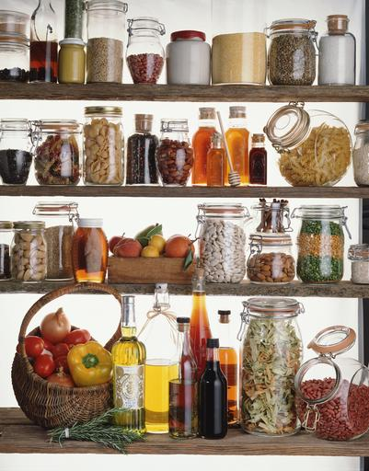
- Menus
- Condiments
- Ash trays and matches
- Pads and pens
- Glasses
- An assortment of cutlery and crockery
- Linen
- Toothpicks
- Cash register rolls
- Take away boxes or containers
- Waiters friends
- Disposable napkins
- Cleaning products.
Where you have run out of any of the above or you suspect stocks are below what can reasonably be needed, you should requisition or reorder them.

9.4 Dispose of waste

Introduction
As with all outlets, there will be a wide variety of items that must be discarded during and at the end of a shift.
Each organisation will have policies and procedures on how to handle common types of disposables.
Dispose of leftover food
Throughout the dining session and at the end of trade you may be required to dispose of leftover food used during service.
Correctly disposing of these items helps to maintain food safety and the operational effectiveness of the property
Whenever food handlers handle rubbish, it is a legal requirement that they wash their hands properly before handling food or food items or utensils again.
Hygiene regulations
In terms of the requirements of safe food handling no food or beverages that are returned from a guest can be re-used. They must all be thrown out.
Food that is left over in terms of portion controlled butters, sugar etc. can be re-used providing the package has not been damaged, it looks presentable and (for high risk food) has not been stored in the Temperature Danger Zone for longer than 4 hours.
Butters and dairy products must be stored under refrigeration at 5ºC or below.
Proprietary sauces in the bottle can also be re-used providing the bottle, neck and cap are cleaned.
Salt and pepper in shakers can also be re-used.
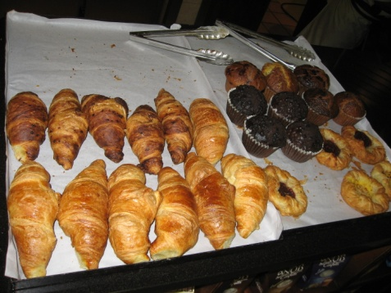
Leftover food
The kitchen will be responsible for dealing with leftover food. That is, food that has been displayed for sale but which has not been served.
It is perfectly legal to re-use leftover food provided the appropriate safe food handling practices are followed.
Your role may include returning these items, from bain-maries or buffet tables, to the kitchen for processing.
The basics in relation to dealing safely with left over foods are:
- No high risk foods can be re-used if they have spent 4 hours or more in the temperature Danger Zone (5ºC - 60ºC). High risk foods are foods that are high in protein and include all meats, poultry, seafood and dairy products
- Foods that are left over must be covered, labelled and refrigerated and kept refrigerated until next required for service
- Leftover food should be used first at the next service session. Stock rotation is important
- Leftover food that is to be served hot should be reheated prior to service to 75ºC for one minute
- Where any doubt exists about the safety of the food that is left over, it should be discarded.
Enterprise requirements
Each property will have its own procedures and requirements for dealing with leftovers and disposables.
Options include:
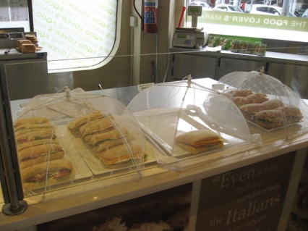
- Throwing out all leftover food. Some properties have a standing rule that requires all leftover food to be disposed of
- Allowing staff to eat items that are left over. Some properties may allow staff to tale leftover food home with them but this should not be expected. Check with your supervisor first
- Requiring high cost items to be stored for later use but allowing low-cost items to be thrown out. This may mean that meat dishes are carved while vegetables are discarded
- Separating disposables from food waste.
Disposing of disposables
Disposables are ‘single use’ items.
These are items intended for one use only, after which they cannot be re-used and must be discarded.
Disposables may be used as part of eat-in dining but are more prevalent where take-away food sales occur.
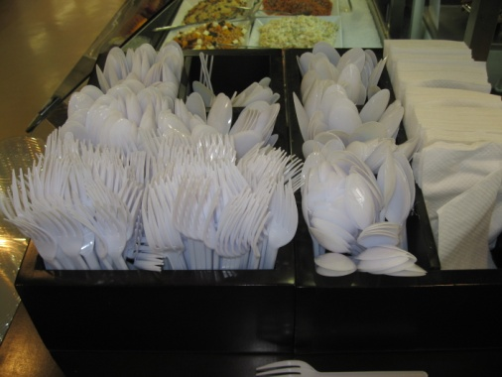
Examples of disposable items include:
- Plastic cutlery
- Drinking straws
- Paper serviettes
- Containers for serving take-away food, such as aluminium foil and plastic containers, take-away coffee, milk shake and other drink containers and pizza boxes. The lids to any take-away containers are also included.

Dispose of recyclable items
Many properties have adopted policies that enable them to become environmentally responsible.
The basis for these policies revolves around the need to:
- Reduce - asking people to generate less waste
- Re-use - encouraging the use of a product more than once before it is discarded
- Recycle - suggesting that products can be re-made into something else.
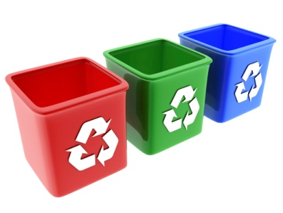
These policies can apply not only to food and beverage items but to all waste produced by the venue.
In relation to actual food and beverages there is little that can be done in the way of recycling. These are usually disposed of in the ‘normal’ way used by the property to get rid of its waste.
In some cases soft food scraps may be put through a waste disposal unit to reduce space occupied.
However, it is the treatment of materials used to supply raw ingredients to the property where the concept of recycling arises.
The activities of ‘Re-use’ and ‘Reduce’ fall outside the aim of this unit, but ‘recycling’ involves the sorting and disposal of waste, and sometimes its cleaning prior to separation and recycling.
Current waste management practices include the sorting of waste into the following categories in order to facilitate recycling:
- Paper – cardboard, newspapers and cardboard containers
- Plastic – soft drink, milk, juice and cordial bottles and packaging, bags
- Glass – bottles (clear, green and amber), jars and clear sauce bottles
- Steel cans – food cans and aerosol cans
- Aluminium – cans and foil
- Food waste – unusable waste scraps, trimmings and plate waste.
As a general rule, items for recycling should be cleaned (washed or rinsed) and flattened ready for collection. Each category of recyclable waste should be stored in a separate container for ease of pick-up, and to promote ease of processing.
Premises should always check with their local council to identify any local requirements that might apply

Disposing of cleaning chemicals
As environmental considerations have become increasingly important, so too has concern over the disposal of chemicals gained in significance.
There will be a need to dispose of cleaning chemicals when:
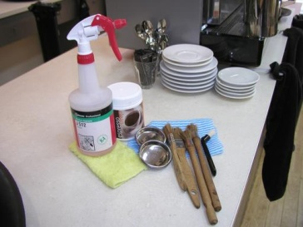
- Chemicals have become dated
- Containers have lost their labels and you don’t know what’s inside. Rather than guessing at what it is and risk using it inappropriately and unsafely
- You decide to discontinue using a certain product.
This disposal of chemicals must be done safely and according to safe environmental practices. This means:
- Cleaning chemicals must not be poured down the sink
- Cleaning chemicals must not be thrown out with normal rubbish.

9.5 Clear and clean service area and service items

Introduction
Once all the main end of shift tasks have been completed, it is now time to ensure that the service area and items are clean and tidy.
Organizational policies and procedures will highlight the correct steps in cleaning each outlet and explain how to keep your workplace free of clutter or conditions that allow bacteria and vermin to thrive.
Steps to maintaining a clear and clean outlet
Management and staff must:
- Regularly clean and maintain the premises
- Control pests and vermin
- Implement a daily cleaning schedule
- Maintain and clean equipment (making sure any equipment used for storing or holding hot or cold food is kept at the required temperature)
- Maintain food or beverage preparation and service areas at the highest standard of hygiene
- Follow correct food storage procedures
- Follow correct garbage removal procedures
- Follow your workplace ‘no smoking’ requirements
- Do not smoke in food preparation and storage areas.
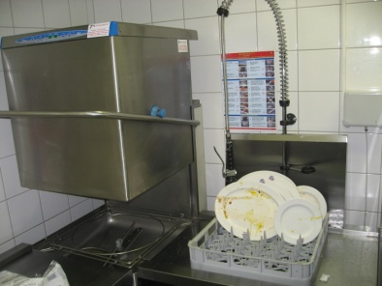
Cleaning glassware, crockery and cutlery
You may or may not be required to clean dishes, glasses etc. that have been used as part of the service process. There is a wide variation between premises in this regard.
Some businesses will simply ask you to carry the used items back to either the kitchen or bar and off-load them. Another staff member will handle things from there.
Some premises will require you to off-load them and empty glasses and other containers of ice, slices of lemon, decorations, remaining liquid etc. and clear plates into a bin or waste disposal unit.
Other properties will require you to undertake the entire cleaning process for crockery, cutlery, glassware etc.

Glasses and glassware
The basic procedure is to use a glass washing machine with the procedure being:
- Empty glasses and other containers of all contents
- Load the glasses into a glass washing tray. They have to be put in upside down
- Wash the glasses in the machine when required or when the trays are full. Use the wash cycle preferred by the establishment
- Take the glasses out of the machine and either allow to air dry or hand-polish according to house requirements
- Put the clean glasses in their nominated storage areas ready for use.
Points to note regarding the glass washing machine are:
- The correct wash cycle is chosen – where options exist
- No slices of lemon etc. are allowed to block up the plug hole in the glass washing machine
- The temperature of the water being used is a minimum of 70ºC
- The machine is being supplied with the appropriate glass washing detergent, appropriately diluted (where applicable).
Crockery and cutlery
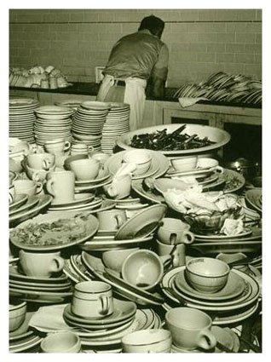
Most premises use a dish washing machine to wash crockery and cutlery and machine-specific training should be provided to you on the job.
The basic cleaning procedure is:
- Remove visible food debris. For example, scrape the plates
- Rinse with warm water to remove loose dirt
- Wash with a detergent
- Rinse again to remove the detergent and debris
- Apply a sanitiser. Sanitisers are chemicals designed to kill bacteria
- Rinse to remove the sanitiser
- Allow to air dry.
Air drying is the preferred option as it eliminates using a cloth to dry surfaces, which may inadvertently introduce bacteria to the surface that has just been cleaned and sanitised.
The procedure for washing eating utensils and dishes by machine is as follows:
- Scrape and rinse items prior to stacking in trays. Use the right racks for the right items
- Wash for a minimum of 60 seconds at a temperature between 66°C and 71°C
- Rinse for a minimum of 10 seconds at a temperature of at least 77°C.
In some circumstances there will be no dishwashing machine. This is common in small businesses, and it is quite legal to use a double bowl sink providing certain requirements are observed.

When using a double bowl sink to wash eating utensils and dishes:
- One bowl must contain water at 45°C and detergent, for washing
- One bowl must contain clean water at a minimum of 77°C for sanitising
- Sanitising must involve soaking the items for a minimum of 3 minutes. It is not acceptable to just run hot water over items to remove the suds
- A thermometer must be on hand to check water temperature.
Items must once again be left to air dry, which means draining and leaving to dry while hot. Tea towels must not be used.
Operators must make sure that detergents and sanitisers are diluted according to manufacturer’s recommendations, and that all other manufacturer’s advice is adhered to.
If you are not sure how to use the dishwasher where you work, or not sure about what detergent to use for what job, or how much to dilute it you should ask for assistance.

Clean service area
The focus now is on ensuring the work area is clean, tidy and hygienic. Whilst Section 1 of this manual describes a range of tasks to undertake to get an area ready for service, none of these can take place unless the work area itself is clean and tidy.
Clearing and cleaning
Various areas in a restaurant need to be cleaned, cleared or dismantled at the end of service sessions.
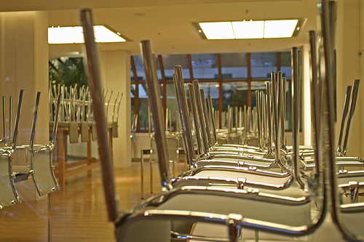
These procedures must be completed in accordance with establishment standards and comply with all safety requirements.
Sometimes cleaning staff perform these functions and sometimes waiting and bar staff do.
In some cases, these tasks are completed at the end of the shift, and in other cases, the duties are left until the start of the next shift.
Some of those areas may include:
- Stripping tables. This includes removal of all table items, and the tablecloth. Part of this process may include checking the seats of chairs to ensure they are clean and tidying the area immediately around each table. In some cases you may be required to put the chairs on the tables to facilitate a full clean of the floor by cleaners
- Around the coffee machine where coffee grounds and spillage are common, and there is normally a need to do a general ‘clean and tidy’. Where required, replacements and top-up of items such as coffee, sugar, crockery etc. should occur
- The waiter’s stations – to clean and replenish supplies
- Laundry areas. In cases where service staff are responsible for laundering of the dining room/bar linen they may have basic cleaning and tidying responsibilities including checking levels of chemicals and linen supplies
- Kitchen food service area. The tasks here should be restricted to service-related activities such as refilling condiments, tidying and replacing used items back into this area
- Restroom facilities. Commonly the primary responsibility for cleaning this area belongs to the cleaners but waiting staff may have end of shift duties such as:
- Checking to make sure no patrons remain in these areas after the premises have closed
- Checking to see if any items have been left there
- Checking to identify damage or cleaning needs that demand immediate action
- Replenishment of toilet supplies, as appropriate
- Furniture. Basic requirements may include:
- Relocating tables and chairs to their ‘original’ position. Note that some properties simply leave tables and chairs as they are and do not relocate then until the seating plan for the next session is developed
- Taking table tops off tables. Where the venue adds table tops to tables, it is a standard requirement that these table tops are removed and stored at the end of the session
- Removing extra chairs that have been brought in. A dining area that normally seats 80 may have had an additional 6 chairs brought in for a session to cater for special needs. These 6 chairs have to be put back where they were taken from
- Removing high chairs. Where patrons have requested a high chair it is standard practice to replace these chairs back into storage
- Fixtures and fittings. A check on these should be made which may include:
- Checking for damage
- Watering plants as required
- Clearing papers or rubbish and used glasses etc.
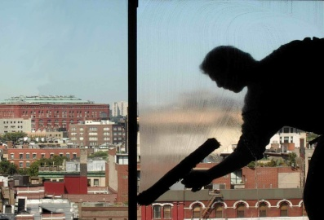
- Windows and doors – spot cleaning as required and checking to ensure they are closed and locked
- All floor areas – picking up loose rubbish and checking to identify areas that require special attention
- Displays – including re-stocking display items and securing items
- Guest waiting area and reception – spot cleaning and tidying
- Garbage area – removing garbage from internal rubbish bins and replacing bin liners.
As mentioned above:
- Where you identify an item that is unsafe, not working properly or is damaged, you should notify the appropriate person
- Clearing and cleaning duties should incorporate other checks such as OSH checks, security checks, safety inspections to save time.

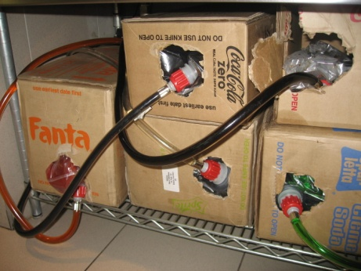
Dismantling items
Where necessary, staff may be required to dismantle:
- Post-mix stations for cleaning
- Espresso machines for cleaning
- Table tops to return table tops top storage
- Bain-maries for cleaning.
Storing cleaning equipment away after use
After cleaning duties have been completed, all cleaning items, equipment and chemicals must be stored away in the appropriate manner so that others can use them when required.
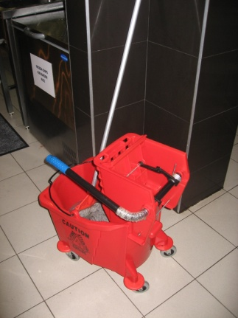
Usually, items will simply be replaced back to the area from where they were obtained.
Things to note when storing items away after cleaning tasks include:
- Stowing items neatly and tidily – don’t just throw items into a room. Treat them with care and respect and ensure they are easy for the next user to get at
- Checking the equipment for faults or damage. Where items are not working properly this must be reported immediately to your supervisor so that arrangements for repair, or some other alternative, can be made. Special attention must be paid to electrical equipment
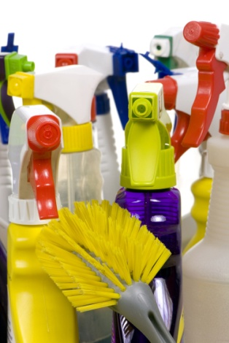
- Cleaning the equipment used. This can include:
- Emptying vacuum bags
- Emptying the tanks of wet vacuum cleaners
- Wiping down exterior surfaces
- Drying equipment, where appropriate
- Washing and sanitising mops and hanging them to dry
- Cleaning brooms
- Checking supply level of cleaning chemicals. Notify your supervisor where supplies of these are running low. You may be required to complete a requisition for these, or you may be expected to obtain the necessary supplies for the storeroom
- Checking supplies of cleaning materials such as cloths, trigger spray bottles, cleaning pads, scourers, protective gloves and obtaining what is required.

Set up area correctly for next service period
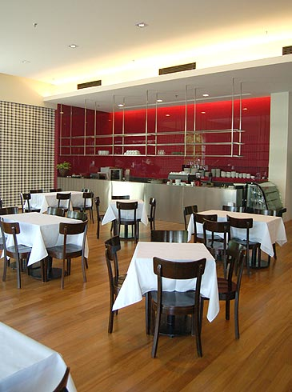
At the end of each shift, the dining area may need to be set up for the next shift. Sometimes this is left for the next shift to do.
As mentioned, Section 1 of this manual will detail the majority of steps undertaken to prepare for an upcoming shift, so they won’t be repeated in this section.
Set up may involve minimal work if the next shift is going to be serving guests with the same or similar type or style of menu and floor plan. However setting up for the next shift may involve a great deal more effort and time if the type of service or style of menu is different.
Therefore there may be some activities that have not been mentioned that need to take place, especially if the next service offering is different to that that has finished.
Setting up for a breakfast shift
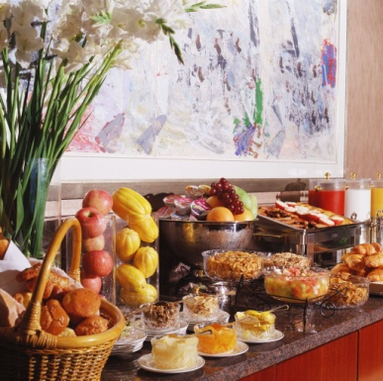
Sometimes the evening shift service staff will have to partially set up for the breakfast shift the following morning.
This may include having to:
- Re-lay all tables and set covers for a breakfast menu
- Place breakfast menus on tables or at other designated locations in the room
- Place sealed portion-control condiments (such as sugar, jam and honey) onto service areas or customer tables
- Set up the breakfast buffet with the appropriate equipment, displays and non-perishable food items such as cereals, etc.
- Re-stock refrigerated and non-refrigerated items that will be needed to service the breakfast menu.

Setting up for a function
Sometimes staff may have to set up the dining area for a function.
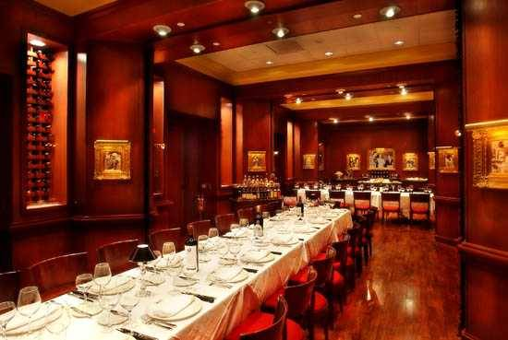
These requirements will vary depending on the type and style of menu, service style, and other requirements to meet the demands of the guests, host, or client for the function.
A ‘Function Sheet’ should be used to direct activities which may include a need to:
- Rearrange all tables and chairs
- Set covers on tables according to the menu
- Set up a buffet and equipment needed to service it
- Stock specific food and beverage items
- Clear an area for entertainment or displays.
Enterprise procedures and requirements
Regardless of the set up activities that are taking place, it is essential that any organisational procedures and policies be followed by ball staff. Whilst these will vary for different organisations and for different shifts, some common requirements include:
- Ensuring safety of premises and furniture, equipment etc.
- Preserving food safety
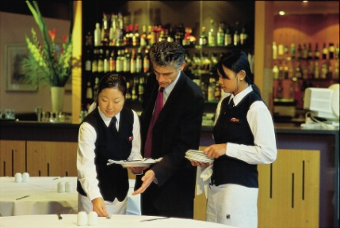
- Ensuring security of the premises during set up. Most premises are closed to the public during these preparation times but need to open as required to allow access by suppliers to the area. This need for access obviously has the potential to jeopardise security so special attention needs to be paid to security at these times
- Following identified sequences for room preparation. Properties will normally have a staged way of setting up a room so following the identified procedures is a necessity
- Communicating with others to integrate total property needs
- Completing necessary documentation such as requisitions forms, ‘change required’ slips, maintenance requests etc.
Adhering to imposed labour budget restrictions such as making sure that certain staff knock off when required as opposed to dragging out their work time to gain extra pay.

9.6 Conduct session de-briefing

Introduction
It is recommended that there is a debriefing session at the completion of every service session.
The debriefing is a short meeting (5 – 10 minutes) where management and staff can review and evaluate the previous session with a view to congratulating staff on their work and effort, and identifying areas where improvements to service can occur.
Reviewing and evaluating the service session
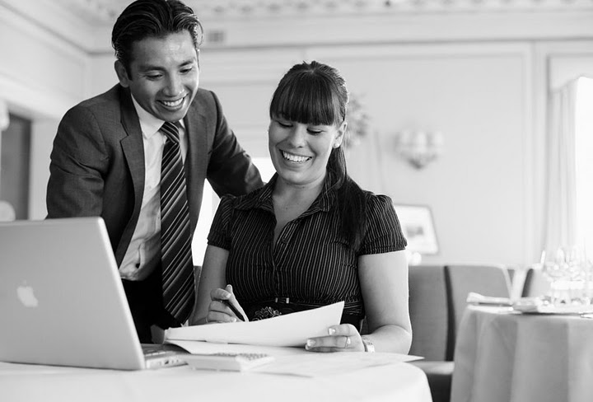
Prime concerns at this meeting should be:
- Communication between food and beverage staff
- Communication between food and kitchen staff
- Cooperation between staff in all food and beverage areas
- Integration of service between food and beverage staff.
The supervisor leads the session where the food and beverage staff have separate supervisors, the two supervisors conduct the debriefing jointly and:
- Congratulate staff on work that has been well done during service. This can be generic in nature or it may single out individual staff who performed really well
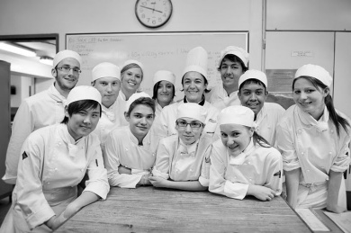
- Highlight and lead discussion on problems and issues that arose with a view to determining what went wrong or how a similar event can be avoided in the future
- Provide the staff with feedback from their perspective of how the session went and provide feedback they have captured from others such as customers, management or other departments
- Review the quality of service delivery provided with a view to identifying changes that could lead to possible improvements in service delivery
- Encourage staff to identify issues of concern to them including identification of problems they have found with equipment, suspicious persons, procedures that are not working effectively, lack of cooperation etc.
- Present issues and details of what can be expected in the next session such as pre-warning staff about a function, a revised starting time for the next shift, expected customer numbers, proposed special events etc.
- Thank staff for their efforts and contribution.

9.7 Conduct handover to incoming shift, where appropriate

Introduction
A handover is a situation where the department remains open but the staff working in that department change.
It is uncommon and often inadvisable for all the staff to change when there is a handover as it is best if there is some continuity of staff. However, this situation can sometimes occur especially where there is only one staff member running a department.
Providing handover
There may be times when a shift has to be handed over to an incoming colleague.
During such times, all relevant information should be shared with incoming staff.
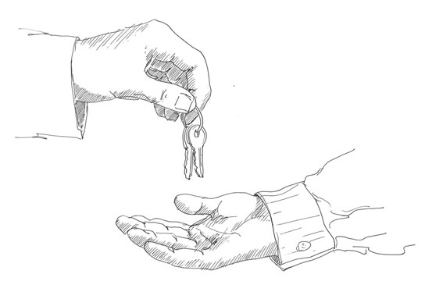
The intention should be to achieve the handover without the guests even being aware that it has happened, or with a minimal disruption to them.
The only allowable departure from this is where you have developed a special relationship with guests, and it seems appropriate to say “good bye” to them. In these cases, not to do so may be interpreted as being rude and impersonal.
It is imperative that the flow of service continues.
Pre-handover checks
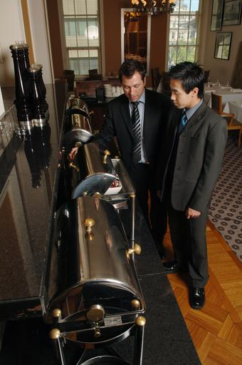
Prior to doing a handover, the outgoing shift should ensure:
- The department is clean and in good order. This includes all areas including floors, tables, chairs, storage areas, waiters stations, equipment
- Available stock has already been put away. New, in-coming staff should not be responsible for this unless there has been an extremely busy session that has prevented outgoing staff from doing this
- Where the department handles cash payments, there must be change in the register sufficient for the next shift to at least start their shift without experiencing a shortage of change. Where necessary change should be ordered to supplement what is already there.

Sharing relevant information
Information that may need to be addressed and passed on could include:
- Status of the customer’s orders and service – what’s been served, where they are up to, what’s happening in the kitchen or bar in relation to the order. Incoming staff need to be briefed, for example, on what Table 4 has ordered, what has been served so far and how long it has been since their last course was cleared
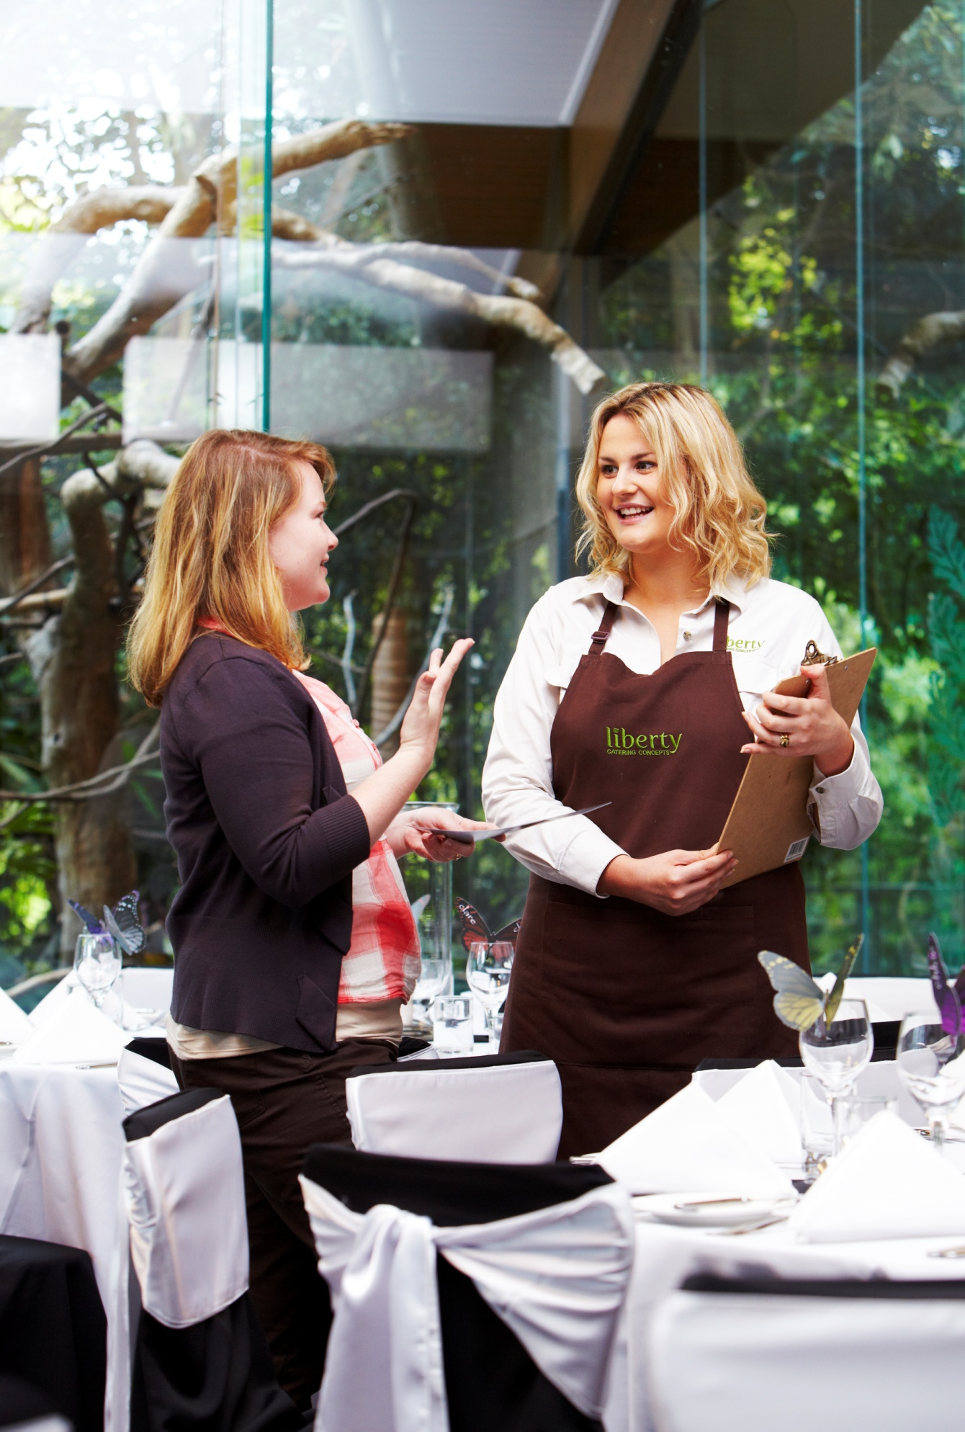
- Availability of beverage products and supplies – what is running low, what has run out, how many serves of XYZ there are, including what action, if any, has been taken to secure extra supplies
- Changes or alterations to the menu. This should include sharing details about today’s specials, items that have been added at the last minute or just for today including items that the kitchen wants promoted
- Any customer complaints. This includes who has complained and about what, any complaints that seem to be part of a trend and information about what action has been taken in response to these complaints
- Roles for incoming staff members so that individual workers know exactly what they are to be doing for the up-coming shift. For example are they doing food? Beverage? Both? Acting as runners? Accepting payment? Which station are they working?
- Information about specific pieces of equipment or utensils with attention to issues such as malfunctions, damage or lack of equipment
- Discussing financial transactions including identification of:
- Who has already paid
- Tables/guests where advanced deposits have been received
- Any guests who have indicated that they alone and no-one else at the table are to get the account
- People who may be dining on vouchers
- Guests who are in-house guests and can be expected to charge to their rooms
- Tables where accounts have been presented but not yet paid
- The status of every account or table in the room.

Work Projects
It is a requirement of this Unit that you complete Work Projects as advised by your Trainer. You must submit documentation, suitable evidence or other relevant proof of completion of the project to your Trainer by the agreed date.
9.1. To fulfil the requirements of this Work Project you are asked to identify how to turn off electrical and service-related equipment
9.2. To fulfil the requirements of this Work Project you are asked to identify how to remove used linen items for laundering
9.3. To fulfil the requirements of this Work Project you are asked to identify how to store, stock and replenish, where necessary, for next service session
9.4. To fulfil the requirements of this Work Project you are asked to identify how to dispose of waste
9.5. To fulfil the requirements of this Work Project you are asked to identify how to clear and clean service area and service items
9.6. To fulfil the requirements of this Work Project you are asked to identify importance of conducting a session debriefing
9.7. To fulfil the requirements of this Work Project you are asked to identify importance of conducting a handover to incoming shift

Summary

Conduct shut down activities
Turn off electrical and service-related equipment, where appropriate
Storing and preparing equipment.
Remove used linen items for laundering
Collect, sort and count linen.
Store, stock and replenish, where necessary, for next service session
Storing in accordance with instructions and regulations.
Replenishing items
Reordering stock and supplies
Items to reorder.
Dispose of waste
Dispose of leftover food
Disposing of disposables
Dispose of recyclable items
Disposing of cleaning chemicals.
Clear and clean service area and service items
Steps to maintaining a clear and clean outlet
Cleaning glassware, crockery and cutlery
Clean service area
Dismantling items
Storing cleaning equipment away after use
Set up area correctly for next service period
Enterprise procedures and requirements.
Conduct session debriefing
Reviewing and evaluating the service session.
Conduct handover to incoming shift, where appropriate
Providing handover.

Presentation of written work

1. Introduction
It is important for students to present carefully prepared written work. Written presentation in industry must be professional in appearance and accurate in content. If students develop good writing skills whilst studying, they are able to easily transfer those skills to the workplace.

2. Style
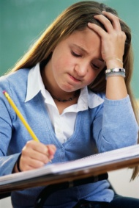
Students should write in a style that is simple and concise. Short sentences and paragraphs are easier to read and understand. It helps to write a plan and at least one draft of the written work so that the final product will be well organised. The points presented will then follow a logical sequence and be relevant. Students should frequently refer to the question asked, to keep ‘on track’. Teachers recognise and are critical of work that does not answer the question, or is ‘padded’ with irrelevant material. In summary, remember to:
- Plan ahead
- Be clear and concise
- Answer the question
- Proofread the final draft.

3. Presenting Written Work
Types of written work
Students may be asked to write:
- Short and long reports
- Essays
- Records of interviews
- Questionnaires
- Business letters
- Resumes.
Format
All written work should be presented on A4 paper, single-sided with a left-hand margin. If work is word-processed, one-and-a-half or double spacing should be used. Handwritten work must be legible and should also be well spaced to allow for ease of reading. New paragraphs should not be indented but should be separated by a space. Pages must be numbered. If headings are also to be numbered, students should use a logical and sequential system of numbering.
Cover Sheet
All written work should be submitted with a cover sheet stapled to the front that contains:
- The student’s name and student number
- The name of the class/unit
- The due date of the work
- The title of the work
- The teacher’s name
- A signed declaration that the work does not involve plagiarism.
Keeping a Copy
Students must keep a copy of the written work in case it is lost. This rarely happens but it can be disastrous if a copy has not been kept.
Inclusive language
This means language that includes every section of the population. For instance, if a student were to write ‘A nurse is responsible for the patients in her care at all times’ it would be implying that all nurses are female and would be excluding male nurses.
Examples of appropriate language are shown on the right:
Mankind | Humankind
Barman/maid | Bar attendant
Host/hostess | Host
Waiter/waitress | Waiter or waiting staff

Recommended reading
Arduser, Lora and Brown, Douglas R; 2004 (1st edition); The Waiter and Waitress and Waitstaff Training Handbook: A Complete Guide to the Proper Steps in Service for Food and Beverage Employees; Atlantic Publishing Group Inc
Dahmer, Sondra and Kahl, Kurt; 2008 (2nd edition); Restaurant Service Basics; Wiley
Fuller, John; 1980 (1st edition); Gueridon and Lamp Cookery; Hutchinson
Johnston, R and Clark G, 2008 (3rd Edition), Service Operations Management. Pearson Education
Kotschevar, Lendal and Luciani, Valentino; 2006 (2nd edition); Presenting Service: The Ultimate Guide for the Foodservice Professional; Wiley
Lillicrap, Dennis and Cousins, John; 2010 (1st edition); Essential Food and Beverage Service: Levels 1 and 2; Hodder Arnold
Walker, John R; 2008 (5th Edition); Introduction to Hospitality; Prentice Hall
Zeithaml, Valarie A; 2009 (1st edition); Delivering Quality Service; Free Press
In addition
The following is sourced from ‘Trove: National Library of Australia’ at http://trove.nla.gov.au/.
Clyne, Carol Murphy & Clyne, Vincent 2014, Modern buffet presentation, Wiley, Hoboken, N.J
Hayes, David K 2014, The professional restaurant manager
Payment, Simone 2014, Careers in restaurants, First Edition, New York Rosen Publishing

Trainee evaluation sheet

Provide Food and Beverage Services
The following statements are about the competency you have just completed.
Please tick the appropriate box | Agree | Don’t Know | Do Not Agree | Does Not Apply
There was too much in this competency to cover without rushing.
Most of the competency seemed relevant to me.
The competency was at the right level for me.
I got enough help from my trainer.
The amount of activities was sufficient.
The competency allowed me to use my own initiative.
My training was well-organised.
My trainer had time to answer my questions.
I understood how I was going to be assessed.
I was given enough time to practice.
My trainer feedback was useful.
Enough equipment was available and it worked well.
The activities were too hard for me.

The best things about this unit were:

The worst things about this unit were:

The things you should change in this unit are:

Trainee self-assessment checklist
As an indicator to your Trainer/Assessor of your readiness for assessment in this unit please complete the following and hand to your Trainer/Assessor.

Provide Food and Beverage Services
 |  | Yes | No*
Element 1: Prepare food and beverage environment for service
1.1 | Check requirements for the upcoming service session
1.2 | Check cleanliness of the facility and conduct spot and makeup cleaning as required
1.3 | Set up dining area for trading session
1.4 | Process incoming reservations to the establishment
Element 2: Set tables
2.1 | Match table setting to menu for the session
2.2 | Set tables and dress where appropriate
2.3 | Complete final inspection of room and table set ups
2.4 | Identify and report recurring problems with set up to the appropriate person to prevent recurrence
Element 3: Meet and greet guests
3.1 | Welcome guests on arrival
3.2 | Seat guests at nominated or designated tables
3.3 | Offer pre-meal services
3.4 | Present menus and wine/drink lists
3.5 | Provide service advice and information to guests
Element 4: Take food and beverage orders
4.1 | Take beverage orders and food orders
4.2 | Sell menu items and drinks proactively
4.3 | Recommend wines and drinks to accompany selected foods
4.4 | Respond to guest queries regarding menu items and drink choices
4.5 | Transfer orders to service and preparation points
4.6 | Adjust settings/covers to reflect menu items selected
4.7 | Liaise with other staff regarding intended service delivery
Element 5: Serve food
5.1 | Serve bread rolls at table
5.2 | Serve dishes as ordered by guests
5.3 | Check guest satisfaction as part of service delivery
5.4 | Take remedial action in the event of guest dissatisfaction
5.5 | Clear table at appropriate times throughout meal and on completion of meal
Element 6: Serve drinks
6.1 | Serve pre-dinner drinks to table
6.2 | Serve wines to table
6.3 | Serve after-meal drinks to table
6.4 | Coordinate timing of beverage service to match courses/menu items being served
6.5 | Clear glasses and beverage items
Element 7: Present account to guest
7.1 | Compile guest account ready for presentation
7.2 | Present account to guest
7.3 | Accept payment for account
7.4 | Process payment of account
Element 8: Provide departure services
8.1 | Assist guest in leaving table
8.2 | Provide end-of-service assistance, as required
8.3 | Farewell guests
Element 9: Conduct shut down activities
9.1 | Turn off electrical and service-related equipment, where appropriate
9.2 | Remove used linen items for laundering
9.3 | Store, stock and replenish, where necessary, for next service session
9.4 | Dispose of waste
9.5 | Clear and clean service area and service items
9.6 | Conduct session de-briefing
9.7 | Conduct handover to incoming shift, where appropriate
Statement by Trainee:
I believe I am ready to be assessed on the following as indicated above:
Signed: _____________________________ | Date: ____________

Note:
For all boxes where a No* is ticked, please provide details of the extra steps or work you need to do to become ready for assessment.





